

Manual

***Tools for Korg Workstations PCG and Related Files***

**version 2.8.0**

**Release Date October 27, 2016**

**Developer Michel Keijzers (MiKeSoft)**

**Online version:** [**https://pcgtools.mkspace.nl/ Manual.pdf**](https://pcgtools.mkspace.nl/%20Manual.pdf)

Brief Overview

1 About PCG Tools 1

2 About the Manual 3

3 Overview 5

4 Korg Files 22

5 Workflow 31

6 Main Screen 34

7 Using Patch Files 59

8 Using SNG (Song) Files 140

9 Keyboard Usage & Shortcut Keys 143

10 Installation of Core FTP LE 146

Terms of Usage

PCG Tools is a free application, however the executable and the source code may never be used for commercial reasons.

Also the application may not be spread except by the developer. It may not be uploaded to web sites, peer to peer networks, spread by email or by other means without permission of the developer.

The reason for this, is that the developer maintains a list of people who are using PCG Tools and when a new update is available, it will be send to everybody on this update list, to make sure everybody always receives the latest version.

This application is not affiliated by Korg, so requests, bugs, wishes, questions etc. should be directed to michel.keijzers@hotmail or being posted on the main PCG Tools ([www.korgforums.com/forum/phpBB2/viewtopic.php?t=63765](http://www.korgforums.com/forum/phpBB2/viewtopic.php?t=63765)) thread or one of the model specific threads at www.korgforums.com. (see paragraph **Fout! Verwijzingsbron niet gevonden.**).

**WPF MDI**

This application uses third party source code. The license can be read in file wpfmdi_license.txt.

**Notice**

The developer reserves the right to make improvements or changes in the software product and the manual at any time and without notice.

**Disclaimer**

THE DEVELOPER, MAKES NO WARRANTIES, EITHER EXPRESSED OR IMPLIED, WITH RESPECT TO THIS MANUAL OR WITH RESPECT TO THE SOFTWARE DESCRIBED IN THIS MANUAL, ITS QUALITY, PERFORMANCE MERCHANTABILITY, OR FITNESS FOR ANY PARTICULAR PURPOSE.

THE APPLICATION AND MANUABL IS PUBLISHED AS IS. IN NO EVENT SHALL THE DEVELOPER BE LIABLE FOR INCIDENTAL OR SEQUENTIAL CORRUPTION OF FILES TOUCHED BY THIS SOFTWARE.

© 2011-2014 Michel Keijzers (MikeSoft)

All rights reserved.

Content

1 About PCG Tools 1

1.1 Relation to Korg.com 1

1.2 Home Page / Web site 1

1.3 Notifications / PCG Tools Yahoo group 1

1.4 Forum / Discussions 1

1.5 Social Media 2

1.5.1 FaceBook 2

1.5.2 Google Plus 2

1.5.3 Twitter 2

1.6 Donations 2

2 About the Manual 3

2.1 Introduction 3

2.2 Online Version 3

2.3 Conventions 4

3 Overview 5

3.1 Solutions for managing PCG and SNG files 5

3.1.1 Introduction 5

3.1.2 List Generator solutions 5

3.1.3 Librarian solutions 6

3.1.4 Editor solutions 6

3.1.5 Additional solutions 6

3.1.6 Song (SNG) files 7

3.1.7 External Links pages 7

3.2 What is not possible with this application? 7

3.3 System Requirements 7

3.3.1 Non Windows Computers 8

3.4 Setup 8

3.4.1 Instructions 8

3.4.2 Removing the application 16

3.4.3 Installation Problems 17

3.4.4 Standalone Installation 17

3.4.5 Microsoft Library 18

3.4.5.1 Introduction 18

3.4.5.2 Windows XP 19

3.5 Workstation Models 19

3.5.1 Supported Workstation Models 19

3.5.2 Workstation Dependent Features 20

4 Korg Files 22

4.1 PCG / Patch Files 22

4.1.1 Structure 23

4.1.2 Program 24

4.1.3 Program Bank 24

4.1.4 Virtual Banks 27

4.1.5 Program Banks 27

4.1.6 Combi 27

4.1.7 Timbres 28

4.1.8 Timbre 28

4.1.9 Combi Bank 28

4.1.10 Combi Banks 29

4.1.11 Set List Slot [Kronos Only] 29

4.1.12 Set List [Kronos Only] 29

4.1.13 Set Lists [Kronos Only] 29

4.1.14 Drum Kit 29

4.1.15 Drum Kit Bank 29

4.1.16 Drum Kit Banks 29

4.1.17 Wave Sequence 29

4.1.18 Wave Sequence Bank 30

4.1.19 Wave Sequence Banks 30

4.1.20 Global 30

4.1.21 Category 30

4.1.22 Sub Category 30

4.2 Song (SNG) Files 30

4.3 KMP/KSF/KSC Files 30

5 Workflow 31

5.1 Description 31

5.2 Workflow for Korg Kronos (X) with FTP connection 31

5.3 Workflow for PCG / SNG files 31

5.4 Workflow for other files (like SYX, MID, 01W, …) 32

5.5 Connection/Storage Types per Workstation Model 32

6 Main Screen 34

6.1 Splash Screen 34

6.2 Application Start 35

6.3 Initial screen 35

6.4 File Menu 36

6.4.1 Open File Command 36

6.4.2 Save File Command 39

6.4.3 Save (File) As Command 40

6.4.4 Export to Sequencer Command 40

6.4.5 Revert to Saved Command 40

6.4.6 Close Command 41

6.4.7 Exit Command 42

6.5 Edit Menu 43

6.6 Show Menu 43

6.6.1 Timbres 43

6.6.2 Special Event 43

6.7 Tools Menu 43

6.8 Theme Menu 43

6.9 Languages Menu 45

6.10 Options Menu 46

6.10.1 Menu items 46

6.10.2 Settings Menu 46

6.10.2.1 Files Settings 46

6.10.2.2 Edit settings 48

6.10.2.3 Cut/Copy/Paste Settings 49

6.10.2.4 Sort Settings 50

6.10.2.5 Categories Settings 52

6.11 Windows Menu 52

6.11.1 Goto Next Window 52

6.11.2 Goto Previous Window 52

6.12 Help Menu 53

6.12.1 About Command 53

6.12.2 Home Page 54

6.12.3 Manual 54

6.12.4 External Links Command 54

6.12.4.1 Korg related External Links 55

6.12.4.2 Donators External Links 55

6.12.4.3 Translators External Links 56

6.12.4.4 Third Parties External Links 56

6.12.5 Oasys Codes Sponsors 57

6.13 Toolbar 58

7 Using Patch Files 59

7.1 Introduction 59

7.2 Status Bar 59

7.2.1 PCG/OS Version 60

7.3 PCG Window 61

7.3.1 Introduction 61

7.3.2 Title 62

7.3.3 Programs/Combis/Set Lists / Wave Sequences / Drum Kits Radio buttons 62

7.3.4 Banks Listview (Left side) 62

7.3.4.1 Program Banks 64

7.3.4.2 Combi Banks 65

7.3.4.3 Set Lists [KRONOS ONLY] 66

7.3.4.4 Wave Sequence Banks 67

7.3.4.5 Drum Kits Banks 68

7.3.5 Patches Listview (Right side) 68

7.3.5.1 Number of Selected Patches 68

7.3.5.2 Programs/Combis 69

7.3.5.3 Set List Slots [KRONOS ONLY] 70

7.3.5.4 Wave Sequences and Drum Kits 71

7.3.6 Generic Commands 72

7.3.6.1 Edit Command 73

7.3.6.1.1 Edit Program 73

7.3.6.1.2 Edit Combi 74

7.3.6.1.3 Edit Set List Slot [KRONOS ONLY] 74

7.3.6.2 Move Up Command 76

7.3.6.3 Down Command 76

7.3.6.4 Clear Command 76

7.3.6.5 Compact Command 79

7.3.6.6 Sort Command 81

7.3.6.7 Timbres Command 83

7.3.7 Cut/Copy/Paste Commands 84

7.3.7.1 Introduction 84

7.3.7.2 Copying between different file types 84

7.3.7.3 Copying between different workstation models 84

7.3.7.4 Cut Command 85

7.3.7.5 Copy Command 87

7.3.7.6 Paste Command 89

7.3.7.6.1 Pasting to different workstation models 90

7.3.7.6.2 Pasting to different OS versions. 90

7.3.7.7 Cut/Copy/Paste Settings Command 91

7.3.7.7.1 Showing the settings 91

7.3.7.7.2 Settings 92

7.3.7.7.3 Restore Button 94

7.3.7.8 Cut/Copy/Paste Exit Command 94

7.3.7.9 Cut/Copy/Paste Recall Command 95

7.3.7.10 Cut/Copy/Paste Examples 96

7.3.7.10.1 Introduction 96

7.3.7.10.2 Example: Copying programs inside a patch file 97

7.3.7.10.3 Example: Copying programs from one patch file to another patch file 98

7.3.7.10.4 Example: Copying combis inside a patch file 99

7.3.7.10.5 Example: Creating a PCG with default set list slots [KRONOS ONLY] 99

7.3.7.10.6 Using cut and paste (inside a patch file) 100

7.3.7.10.7 Example: Having fun with Copy and Paste 100

7.4 Master Files 102

7.4.1 Introduction 102

7.4.2 Usage 102

7.4.3 Conditions of a Master File 102

7.4.4 Master Files Menu 102

7.4.5 Show Master Files Command 103

7.4.6 Set patch File as Master File 104

7.4.7 Auto Load Master Files 104

7.5 Combi Window 106

7.5.1 Content 106

7.5.2 Commands 107

7.5.2.1 Move Up Command 107

7.5.2.2 Move Down Command 107

7.5.2.3 Clear Command 108

7.5.2.4 Assigned Clear Program 108

7.6 List Generator (Generate List) 110

7.6.1 List Types 110

7.6.1.1 Patch List 111

7.6.1.2 Program Usage List 113

7.6.1.3 Combi Content List 115

7.6.1.3.1 Compact Combi Content List 115

7.6.1.3.2 Short Combi Content List 115

7.6.1.3.3 Long Combi Content List 116

7.6.1.4 Differences List 117

7.6.1.5 File Content List 119

7.6.2 Settings 120

7.6.2.1 Filter On Text 122

7.6.2.2 Filter Program Banks 123

7.6.2.3 Filter Combi Banks 124

7.6.2.4 Filter Set List Slots [KRONOS ONLY] 125

7.6.2.5 Filter Drum Kits 126

7.6.2.6 Filter Wave Sequences 126

7.6.2.7 Filter on Favorites [KRONOS (X) ONLY] 126

7.6.2.8 Optional Columns 127

7.6.2.9 Sorting 128

7.6.2.9.1 Type/Bank/Index 128

7.6.2.9.2 Category, then Patch Name 128

7.6.2.9.3 Patch Name 130

7.6.2.10 Output 130

7.6.2.10.1 ASCII Table Output 130

7.6.2.10.2 (Plain) Text Output 131

7.6.2.10.3 CSV (Comma Separated Value) File Output 131

7.6.2.10.4 XML 133

7.6.3 Command Line Arguments 135

7.7 Additional patch File Features 138

7.7.1 Generating a Cubase Instrument Definition File 138

8 Using SNG (Song) Files 140

8.1 Songs Tab 140

8.2 Samples Tab 142

9 Keyboard Usage & Shortcut Keys 143

9.1 Keyboard Command Selection 143

9.2 Generic Commands Shortcut Keys 143

9.3 Main Menu Shortcut Keys 144

9.4 Keyboard Shortcut Keys and Mouse handling 144

9.5 PCG Window Shortcut Keys 145

9.6 SNG Window 145

10 Installation of Core FTP LE 146

10.1 Introduction 146

10.2 Setup the FTP connection on the Kronos site. 146

10.3 Install Core FTP LE 146

10.4 Set up the FTP connection 148

List of Figures

Figure 1: Homepage 8

Figure 2: Download page 9

Figure 3: Download 9

Figure 4: Confirm 10

Figure 5: Preparing to Install 11

Figure 6: Welcome to the InstallShield Wizard for PCG Tools 12

Figure 7: PCG Tools Eula 12

Figure 8: Customer Information 13

Figure 9: Destination Folder 13

Figure 10: Ready to Install the Program 14

Figuur 11: Progress 15

Figure 12: Installation complete 16

Figure 13: Start menu 16

Figure 14: Setup screen 12 17

Figure 15: Microsoft Library 18

Figure 16: PCG File Structure 23

Figure 17: Splash screen 34

Figure 18: PCG Tools icon 35

Figure 19: Initial main screen 35

Figure 20: Opened File 37

Figure 21: Corrupted or Unsupported File 39

Figure 22: Empty patch File 39

Figure 23: Changed patch file 40

Figure 24: Warning Dialog when closing a changed file 41

Figure 25: Warning Dialog when exiting PCG Tools 42

Figure 26: Special Event 43

Figure 27: Generic Theme 44

Figure 28: Luna Theme 44

Figure 29: Aero Theme 45

Figure 30: Language Menu 46

Figure 31: Language change 46

Figure 32: Files Settings 47

Figure 33: Cut/Copy/Paste Settings 49

Figure 34: Sort Settings 50

Figure 35: Categories Settings 52

Figure 36: About window 53

Figuur 37: Home Page 54

Figure 38: Korg Related External Links 55

Figure 39: Donators External Links 56

Figure 40: Translators External Links 56

Figure 41: Third Parties External Links 57

Figure 42: Oasys Codes Sponsors 58

Figure 43: Status Bar 59

Figure 44: PCG Window 61

Figure 45: Wrapped PCG Window 62

Figure 46: Listviews 63

Figure 47: Program Banks 64

Figure 48: Combi Banks 65

Figure 49: Set Lists 66

Figure 50: Wave Sequence Banks 67

Figure 51: Drum Kits Bank 68

Figure 52: Programs 69

Figure 53: Set List Slots 70

Figure 54: Wave Sequences 71

Figure 55: Generic Commands 72

Figure 56: Edit Program 73

Figure 57: Program Name too long 74

Figure 58: Edit Set List Slot 74

Figure 59: Set List Slot Description Too Long 75

Figure 60: Set List Slots with Line Feeds/Returns 75

Figure 61: Clear Command 78

Figure 62: Before Compacting 79

Figure 63: After Compacting 80

Figure 64: Select Sort Selection 81

Figure 65: Programs sorted by name. 82

Figure 66: Set list slots sorted by Artist 83

Figure 67: Program after cut and paste 86

Figure 68: Clipboard content after copying a set list 87

Figure 69: Clipboard content after copying a set list 88

Figure 70: Incompatible Korg workstation model 89

Figure 71: Incompatible OS version 90

Figure 72: Cut/Copy/Paste Settings 92

Figure 73: Copy/Paste Exit Warning Dialog 95

Figure 74: Copy Programs inside a patch file 97

Figure 75: Copy Programs from one Patch file to another Patch file 98

Figure 76: Master Files menu 103

Figure 77: Show Master Files 103

Figure 78: Auto Load Master Files 104

Figure 79: Ask to load Master File 105

Figure 80: Combi Window 106

Figure 81: Assign Clear Program 109

Figure 82: List Generator 110

Figure 83: Patch List in ASCII Table, sorted by name 111

Figure 84: Patch List of programs only, in ASCII Table output, sorted by bank/index. 112

Figure 85: Patch List with Combis, Text Output 112

Figure 86: Patch List with Set List Slots, XML Output (shown in browser) 112

Figure 87: Programs Usage List, ASCII Table Output 113

Figure 88: Programs Usage List, Text Output 114

Figure 89: Programs Usage List, CSV output (after splitting to columns in Excel) 114

Figure 90: Programs Usage List, XML Output 115

Figure 91: Combi Content List, Compact form, ASCII Table Output 115

Figure 92: Combi Content List, Short Form, ASCII Table Output 116

Figure 93: Combi Content List, Long Form, ASCII Table Output 116

Figure 94: Differences List 117

Figure 95: Dialog before generating a Differences List 119

Figure 96: File Content List 119

Figure 97: List Generator settings 120

Figure 98: List Generator settings with minimized expanders 121

Figure 99: Searching for patches with a certain name in it (1) 122

Figure 100: Searching for patches with a certain name in it (2) 123

Figure 101: Combis using a Program 125

Figure 102: Programs being used by Combis 125

Figure 103: Programs used by a certain Set List Slot 126

Figure 104: CRC Values 127

Figure 105: Type/Bank/Index Sorted Patch List 128

Figure 106: Category Sorted Patch List 129

Figure 107: Patch Name Sorted Patch List 130

Figure 108: ASCII Table Output 130

Figure 109: Text Output 131

Figure 110: Error message after document in use. 131

Figure 111: CSV (Comma Separated Values) Output in Microsoft Excel 132

Figure 112: CSV (Comma Separated Values) Output as Text File 132

Figure 113: XML Output 133

Figure 114: XML Source of a Patch List 134

Figure 115: XSL Source of a Patch List 134

Figure 116: Patch List command 135

Figure 117: Fragment of a patch list 135

Figure 118: Command Line Arguments 138

Figure 119: Cubase Instrument Definition File 139

Figure 120: Songs Tab 141

Figure 121: Samples Tab 142

Figure 122: Core FTP Installation screen shot 1 147

Figure 123: Core FTP Installation screen shot 2 147

Figure 124Core FTP Installation screen shot 3 148

Figure 125: Core FTP Installation screen shot 4 148

Figure 126: FTP Site Manager 149

Figure 127: FTP Connection 150

List of Tables

Table 1: List of Email Addresses xiv

Table 2: Abbreviations xv

Table 3: Glossary xviii

Table 4: History Changes xix

Table 5: Convention keywords 4

Table 6: Windows System Requirements 7

Table 7: Virtualization Software for non Windows platforms 8

Table 8: Supported models of PCG Tools 20

Table 9:Model Differences table 1 20

Table 10: Model Differences table 2 20

Table 11: Model Differences table 3 21

Table 12: Program Banks from various workstation models 27

Table 13: Programs referring by combis advantages/disadvantages 28

Table 14 Auto Load Master Files Settings 47

Table 15: Edit settings 48

Table 20: Status Bar Items 59

Table 21: Edit Program Items 73

Table 22: Edit Set List Slot Items 74

Table 23: Compatible workstation models 85

Table 24: Cut / Copied Patches 88

Table 25: Copy/Paste Settings 93

Table 26: List Types 111

Table 27: Differences List Options 117

Table 28: Properties/Settings affecting generation speed of Differences List 118

Table 29: List Generator Settings Groups 121

Table 30: Filter On Text Settings 122

Table 31: Generic Commands Shortcut Keys 143

Table 32: Main Menu Shortcut Keys 144

Table 33: Keyboard Shortcut Keys and Mouse Handling 145

Table 34: PCG Window Shortcut Keys 145

Table 35: New (FTP) Site 149

List of Email Addresses

|  |  |
| --- | --- |
| **Person / Company** | **Email Address** |
| Michel Keijzers / MikeSoft | <mailto::michel.keijzers@hotmail.com> |

Table 1: List of Email Addresses

List of Abbreviations

| **Abbreviation** | **Description** |
| --- | --- |
| AI | Advanced Integrated Square |
| AI2 | Improved Advanced Integrated Square |
| ASCII | American Standard Code for Information Interchange |
| BRng | (Pitch) Bend Range |
| Cmb | Combination. |
| Combi | Combination. |
| CRC Value | Cyclic Redundancy Check Value |
| CSV (file) | Comma Separated Value (file) |
| EDS | Enhanced Definition Synthesis, synthesis engine used by Korg M3 and M50. |
| EDS-X | Enhanced Definition Synthesis - Expanded, synthesis engine used by Korg Krome. |
| EXI | A model/physical engine to create sounds, not (principally) based on samples. |
| Fav | Favorite |
| FTP | File Transfer Protocol |
| GM | General MIDI |
| GUI | Graphical User Interface |
| HD1 | High Definition 1, synthesis engine used by Korg Oasys and Kronos workstation models. |
| HI | Hyper Integrated, synthesis engine used by Korg Triton and Karma workstation models. |
| I / Int | Internal program or combi bank |
| KARMA | Kay Algorithmic Realtime Music Architecture |
| .mid | Extension of MIDI files |
| MIDI | Musical Instrument Digital Interface |
| MPE | Multidimensional Polyphonic Expression |
| OSC | Oscillator |
| PA | Personal Arranger |
| .pcg | File extension for PCG files |
| PCG | Programs, Combis, Global |
| Porta | Portamento |
| Prg | Program |
| Pri | Priority |
| SNG | Song |
| Sta | Status |
| .syx | File extension for SYX files |
| SYX | A SYX file contains SYstem eXclusive data |
| Trans | Transpose |
| U | User program/combi bank |
| UI | User Interface |
| Vel | Velocity |
| Vol | Volume |
| XML | Extensible Markup Language |
| XSL | Extensible Stylesheet Language |

Table 2: Abbreviations

Glossary

|  |  |
| --- | --- |
| **Term** | **Description** |
| ACCESS | Sampling engine used on the Korg Trinity. |
| Advanced Integrated Square |  |
| Artist | Part before or after the split character designated as the artist of a song. |
| ASCII Table | Table with control code characters and characters like 0..9, a..z, A..Z a and special symbols. |
| Banks Listview | The left list shown in the patch file which is active when a thick grey box is drawn around it. It contains the banks of the selected type. |
| Bend Range | See Pitch Bend Range. |
| Broken combi or set list slot | A combi or set list slot is called broken, when a used program/combi is unintentionally changed or overwritten. |
| Category | Programs and combis are grouped in categories (and depending on the workstation model, sub categories). |
| Clearing | Clearing a patch is similar to initializing a patch (on a workstation), but only sets certain parameters and sets an empty string instead of e.g. "INIT COMBI". |
| Cleaning | Cleaning a combi means to initialize timbres inside a combi which are not used (depending on certain settings). |
| Combi | A combination of 8 or 16 timbres (depending on the workstation model) |
| Combi Bank | A bank of 128 combis. |
| Comma Separated Value (file) | File with columns, split by columns which can be used for importing in spreadsheets, like Microsoft Excel©. |
| Command | A command is an action that can be selected to be performed. |
| Compacting | Compacting patches removes all empty selected patches down and all nonempty selected patches up. |
| Complete patch File | A patch File that contains the complete contents of the PCG information of a workstation model. |
| Copy | The command to select patches for copying patches to another location. |
| Cut | The command to select patches for moving patches to another location. |
| Cyclic Redundancy Check | A check/algorithm that combines a series of bytes resulting in a single value, useful for checking for example if two byte series are equal. |
| Delete | There is no Delete command, patches can either be cleared or can be compacted. |
| Dialog | A window that needs to be closed before continuing with the application. |
| DropBox | Sever where the installation and manual of PCG Tools can be downloaded. |
| Effect | An effect can be used to alter a patch and is added at the end of the signal chain. |
| Empty Patch | A patch with an empty name, this does not have to mean it is inaudible. |
| Erase | There is no Erase command, patches can either be cleared or can be compacted. |
| Error Dialog | A dialog to notify the user of a problem that occurred while performing a command. |
| FaceBook | Social media site |
| File Transfer Protocol | A protocol for communication for transferring files, in our case PCG files over ethernet. |
| General MIDI | A standardized set of 1 or more program banks which contain the same predefined set of programs. |
| Global MIDI Channel | The MIDI channel the workstation itself is assigned to. |
| Google Plus | Social media site |
| Init Patch | A patch that is initialized, assigned to default values and containing the word 'INIT' in its name. |
| Instrument Definition File | A file that contains a patch list to be used for (external) sequencers, e.g. Cubase®. |
| Internal Bank | Banks denoted as I-A to I-G or INT-A to INT-D and considered internal banks with predefined programs/combis (although can also contain user defined programs/combis). |
| Internal Memory | Internal workstation Memory, which contains the programs, combi, global info and depending on the workstation model more info. |
| KARMA | Generates MIDI data based on algorithms, can be seen as an advanced arpeggiator. |
| Language | Language used by the GUI. |
| Layer | Multiple programs that are assigned to the same key/velocity zone. |
| Memory | Computer Memory, which is the RAM memory of the computer which is used. |
| Keyboard Zone | The range of keys in which a timbre is audible. |
| MIDI | A communication protocol that let musical devices (including computers) communicate with each other. |
| MIDI Channel | The channel on which a related item is assigned to, can be 1 to 16. |
| Modeled Program | A program that is created by a non sample based engine, like Moss or one of the EXIs of a Korg Oasys or Kronos. |
| MOSS | Modeling engine used on several workstation models like the Korg Trinity and Korg Triton Extreme. Originally introduced in the Korg Z1. |
| Oscillator | Repeat waveform that is the basis of a sound. |
| Paste | Storing (a part of the) copied patches to a destination. |
| Patches List View | The right list shown in the patches file which is active when a thick grey box is drawn around it. It contains the patches of the first selected bank. |
| Patch | Another name for a program, combi or set list slot. |
| Patch File | A file that contains programs, combis and global information (and more).  Note that in this manual, also other file types can be meant (which can contain the same kind of information). |
| Pitch Bend Range | The range of the frequency for moving the joystick in the X direction. |
| Portamento | When playing legato, the frequency gradually moves toward the new key (frequency). |
| Pri | Priority of a timbre. |
| Program | A sound that contains up to two oscillators. |
| Program Bank | A bank of 128 programs. |
| Read Only | A bank that is read only cannot be modified/written to (e.g. the GM program banks). |
| Sample | A waveform that is the base of a sound. |
| Sampled Program | A program that is based on samples (a program created with the AI2, EDS or HD1 engine). |
| Semitone | A half tone, e.g. the difference in pitch between a c and c#. |
| Sequencer | A built in feature of a workstation or an external application for creating songs. |
| Set List Slot | One of the 128 slots inside one set list which refers to a program, a combi or a song. |
| Set List | A list of 128 set list slots. There are 128 available in the Korg Kronos. A set list can be seen as a bank for set list slots. |
| Social Media | Social media sites, used as platform for discussing and making announcements about PCG Tools. |
| Song | A musical piece that can be recorded in some workstation models and stored in the internal memory. |
| Split | Multiple programs that have a different key zone on the same keyboard of a work station. |
| Split Character | A character that can be defined to split the name of a patch in an artist and title part. |
| Status | Status of a timbre. |
| Timbre | A part of a combi which can reference to an external board, can be switched or (normally) references to a program. |
| Title | Part before or after the split character designated as the title of a song. |
| Transpose | The shifting of a timbre in semitones. |
| Twitter | Social media site |
| Velocity Zone | The velocity range in which a timbre is audible. |
| Warning Dialog | A dialog to notify the user of something to take into account. |
| Work Station (Model) | A type of work station, e.g. Korg Triton Extreme, Korg M3, Korg Kronos. |
| Workstation Dependent Feature | Some features are not available on all workstation models. |
| XML File | A file that contains data which can be used for being shown in a browser or use as export file for other applications. |
| XSL File | A file that defines how the associated XML file should be visualized. |
| Z1 | Chip (also a synth) using the MOSS synth engine. |

Table 3: Glossary

Figuur

Manual History

| **Version** | **Date** | **Changes** |
| --- | --- | --- |
| 1.0.0 | 10-Apr-2012 | Initial version. |
| 1.1.0 | 6-May-2012 | - Added Cut & Paste functionality.  - Added external links.  - Added more extensive application setup information.  - Added list of internet links and email addresses.  - Added history/changes. |
| 1.3.1. | 14-Jul-2012 | - Added Assigned Clean Program for cleaning timbres in Combi Window.  - Added external links/donators. - Added chapter about standalone installation and installation path.  - Added splash screen and special events.  - Changed screen shots of new GUI look.  - Added information about setup/installation problems.  - Added screenshots/info about incompatibility between workstations.  - Added favorite column for set list generator patch lists.  - Added settings menu.  - Added remark about Triton and Korg workstation model names.  - Added remark about copying between Korg M3 and Korg Triton files. |
| 1.4.0 |  | (manual was not updated for version 1.4.0). |
| 1.5.0 |  | (manual was not updated for version 1.5.0). |
| 1.6.0 | 20-Feb-2013 | - Adapted links, terms, abbreviations, foreword, wish list, issue list and all items from version 1.4.0 to 1.6.0. |
| 1.7.1 | 30-Mar-2013 | - Added sorting and support for Korg Trinity. |
| 1.8.0 | 25-Jan-2014 | - Added support for Korg Kross.  - Added sorting programs, combis and set list slots.  - Mention of website.  - Added Czech translation.  - Changed links.  - Added remark for installing Microsoft .NET Framework 4.0. |
| 1.9.0 | 31-Jan-2014 | - Added Serbian translation and additional languages text. |
| 2.4.0 | 24-Aug-2014 | - Removed items that now can be found on the website.  - Added all changes after version 1.9.0 to 2.3.0. |
| 2.8.0 | 28-Oct-2016 | - Added differences from after version 2.4.0 to 2.8.0. |

Table 4: History Changes

Foreword

**Thank you**

… for showing interest in this application and reading the manual. In this manual I try to explain all functionality that is covered by PCG Tools and also add tips and examples to make it more worthwhile to read through this manual.

**History**

Around May 2011, this application started as a small challenge being performed in a few days time. A forum member at <http://www.korgforums.com> posted a thread about a missing feature that exists in Korg workstations for decades.

When changing a program, all combis using that program will be changed too. The missing feature is that one cannot know easily by which combis (or set list slots in case of a Korg Kronos (X)) a program is used. The only solution is to go through all combis (and set list slots) and check if the program is inside the timbres list or being referenced by the set list slot. With the Kronos (X) having the possibility of thousands of combis and set list slots this is an impossible task to do manually.

Since I am a professional software engineer and I was very interested in the Korg Kronos (X) as 'upgrade' for my Korg M50 and Triton Extreme, and because I wanted to learn more about a certain programming language (C#) professionally, I wrote in the forum I could write a small application that could generate a list of all programs together with all combis and set list slots it was used in. I wrote I could do it in a day but I needed two.

That small 'application' was what now is the base of the List Generator, part of the PCG Window and part of the complete PCG Tools application. The first version was published in the begin of July, 2011.

**Present**

Now, more than two years later, the application has gained a lot more functionality, I am the proud owner of a Kronos, I learned a lot about the programming language and more than 2,000 Korg owners (I assume) are using this application. Besides, I learnt a lot about Korg workstations by being active in www.korgforums.com, and have very nice contacts with a lot of Korg owners and participants of that site. Also, I have good contacts with some employees inside the Korg company.

Currently, the base of the application is an application where both multiple PCG and Song (SNG) files can be used. The application not only can generate lists, but serves as a Librarian and even a bit as an Editor.

The first version was only supporting the Korg Kronos, the current version supports all recent Korg workstations, like the Korg Kronos, Korg Kronos X, Oasys, Korg Krome, M3, M50, all Tritons, Karma and all Trinity’s.

And for software insiders: the first version of this application started with about 500 lines, the current code has around 50,000 lines and still is growing.

**Thanks**

This application would never have been such a success with help of others. The following people/teams (in random order) have greatly helped me.

Sharp and other moderators at KorgForums.com: Due to this forum website, my application received a lot of attention and he helped me out with gaining even more exposure.

Korg R&D Product Manager Dan Philips: He answered numerous questions, forwarded my sometimes detailed questions to other employees of Korg. He arranged valuable documentation to speed up certain parts of this application.

Korg Product Manager Rich Formidoni: He answered also numerous questions and gave me the encouragement to continue.

Korg R&D Software Engineer Steve Pavao: He answered several specific questions with detailed answers and provided a lot of in depth information to speed up the programming of my application.

KorganizR for adding some features for PCG Tools: drum kits, wave sequences and the file content lists (part of the set list generator).

McHale and Phinnin, forum members of KorgForums.com: without their help and help from various other members I was not as far as I would be now. Especially during the time I did not have a Korg Kronos myself, they tested a lot of test versions and spent a lot of time helping me analyzing the structure of patch files.

Mathieu Maes for starting the development of a web based version of PCG Tools and for the beautiful PCG Tools logo he created.

Francois Rossi for his thinking about internationalization in general and the French translation. And all other translators who made several languages present: Honza, Yuma, Mathieu Maes, .Jens, Rubens Felicio, Bekawe, Mario Pablo, Luis Costa, Saša Rajak, Umut Erhan and more.

Vanni Torelli for his great theme I could use to look the screens better, for his improvements in the GUI and his help with the source code management system.

All beta testers, some already mentioned above and further JimKnopf, Cello, PpublicDuende, rs.felicio, AdDeRoo,MattGerassimof, CJ Johansson and Paul Hirschvogel for testing the application and proofreaders and manual who helped me to improve the quality of the application and manual. Also everyone who sent helpful additions, ideas, compliments and bugs.

I also want to thank xadet, the coordinate/project member from WPF Multiple Document Interface, which I used for the external library to display multiple windows.

Furthermore, I want to thank the members of the Assembla project, which is a great tool for managing versions and online storage of source code.

Also, I like to thank the members of GitHub, which is a great version system for source code.

Besides these people, I would like to thank MailChimp because of the possibility to send the PCG Tools newsletter for free to all subscribers upto the time Yahoo Groups will be used, so thanks to Yahoo too.

Also I want to thank all translators: François Rossi, Mathieumaes, Jens, Yuma, Jim Dijkstra, Rubens S. Felicio, Luis Costa, Bernardo W., Mario Pablo, Syntey, Sasa Rajak, Umut Erhan, DaimianoMusic and Adrian4U.

And last of not least donators of my application. It means a lot to me that this application is seen as a useful and valuable tool.

**Future**

I get regularly wishes to add new features or improve features for PCG Tools. The list can be found on the website. However, the list is growing harder than I can implement, so probably not all will be implemented in the end, but the application will grow gradually in the future.

# 

# About PCG Tools

## Relation to Korg.com

This application is not affiliated with Korg neither with KorgForums or any other company/website. This means that Korg does not decide the content of either the manual or the features of the application, nor should they be contacted for info, wishes, requests or other questions about this application or manual.

## Home Page / Web site

PCG Tools does have a dedicated website: <https://pcgtools.mkspace.nl> .

On this website all important information and links shown below are mentioned.

There is only one application which supports all supported Korg workstation models, so only one download is enough. However, for some models you can download additional files.

## Notifications / PCG Tools Yahoo group

The PCG Tools Yahoo group will be used mainly for announcing new versions of PCG Tools or the manual and for very important messages about PCG Tools. Probably it will be sent not more than twice a month at maximum.

The reason I use the notification method to spread news, is to make sure everyone gets notifications about features and updates, preventing a lot of problems due to fixed bugs for example.

The Yahoo group can be found at <http://groups.yahoo.com/neo/groups/pcgtools/info> .

## Forum / Discussions

You can contact me by sending an e-mail at the address above for bug reports, ideas, wishes and all remarks related to PCG Tools.

However, for more generic wishes, ideas etc. it’s best to write on the KorgForums site for PCG Tools at <http://www.korgforums.com/forum/phpBB2/viewtopic.php?t=63765>or to the PCG Tools FaceBook page: <http://www.facebook.com/pcgtools> .

## Social Media

PCG Tools is also active on several social media sites.

### FaceBook

On FaceBook, there is a page for PCG Tools called ‘PCG Tools’ at ([www.facebook.com](http://www.facebook.com)/pcgtools. The page PCG Tools is mainly for announcements and discussions regarding PCG Tools.

### Google Plus

On Google+ (<http://plus.google.com> ), a discussion forum/announcement page is created.

### Twitter

On Twitter, PCG Tools also is active with the hash tag: #PcgTools and the URL is [www.twitter.com/pcgtools](http://www.twitter.com/pcgtools) .

## Donations

Although PCG Tools is free, if you think this application is worthwhile to you, saving you time or otherwise useful and you like to donate some money, please consider sending a donation. The donation button can be found in the About box (Help menu, About menu item).

Paypal is selected because it is a secure site (although they charge a small fee for their services).

People who donate, can also send a link and/or logo which I will add in the External Links window in the About menu within PCG Tools.

Btw, the hours I worked at the application are not counted but must be somewhere between 1,500 and 2,500 hours.

The link to the donation page for PCG Tools is:

<https://www.paypal.com/us/cgi-bin/webscr?cmd=_flow&SESSION=vS9CHxw3LPXYqryxkze1zd0xlI9ySVsfpHfKSu9c0SMThNaBjl93IIH-zw8&dispatch=5885d80a13c0db1f8e263663d3faee8d5348ead9d61c709ee8c979deef3ea735>

and is addressed to my Hotmail address (michelkeijzers@hotmail.com).

People who made a donation have the following privileges:

* They are mentioned in the splash screen occasionaly (depending on their donation amount.
* They get a logo/link if they like in the manual.
* They get a logo/link if they like in the external links page of the help menu in the application.
* They get move elaborate answers to questions (although I try to answer everyone politely).

# About the Manual

## Introduction

This manual will be regularly updated, however screenshots will only be updated every now and then. This means that there might be small differences in the screen shots and the actual application, but never in such a way that the explained features are not explained well enough.

## Online Version

This manual is also accessible online at:

<https://pcgtools.mkspace.nl/Releases/manual.pdf>

Chapter 3 (Overview) shows what is possible with PCG tools. It gives an overview of the main features and also handles system requirements and setup.

**[NOTE]:** From this page, workstation dependent features are not mentioned explicitly unless it does not clutter up the text.

Chapter 4 (Korg Files) contains a description of what a PCG and SNG file is and an explanation of the contents of these files. If you are familiar with these files, you can skip this chapter (although some global terms are explained which are used heavily in the manual and application).

Chapter 5 (Workflow) describes the way how to use this application in relation to (the) Korg workstation(s), how to get the patch file from the Korg workstation to the computer into this application and back to the workstation.

Chapter 6 (Main Screen) handles the main screen and generic options, how to load and save files for example.

Chapter 7 (Using Patch Files) handles patch files and the list generator for patch files and is the largest part of the manual.

Chapter 8 (Using SNG (Song) Files) handles SNG files and what is possible with these files.

Chapter 9 (Keyboard Usage & Shortcut Keys) shows a list with all shortcut keys and how to make selections faster by using default Windows behavior that might not known by every user.

Chapter 10 (Installation of Core FTP LE) explains how to use an FTP program with the Korg Kronos (X).

Chapter 11 shows the complete version history of PCG Tools.

Chapter 12 contains the complete wish list … some items will end up in PCG Tools, most will not due to time shortage.

Chapter 13 contains the known issues. Most of them are not a problem bit difficult to solve; some are somewhat nasty, but a workaround is available.

## Conventions

During this manual several special keywords are used, shown in brackets. The meaning is explained in Table 5.

|  |  |
| --- | --- |
| **Keyword** | **Meaning** |
| **[BACKGROUND]** | Shows background information, not necessary for understanding the paragraph. |
| **[KRONOS (X) ONLY]** | This keyword means the feature is model dependent for the specified workstation model(s), check paragraph 3.5 for a complete list. It only is used when a complete paragraph or part is dependent on a workstation feature. Note that where the Kronos is mentioned, also Kronos X is meant. |
| **[TIP]** | A tip explains a possibly non trivial usage of this feature. |
| **[WARNING]** | Reason why to be careful to use this feature. |
| **[NOTE]** | A message that is not directly coupled to this feature/section. |
| **[EXAMPLE]** | Example. |

Table 5: Convention keywords

All website reference and email addresses in this manual are hyperlinked, meaning you can click them with the Control key together with the left mouse button to navigate to the link (in your default browser) or sending a mail (with your default email application).

# Overview

## Solutions for managing PCG and SNG files

### Introduction

PCG Tools consists of several parts. The major part handles patch files. With patch files, the following main functionality is possible:

* List generator, which is capable of generating all kind of useful lists.
* Librarian functionality, which is capable of (re)arranging, compating, sorting and modifying programs, combis and set list slots. Drum kits and wave sequences are shown but are not managable.
* Editor functionality to edit (certain) parameters inside programs, combis and set list slots.

The Librarian and Editor functionality are seamlessly connected.

Also some functionality regarding song (SNG) files is available.

For each of the main functionalities, solutions are given to show what it can be used for.

### List Generator solutions

The list generator can give you answers on the following questions and wishes:

* I would like to have a voice name list that contains all (or certain) of YOUR programs, combis and/or set list slots.
* I want such lists in alphabetical order, ordered by category/sub category or ordered by Bank/ID.
* I want to be able to open these lists in Excel or in a(n internet) browser.
* I also want to make lists that are printable, to be used as set list for a gig for example.
* I want to change a program, but I do not want to break a combi. How do I know which programs are used by which combis?
* How do I know which programs and combis are used in which set list slots? **[KRONOS ONLY]**
* Do I have (almost) identical patches in my file and where are they?
* I want to have an overview at a glance for all timbres and its most important parameters of one or more combis.
* I know part of the name of a patch but I cannot remember its location. I even don't know if it was a program, combi or set list slot. Where can I find it (or them)?
* I have marked programs and combis as favorite, but I want to have a list of them. **[KRONOS ONLY]**
* I have a patch file and want a summary of what is inside it, which banks are filled and what ranges within each bank.
* I want to know if patches from one patch file are equal to patches from another patch file.

### Librarian solutions

For the librarian functionality, the following wishes can be performed (not a complete list):

* I want to move one or more programs up or down but I do not want to break any combis or set list slots they are used in.
* I want to move one or more combis up or down but I do not want to break any set list slots they are used in.
* I want to move one or more set list slots up or down. **[KRONOS ONLY]**
* I want to clear one or more patches.
* I want to sort one or more programs but I do not want to break any combi or set list slots they are used in.
* I want to sort one or more combis but I do not want to break any set list slots they are used in.
* I want to sort set list slots **[KRONOS ONLY]**
* I want to sort by category, name or title/artist or vice versa.
* I have removed a lot of patches, and I want to remove the created gaps (by moving all used patches up).
* I want to copy one or more programs inside my patch file or from one path file to another.
* I want to copy one or more combis inside my patch file or from one patch file to another including all the programs used by those combis.
* I want to copy one or more set list slots inside my patch file or from one patch file to another including all the programs and combis used by those set list slots. **[KRONOS ONLY]**
* I want to move patches inside my patch file and automatically fix all references from combis or set list slots referencing the moved patches.
* I want to make a patch file that only consists of the copied combis including their used programs.
* I want to make a patch file that only consists of the copied set list slots including their used programs and combis (and the programs used in those combis). **[KRONOS ONLY]**
* I want to see which drum kits are available and where.
* I want to see which wave sequences are available and where.
* I want to use my set list created for a double keyboard setup for a single keyboard setup). **[KRONOS ONLY]**
* I want to use my combis to be used for MPE (for a ROLI keyboard.

### Editor solutions

For the editor, the following wishes are granted:

* I want to use a PC keyboard to change the name of a program or combi.
* I want to use a PC keyboard to change the description of a set list slot **[KRONOS ONLY]**
* I want to use returns in the description of a set list slot to format the text better. **[KRONOS ONLY]**
* I want to change the category and sub category of a patch.
* I want to mark or unmark the favorite setting of a program or combi. **[KRONOS ONLY]**

### Additional solutions

* I want to make an instrument definition file of my own file for use in Cubase™.
* I want to see the hexadecimal values for a certain patch (for analysis purposes).

### Song (SNG) files

For song files, the following wishes are possible.

* I want to see at a glance which songs are inside an SNG file.
* I want to see at a glance the name and file locations of the user samples used in my SNG file.

### External Links pages

* A lot of external links (URLS) are shown, for people having donated money, people helped with translations, also Korg related sites and some music shops..

## What is not possible with this application?

Simply said, it cannot do what is not written above, but some of them are:

* It is not possible to copy patches from one model to another (e.g. copy patches from a Triton to an Oasys or vice versa). The reason is that the engines, sample data and/or parameter value(s) are different from model to model).
* It is not a DAW or has any integration with a sequencer. Korg has announced to publish this functionality in their Kronos Editor and for most other workstation models DAW integration is already available.
* It is not an editor for changing every possible parameter. Korg has announced to publish this functionality in their Kronos editor and for most models an Editor is already available.
* You cannot immediately receive or send patch data from/to your synthesizer from/to your computer. Instead, an intermediate file is used (sometimes containing system exclusive MIDI data).

## System Requirements

This application uses the DotNet Redistributable Framework 4 which is installed automatically during setup normally. This library (thus PCG Tools too) needs the system requirements shown in Table 6.

|  |  |
| --- | --- |
| Supported operating Systems | Windows 10  Windows 8, Windows 8.1, Windows 8.2  Windows 7, Windows 7 SP1  Windows Server 2003 SP2  Windows Server 2008, Windows Server 2008 R2  Windows Server 2008 R2 SP1  Windows Vista SP1  Windows XP SP3 |
| Supported architectures | x86, x64 |
| Minimum memory | At least 512 MB Ram |
| Processor | Pentium with at least 1 GHz |
| Hard disk space | X86: 850 MB1, x64: 2GB1 |
| Needed application | Internet Explorer 5.0.1 or equivalent browser |

1Only if Microsoft DotNet Framework 4 is not already installed, otherwise the hard disk space required is negligible.

Table 6: Windows System Requirements

### Non Windows Computers

If you have a Macintosh, Linux or other system, you need to have a Windows emulator application. Table 7 shows a list of a few emulators/virtualization software that can be used.

|  |  |  |  |
| --- | --- | --- | --- |
| **Platforms** | **Application Name** | **License** | **Website** |
| Windows, Mac OS X, Linux, Solaris | VirtualBox | Free | <https://www.virtualbox.org/wiki/Downloads> |
| Mac OS X | VMWare Fusion | Commercial | <http://www.vmware.com/products/fusion/features.html> |
| Mac OS X | Parallels | Commercial | <http://www.parallels.com> |

Table 7: Virtualization Software for non Windows platforms

## Setup

Below every step for an installation on a Windows 7 PC is shown. The instructions that follow may differ from other operating systems, and also might depend on the security settings and other settings on the computer.

### Instructions

Go to the homepage: <http://pcgtools.mkspace.nl>.

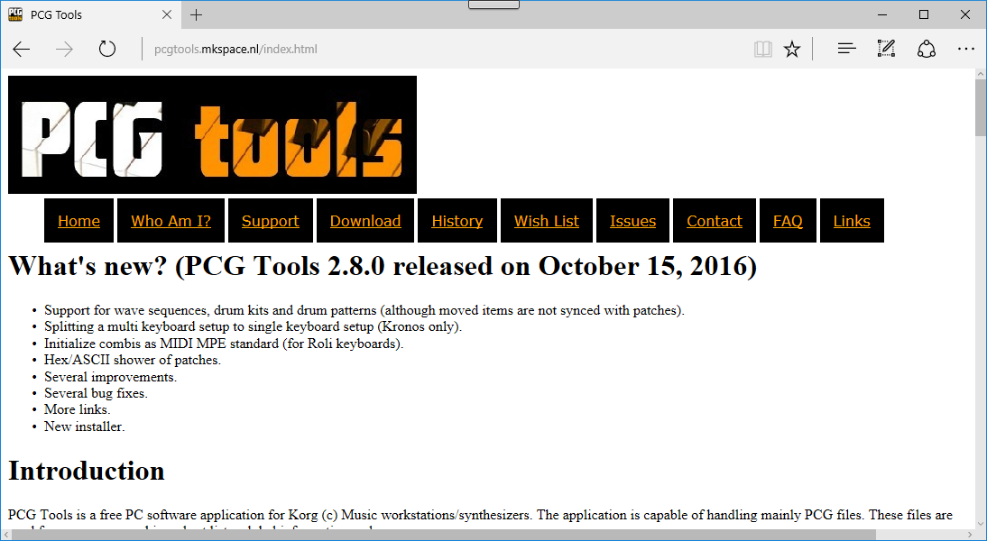

Figure 1: Homepage

Then go to the Download tab.

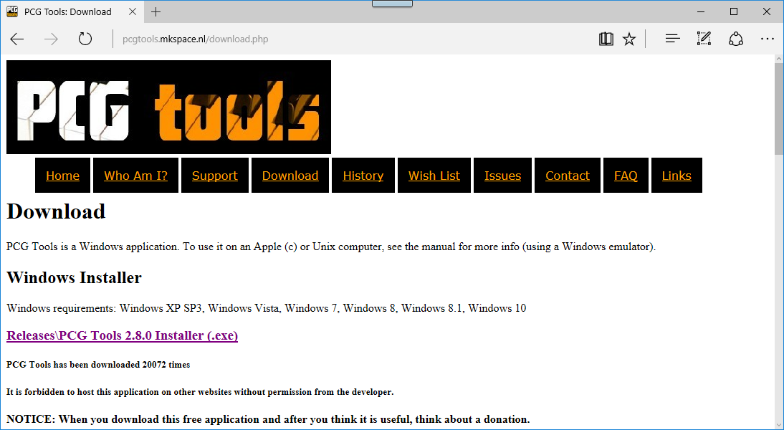

Figure 2: Download page

Click on the Installer (Releases/PCG Tools 2.1.0 Installer (.exe)

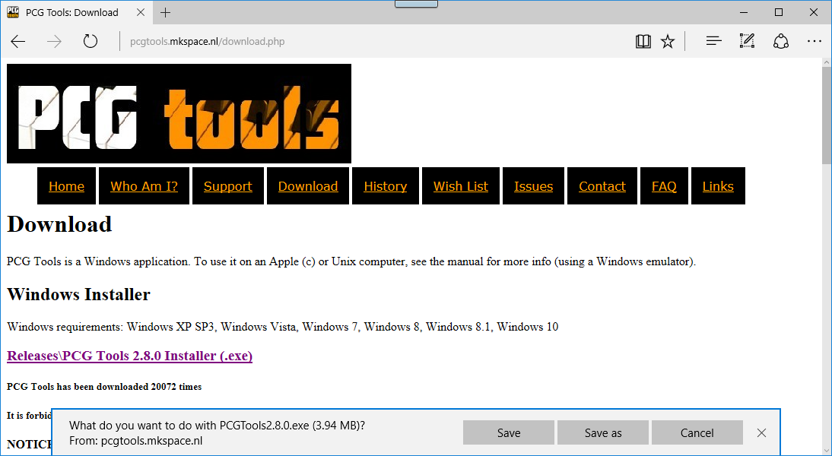

Figure 3: Download

* Press Save... maybe you have a slightly different browser that allows you to open the file directly or let you save it in a different way.

Because PCG Tools is not created by a company but by a 3th party single developer and not for commercial goals, it is not feasible to buy or license a so called Authenticode (see <http://technet.microsoft.com/en-us/library/cc750035.aspx> for more information) since it costs a substantial sum of money. However, to give at least some trust in PCG Tools, please refer to the following internet link where users of this application give their trustworthiness to the application:

<http://www.korgforums.com/forum/phpBB2/viewtopic.php?t=71495&watch=topic&start=0&sid=d7663dc8ef5c793d095cef9a08107034>

Run the installer:

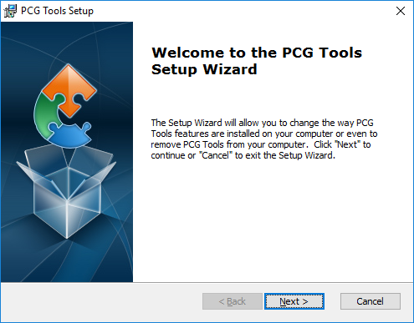

Figure 5: Preparing to Install

Press Next.

Somewhere during the installation process, there might be a question for installing the .NET Microsoft Library. This library is used by lots of programs which are developed with Microsoft .NET Technology and will be installed either automatically or after a request if not already present on your system. For this of course an internet connection needs to be present. Also the library is reasonably large and installation might take some time; maybe even a computer restart.

The download site will always be a Microsoft website so it can be trusted.

In case PCG Tools is already installed, the following screen will appear:

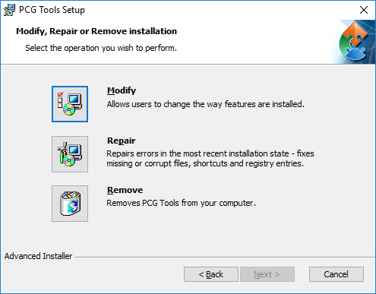

Figure 6: PCG Tools Setup, Modify, Repair or Remove Installation

Depending on if you already have PCG Tools installed, you get this dialog or not.

Use:

* Modify: to e.g. change the folder where PCG Tools is installed.
* Repair: to repair a broken version of PCG Tools.
* Remove: to uninstall PCG Tools from your computer.

Press Next.

In case PCG Tools has not been installed, the following screen will apear:

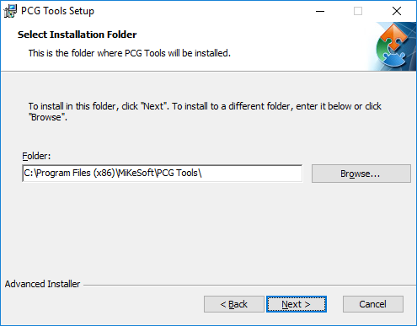

Figure 6: PCG Tools Setup, Select Installation Folder

Optionally change the installation folder, and press Next.

The following screen will appear:

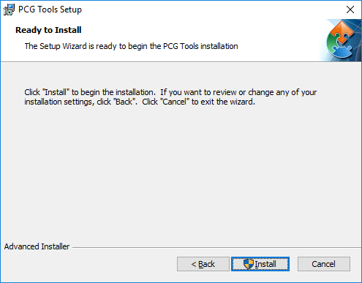

Figure 7: PCG Tools Eula

Press Install.

Depending on your operating system, some user access control window might be shown. Authorize to install the application.

Another screen will show with the progress of the installation. This can be very fast depending on the computer (in my case there was no time to make a screen shot).

When the application is installed the following screen is shown:

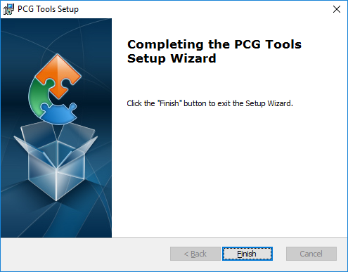

Figuur 11: PCG Tools Setup Finish

Installation is complete. Press the Finish button. Now PCG Tools can be found in the Start menu:

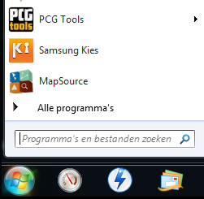

Figure 13: Start menu

### Removing the application

The application can be removed in two ways:

* In control panel, select applications or software depending in your operating system. In the gathered list select PCG Tools and select remove or uninstall.
* Run the PCG installer as described until the following window is shown.

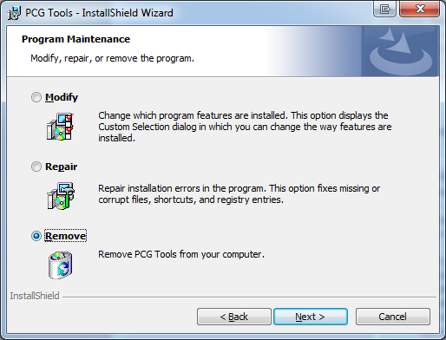

Figure 14: Setup screen 12

* + Select Remove and press Next

Now PCG Tools will be removed from your computer.

### Installation Problems

When PCG Tools does not behave like it should be, run the installer again until you get the following screen as shown above.

* Select Repair and press Next.

A summary window will be shown. Press Install and PCG Tools reinstalls itself.

If this does not help, remove the application (manually in Control Panel or automatically via PCG Tools) and do a complete reinstall.

### Standalone Installation

PCG Tools can also be installed without having an internet connection available.

Before performing the steps mentioned in the previous paragraph, perform the following steps:

* + - 1. Open the configuration screen/panel, then selecting the option 'applications'; the exact names depend on the OS so it may vary. If you cannot find the screen, assume it is not available, and continue with step 3.
      2. Check if in the list that is shown if there is one or more variations of the Microsoft .NET Framework 4.0 library is present.   
         If such a library is present, only copy the setup.exe file from the newsletter (and the password to a temporary text file) to e.g. a USB stick or external hard disk and continue with step 6. If you encounter problems while or after installing, try to install the framework anyway. Note that you need the 4.0 version, older versions should not be removed, but are not being used by PCG Tools.

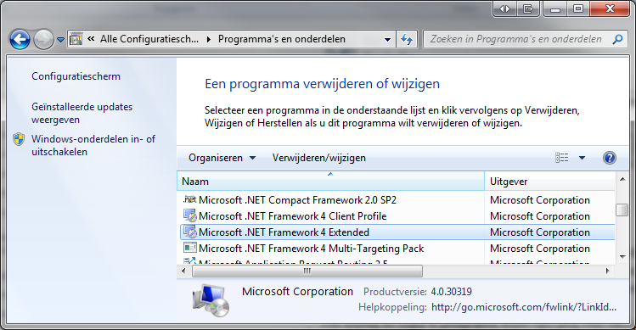

Figure 15: Microsoft Library

* + - 1. Assuming such a library is not present, download and copy it to the USB stick or external hard disk. The download location is:   
         <http://www.microsoft.com/en-us/download/details.aspx?id=17718>
      2. Attach the media to the target computer
      3. Install the .NET 4.0 library.
      4. Continue with the steps in the previous paragraph (i.e. run setup).

### Microsoft Library

#### Introduction

If the needed Microsoft DotNet 4.0 framework is not already installed, it will be done automatically by the setup procedure (if an internet connection is available). The installation of the DotNet framework may take some time, depending on your computer system. However, it needs to be installed only once and not for future updates. Chances are big, that the DotNet framework is already installed on your computer, since this library is used for numerous other applications too.

After setup, start the just installed application by clicking on the created desktop icon or select it in the installed applications.

#### Windows XP

PCG Tools on Windows XP requires Microsoft NET Framework 4. In some cases this framework is not automatically installed during setup. If it is not, you can do it manually by download it from:  
<http://www.microsoft.com/en-us/download/confirmation.aspx?id=17851>. This will download the file name dotNetFx40_Full_setup.exe which will guide you through the full install. After this you can install PCG Tools.

## Workstation Models

### Supported Workstation Models

In the following table all supported series/models and file types are shown.

|  |  |  |
| --- | --- | --- |
| **Supported Series** | **Supported Korg Models** | **Supported File Types** |
| Korg 01 Series | Korg 01/W, Korg 01/W FD, Korg 01/W pro, Korg 01/W pro X, Korg 01R/W | syx, mid (sysex), 01p, 01W, ALL, RAW |
| Korg 03R/W Series | Korg 03R/W | syx, mid (sysex) |
| Korg microKorg Series | Korg microKORG | syx |
| Korg microKORG XL | mkxl_all |
| Korg microKORG XL Plus | mkxlp_prog, mkxlp_all |
| Korg microSTATION Series | Korg microSTATION | pcg |
| Korg Karma Series | Korg Karma | pcg |
| Korg Krome Series | Korg Krome | pcg |
| Korg Kronos Series | Korg Kronos, Korg Kronos X | pcg |
| Korg Kross Series | Korg Kross | pcg |
| Korg M1 Series | Korg M1, Korg M1R, Korg M1EX, Korg M1R-EX | syx, mid (sysex) |
| Korg M3 Series | Korg M3, Korg M3-M | pcg |
| Korg M3R Series | Korg M3R | syx |
| Korg M50 Series | Korg M50 | pcg |
| Korg MS2000 Series | Korg MS2000, Korg MS2000R, Korg MS2000B, Korg MS2000BR | syx, prg, mid (sysex), LIB |
| Korg Oasys Series | Korg Oasys | pcg |
| Korg T Series | Korg T1, Korg T1EX, Korg T2, Korg T2EX, Korg T3, Korg T3EX | syx, mid (sysex) |
| Korg Triton Series | Korg Triton, Korg Triton Pro, Korg Triton Pro X, Korg Triton Extreme, Korg Triton Studio, Korg Triton Classic, Korg Triton LE, Korg Triton Rack, Korg Triton TR | pcg |
| Korg Trinity Series | Korg Trinity V1, Korg Trinity Plus, Korg Trinity Pro, Korg Trinity Pro X, Korg Trinity V2, Korg Trinity SOLO-TRI, Korg Trinity V3, Korg (Trinity) TR Rack | pcg |
| Korg Z1 Series | Korg Z1, Korg Z1EX | syx, mid (sysex) |

Table 8: Supported models of PCG Tools

### Workstation Dependent Features

Table 10 and Table 11 below, all feature difference, which are important for PCG Tools and this manual are listed per workstation model.

|  |  |  |  |  |
| --- | --- | --- | --- | --- |
| Model ->  Feature | **Korg 01 Series** | **Korg 03R/W Series** | **Korg microKorg Series** | **Korg microSTATION Series** |
| Karma | - | - | - | - |
| Sampler | - | - | - | **-** |
| Set Lists | - | **-** | **-** | **-** |
| Favorites | - | **-** | **-** | **-** |
| Sub Categories | **√** | **√** | **√** | **√** |
| Wave Sequences | **√** | - | - | - |
| Mute setting in timbres | **√** | **√** | **√** | **√** |
| Priority setting in timbres | **√** | **√** | - | - |

Table 9:Model Differences table 1

|  |  |  |  |  |  |  |
| --- | --- | --- | --- | --- | --- | --- |
| Model ->  Feature | **Korg Kronos / Korg Kronos X** | **Korg Oasys** | **Korg M3** | **Korg M50 / Korg Krome / Kross** | **Korg Triton / TR Series** | **Korg Karma** |
| Karma | **√** | **√** | **√** | SW only | - | **-** |
| Sampler | **√** | **√** | **√** | **-** | Option | **-** |
| Set Lists | **√** | **-** | **-** | **-** | **-** | **-** |
| Favorites | **√** | **-** | **-** | **-** | **-** | **-** |
| Sub Categories | **√** | **√** | **√** | **√** | **-** | **-** |
| Wave Sequences | **√** | - | - | - | - | - |
| Mute setting in timbres | **√** | **√** | **√** | **√** | - | - |
| Priority setting in timbres | **√** | **√** | - | - | - | - |

Table 10: Model Differences table 2

|  |  |  |  |  |  |
| --- | --- | --- | --- | --- | --- |
| Model ->  Feature | **Korg Trinity series and TR Rack** | **Korg M1 Series** | **Korg MS2000 Series** | **Korg T Series** | **Korg Z1 Series** |
| Karma | - | - | - | - | - |
| Sampler | - | - | - | - | - |
| Set Lists | - | - | - | - | - |
| Favorites | - | - | - | - | - |
| Sub Categories | *1 | - | - | - | - |
| Wave Sequences | - | - | - | - | - |
| Mute setting in timbres | - | - | - | - | - |
| Priority setting in timbres | - | - | - | - | - |

Table 11: Model Differences table 3

*1 Category A and category B.

Karma is an advanced arpeggiator (and more). For the Korg M50, Karma is an optional software package to be ran on a connected computer, for some other work station models it is built in.

With a sampler, user samples can be recorded or loaded. These samples can be used as base samples for programs.

Set Lists are used for easily organizing programs and combis.

Favorites and sub categories are used for easily selecting/filtering programs and combis.

Wave Sequences are waveforms that are sequenced after each other.

Also some settings from timbres, used in a combi are not supported by all workstation models.

**[NOTE]:** From this page, workstation dependent features are not mentioned separately unless it does not clutter up text.

# Korg Files

There are various kind of files that can be imported/exported from/to a Korg workstation. These file types are:

* PCG files: Files containing programs, combis, global sections and more (see paragraph 4.1) and these files have the extension ".PCG". Most modern workstations use this format, like Kronos, Oasys, M3, M50, Tritons.  
  PCG Tools can read these files to be analyzed and to modify.
* MID files: MID files containing system exclusive information can be used in the same way PCG files are used. MID files are currently supported for some older types of workstations/synthesizers, like the Korg T, 01 and Z1 series.
* SYX files: Similar with MID files, except that these contain system exclusive by default. These mostly are used for the same workstations/synthesizers as supported for MID files.
* Mkxl_all, mkxlp_prog, mkxlp_all: these files contain also program and combi information and are used for the Korg microKORG XL and XL Plus.
* KRSall, KRSapr, KRSbpr, KRSpr, KRSacm, KRSbcm, KRScm: These files are used by the Korg Kross.
* LIB: These files are used by the Korg MS2000 series.
* 01p, 01W, ALL, RAW: These files are used by the Korg 01W series.
* Song (SNG) files: Files containing one or more sequencer songs (see paragraph 4.2) and these files have the extension ".SNG".  
  PCG Tools can read these files to be analyzed.
* (User) sample files: Files containing samples and parameters related to it (see paragraph 4.3), having extensions ".KMP", ".KSF" and ".KSC".  
  These files are not supported by PCG Tools.

Normal MIDI (.MID) files can also be used on Korg workstations, however these are not Korg specific and are also not supported by PCG Tools.

## PCG / Patch Files

Korg uses so called PCG files to store programs, combinations, global section and more:

* Program Banks
* Combi Banks
* Global section
* Set Lists
* Wave Sequences
* Drum Kits
* Arpeggios

Since the first three items were the first and important items to be stored in a PCG file, that is where the abbreviation "PCG" comes from (**P**rograms **C**ombination **G**lobal). However, also MID, SYX, KRSxxx, LIB, 01p, 01W, ALL, RAW files contain PCG like information. Where hereafter is spoken about PCG files, also the files mentioned here are supported.

A patch file consists of all (or a part of) the patch memory of a Korg workstation. A patch can be a program, a combi or a set list slot. This means, that a PCG file can contain all program banks, all combi banks and the global section, but it also can contain only a few program banks, or some combi banks and the global section. On the Korg workstation the content to be saved in a PCG file can be selected when saving a PCG file.

### Structure

Figure 16 shows the structure of a complete PCG file. A complete patch file is a patch file where the complete internal memory is stored (i.e. all program banks, all combi banks, all set list slots (if supported by the workstation model), the global section etc.). Creating a complete patch file is also the default setting when saving a patch file.

D:\Korg PCG File Structure.emf

Figure 16: PCG File Structure

A solid line arrow means that the source (where the arrow starts from) consists of the specified number of items where the arrow is pointing to, e.g. The Combi Banks contains 4 to 14 individual Combi Banks (depending on the workstation model), and a Combi Bank contains 128 Combis. A dashed arrow means that the source is/can be assigned to where it points to (e.g. a combi is assigned to a combi category and combi subcategory (latter depends on the workstation model). The default number is 1 (so this is optionally displayed).

**[NOTE]** For sake of simplicity, drum kits and wave sequences are not shown in the diagram.

### Program

A program is built up from one (Single) or two (Dual) oscillators (and optionally uses a drum kit). A so called sampled program is a program which is using one or more of the (multi)samples and a modeled program is (normally) not using multi samples, but uses an external board for sound production.

Examples of sampled programs are programs using the HI, EDS or HD1 rompler engines.

Examples of modeled programs are programs using the MOSS (Korg Trinity, Triton), Radias (Korg M3), or one of the EXIs (Korg Oasys, Korg Kronos).

Each program has parameters. Only a small portion of parameters are used within PCG Tools, e.g. the Name, Favorite setting, Category, Sub category.

### Program Bank

A program bank always contains exactly 128 programs, indexed from 0 to 127 (except for GM banks which are indexed from 1 to 128). A program bank is named with a letter A to N or I-A to I-G, U-A to U-G, U-AA to U-GG, depending on the workstation model. The I stands for Int(ernal bank) and the U for User (bank).

A program can be identified uniquely together with its index, e.g. Program I-A64 or I-A064 means program number 64 in program bank I-A.

A program bank can be one of the following two types: modeled or sampled. Most workstations program banks are of the sampled type, meaning it contains only sampled programs. Other banks are modeled program banks and contain only modeled programs. On some workstation models the banks are predefined (meaning a bank can contain sampled programs and never can contain others), on other workstation models (like the Oasys and Kronos), each bank can be assigned to contain either sampled programs or modeled programs. However, sampled and modeled programs can never be mixed within one program bank.

Also each workstation has one or more GM (General MIDI) banks. These banks are read only and therefore are never stored in a patch file. However, combinations and set list slots can refer to GM programs and will be used in PCG Tools whenever necessary, but their names will not be shown (since these are not present in patch files).

**[WARNING]:** No difference between different GM banks is made. All GM banks are "mapped" within PCG Tools internally to GM (instead of GM, g(1) .. g(9)) for visualization. However, internally (in the patch file) the GM program references will not be changed.

*1 The internal banks of Triton Studio are in PCG Tools noted as I-A..I-E instead of INT-A..INT-E because PCG files from the Triton Studio cannot be differentiated from the Triton Classic/TR/Rack.

*2 The S bank is only used for Trinity V2 (Solo bank) and the M bank is only used for Trinity V3 (MOSS bank).

Table 12 shows which workstation models has which program banks and from which type.

| **Workstation Model** | **Sampled Program Banks** | **Sample Engine** | **Modeled Program Banks** | **Model Engine(s)** | **Combi Banks** | **Remarks** |
| --- | --- | --- | --- | --- | --- | --- |
| Korg 01 series | A..D | AI2 | - | - | A..D |  |
| Korg 03R/W | A | AI2 | - |  | A |  |
| microKorg | A..H | Analog Modeling | - | - | - |  |
| microKorg XL | A | MMT | - | - | A..B |  |
| microSTATION | A..D, GM | EDSi | - | - | A..D |  |
| Korg Kronos / Korg Kronos X | I-A..I-F,  U-A..U-G,  U-AA..U-GG | HD1 | I-A..I-F,  U-A..U-G,  U-AA..U-GG | EXi | I-A..I-G  U-A..U-G | Each program bank can be of either type. |
| Korg Oasys | I-A..I-F,  U-A..U-G | HD1 | I-A..I-F, U-A..U-G | EXi | I-A..I-G,  U-A..U-G | Each program bank can be of either type. |
| Korg M1 series | I, C | AI | - | - | I, C | I = Internal, C = Card |
| Korg M3 | I-A..I-E,  U-A..U-G | EDS | I-F | Radias | I-A..I-G,  U-A..U-G |  |
| Korg M3R | I, C | AI | - | - | I, C |  |
| Korg M50 | A-E, GM | EDS | n.a. | n.a. | A-D |  |
| Korg MS2000 series | A..H | Analog Modeling | - | - | - |  |
| Korg Krome | A-F, GM | EDS-X | n.a. | n.a. | A-D |  |
| Korg Kross | A-F, GM | EDS-X | n.a. | n.a. | A-D |  |
| T Series | A..B | AI | - | - | C |  |
| Triton Extreme | A-E,  H..M | HI2 | F | Z1-MOSS | A-E,  H-M |  |
| Triton Studio | INT-A.. INT-E,  EXB-A.. EXB-G | HI2 | INT-A..  INT-F | Z1-MOSS | INT-A..INT-E,  EXB-A..EXB-G | See *1 |
| Triton Classic/Karma | A-E | HI2 | F | EXB-MOSS | A-D |  |
| TR | A-E | HI2 | F | EXB-MOSS | A-D |  |
| Triton LE | A-D | HI2 | n.a. | n.a. | A-C |  |
| Karma | A-E | HI2 | F | Z1-MOSS | A-F |  |
| Trinity | A-B / A-D | ACCESS | S / M*2 | Z1-MOSS | A-B / A-D | Banks C and D only when EXB-TRI installed |
| Z1 series |  | - | A..B, CARD-A..CARD-B | MOSS Z1 | - |  |

*1 The internal banks of Triton Studio are in PCG Tools noted as I-A..I-E instead of INT-A..INT-E because PCG files from the Triton Studio cannot be differentiated from the Triton Classic/TR/Rack.

*2 The S bank is only used for Trinity V2 (Solo bank) and the M bank is only used for Trinity V3 (MOSS bank).

Table 12: Program Banks from various workstation models

Not all program/combi banks have to be filled. Also, some files exist which contain virtual banks.

When saving a patch file on a workstation, per program bank you can select if it will be saved in the file or not. Default all program banks will be selected for saving.

In PCG Tools a program bank is considered empty when all programs in a bank are empty or have an initialized name.

**[NOTE]** For sake of simplicity, drum kits and wave sequences are not shown in the diagram.

### Virtual Banks

Some files, for example for the Kronos and the MS2000 can contain virtual program or combi banks. These files cannot be read/written from/to a workstation, but can be used a big storage boxes for patches. Two of these files can be loaded from the website and contain initialized banks (or preprogrammed factory data).

Virtual files can contain hundreds of banks, resulting in tens of thousand of programs and combis. Also, these files can be used for copying/pasting between regular files, meaning, you can copy/paste programs/combis from/to the file(s) you use on your synthesizer/workstation for easy access.

The list generator also works for virtual banks files.

### Program Banks

Program banks are the complete set of all program banks described in the previous paragraph. In *1 The internal banks of Triton Studio are in PCG Tools noted as I-A..I-E instead of INT-A..INT-E because PCG files from the Triton Studio cannot be differentiated from the Triton Classic/TR/Rack.

*2 The S bank is only used for Trinity V2 (Solo bank) and the M bank is only used for Trinity V3 (MOSS bank).

Table 12 can be found how many and of which type and name are available per workstation model.

### Combi

A combi is normally used for stacking sounds, splitting the keyboard (or external keyboards) in both velocity ranges and keyboard zones and controlling other keyboards.

Each combi has parameters. Only a small portion of parameters are used within PCG Tools, such as the Name, Favorite setting, Category/Sub category.

A combi is considered broken, if one or more of the used timbres assigned to an incorrect program, which can happen after (unintentionally) overwriting or copy/pasting a program over a program being used in that combi.

### Timbres

A combi consists of 8 or 16 timbres, depending on the workstation model. A combi can be on or off, if used (on), it can set to control an external MIDI device, or (normally) it is assigned to a program.

**[EXAMPLE]:** If you want to stack sounds, you can assign two (or more) timbres to programs. You also can split your keyboard because each timbre has a key zone, so you can define one timbre to be active from key C-1 to C4 and another timbre to be active from C#4 to G9. Also it is possible to set a velocity range and multiple other parameters, making possibilities endless.

### Timbre

A timbre refers to a program contained in a program banks, or to an external keyboard/synthesizer program. Because a timbre only refer to program (and not containing all parameters of a program), it means that changing programs causes to change also the (timbres in the) combis were those programs are used in. This has both advantages and disadvantages, see Table 13.

|  |  |
| --- | --- |
| **Advantages** | **Disadvantages** |
| When a program is improved or changed to your likings, all combis using that program automatically will use the improved program. | When changing a program in a combi without affecting other combis, you have to copy the program to another location and change the reference in the combi to the new location. |
| Less memory is necessary to store programs.[1] |  |

Table 13: Programs referring by combis advantages/disadvantages

Another disadvantage, not because of the fact that programs are inside combis or referring to programs in program banks, is that there is no easy means to know IF and by which combis a specific program is used. Luckily, PCG Tools can create a list to solve this problem.

Of course not all timbres in a combi have to be used (unused timbres can be switched off).

### Combi Bank

Combi banks are the same as Program banks except they contain combis. Korg workstations mostly have 4 to 16 of them, and are named equally as program banks, although they are not related.

A combi bank always contains 128 combis, indexed from 0 to 127. A combi can be identified uniquely together with the combi bank where it resides, e.g. Combi I-A64 or I-A064 means combi number 64 in combi bank I-A. The I stands for an Int(ernal) bank, as opposed to U(ser) bank.

Not all combi banks have to be filled.

When saving a patch file on a workstation, per combi bank you can select if it will be saved in the file or not. Default all combi banks will be selected for saving.

In PCG Tools a combi bank is considered empty when all combi in a bank are empty or have an initialized name.

### Combi Banks

Combi banks are the complete set of all combi banks described in the previous paragraph. In *1 The internal banks of Triton Studio are in PCG Tools noted as I-A..I-E instead of INT-A..INT-E because PCG files from the Triton Studio cannot be differentiated from the Triton Classic/TR/Rack.

*2 The S bank is only used for Trinity V2 (Solo bank) and the M bank is only used for Trinity V3 (MOSS bank).

Table 12 can be found how many are available and their names per workstation model.

**[WARNING]:** When saving combi banks using non factory programs always make sure all used program banks are saved in the patch file too. Otherwise when the patch file is loaded, the references to the programs will refer to unexpected programs (causing so called broken combis).

### Set List Slot [Kronos Only]

The Korg Kronos has introduced a new feature, called set lists. A set list slot is a reference to one program or one combi together with a user defined name, a description of 512 characters and a volume.

### Set List [Kronos Only]

128 Set list slots are combined in a Set List. A set list also can have a name and an equalizer setting.

### Set Lists [Kronos Only]

The Korg Kronos has 128 set lists (each containing of 128 set list slots), resulting in a total of 16,384 set list slots in total.

A set list slot is in PCG Tools unique identified as e.g. 034/123, meaning set list slot 123 of set list 34.

### Drum Kit

A drum kit can be set for a program or combi (and mostly played on MIDI channel 10).

### Drum Kit Bank

Drum kit banks are banks of drum kits. The number of drum kits banks differ per workstation model but are mostly not 128 like programs and combis.

### Drum Kit Banks

These are all drum kit banks together, mostly both internal and user banks.

### Drum Pattern

A drum pattern can be set for a drum kit in a program or combi.

### Drum Pattern Bank

Drum pattern banks are banks of drum patterns. The number of drum pattern banks differ per workstation model but mostly not 128 like programs and combis.

### Drum Pattern Banks

These are all drumk pattern banks together, mostly both internal and user banks.

### Wave Sequence

Wave sequences are used with programs.

### Wave Sequence Bank

Wave sequence banks are banks of wave sequences. The number of wave sequence bank differ per workstation model but are mostly not 128 like programs and combis.

### Wave Sequence Banks

These are all drum kit banks together, mostly both internal and user banks.

### Global

On each Korg workstation there is always exactly one global section in a workstation. It contains the generic data over all programs, combis and set list slots like current MIDI channels, keyboard velocity/aftertouch curves, some controller settings, the categories and sub categories etc.

When saving a patch file the global section can be saved optionally. Default it is selected to be saved.

### Category

Each program or combi (not set list slots) is assigned to a category, which can be seen as groups of sounds, like piano, organs, drums etc. There are 16 or 18 of them (depending on the workstation model, some are empty/unused by default). Each category has a default name, but can be overridden in the global section (it is advised not to change the predefined category names).

**[WARNING]**: When a patch file does not contain the global section (see paragraph 4.1.14), category names are unknown and the index of the category is used in PCG Tools.

### Sub Category

Each program or combi (not set list slots) is assigned in a sub category, which depends on the category. For each category there are 16 sub categories defined (some are empty/unused by default). E.g. the piano category has sub categories Acoustic Piano, Electric Piano, All, etc.

The Trinity does not have a sub category but Category A and Category B. This can be switched in the settings window.

**[WARNING]**: When a patch file does not contain the global section (see paragraph 4.1.14), sub category names are unknown and the index of the sub category is used in PCG Tools.

## Song (SNG) Files

Song files are files were the songs for the sequencers are stored in. In general, songs contain all notes and controller data including used timbres/tracks information. These timbres are very similar to the timbres of a combi (see paragraph 4.1.7). Also a list of used samples are contained in a SNG file.

## KMP/KSF/KSC Files

These files are used to store (user) samples and are not used by PCG Tools and not further explained here.

# 

# Workflow

## Description

PCG Tools can load a lot of different PCG and related files and some SNG files.

To get the workstation content into PCG Tools the workflow is described in the subsequent paragraphs.

## Workflow for Korg Kronos (X) with FTP connection

The workflow for the Korg Kronos with OS2.0 or later and Kronos X is different than for other workstations because it can make use of an FTP connection. To setup up an application and create the connection see Chapter 10. The steps for using PCG Tools assuming the FTP connection is active are:

* Save a PCG and/or SNG file to the SSD.
* Download the file on your computer using an FTP program. See chapter 10 for more info.
* Optionally make a backup.
* Open the file in PCG Tools. You can do this in two ways:
  + Open PCG Tools and load the file.
  + or double click on the patch file name in e.g. the file explorer which opens the PCG Tools application automatically.
* Continue opening files if wanted (e.g. if you want to copy files from one patch file to another).
* Perform actions on the PCG Tools. When the content of the patch file changes, an asterisk will be shown next to the file name in the window title bar. (Currently, SNG file cannot be changed).
* If the contents have changed, it is assumed the file should be saved. It can be saved over the original PCG / SNG file or it can be saved to a different file (name) and location.
* When finished, save the file to your computer.
* Upload this file to the SSD.
* Load the file from the SSD.

## Workflow for PCG / SNG files

The workflow for other workstations supporting PCG/SNG files and Kronos workstations before OS2.0:

* Save a PCG and/or SNG file on the workstation by selecting the Save PCG or Save SNG option. Depending on the workstation type it can be stored on a CompactFlash (CF), SecureDigital (SD) or USB stick/drive.
* Insert the media in the computer.
* Optionally copy the file to the computer.
* Open the file in PCG Tools. You can do this in two ways:
  + Open PCG Tools and load the file.
  + or double click on the patch file name in e.g. the file explorer which opens the PCG Tools application automatically.
* Continue opening files if wanted (e.g. if you want to copy files from one patch file to another).
* Perform actions on the patch files. When the content of the patch file changes, an asterisk will be shown next to the file name in the window title bar. (Currently, SNG file cannot be changed).
* If the contents have changed, it is assumed the file should be saved. It can be saved over the original PCG / SNG file or it can be saved to a different file (name) and location.
* When finished, copy the file to the media (if not already saved over it if you loaded the file directly from the media).
* Insert the media in your workstation.
* Load the media in the workstation by selecting the Load PCG or Load SNG option.

*See next paragraph for a list of media to be used per workstation model.

It is advised to not do too many changes. Regularly save the file and check on the workstation if the content is exactly as intended. Always keep a backup before you change information in a patch file with PCG Tools.

## Workflow for other files (like SYX, MID, 01W, …)

The workflow for workstations not supporting patch files:

* Use e.g. MIDI-OX or another MIDI system exclusive tool to receive a sysex file on the workstation. Or when the file is used in an editor or by another tool, use that tool to receive the information.
* Optionally copy the file to the computer.
* Open the file in PCG Tools. You can do this in two ways:
  + Open the file with the received MIDI information and load the file.
* Continue opening files if wanted (e.g. if you want to copy files from one file to another).
* Perform actions on the files. When the content of the file changes, an asterisk will be shown next to the file name in the window title bar.
* If the contents have changed, it is assumed the file should be saved. It can be saved over the original file or it can be saved to a different file (name) and location.
* When finished, transmit the file with a sysex tool to the workstation. Or, when the file is used in an editor or by another tool, use that tool to transmit the file.

*See next paragraph for a list of media to be used per workstation model.

It is advised to not do too many changes. Regularly save the file and check on the workstation if the content is exactly as intended. Always keep a backup before you change information in a file with PCG Tools.

## Connection/Storage Types per Workstation Model

The following table shows a list of multimedia cards or connection possibilities to be used with PCG Tools per workstation model.

|  |  |  |
| --- | --- | --- |
| **Workstation Model** | **Recommended connection/storage** | **Alternative connection/storage** |
| Korg 01, 01/W, 01R/W | e.g. MIDI-OX | Specialized editor(s) |
| Korg 01/Wfd, 01/Wpro, 01/WproX | Floppy Drive | e.g. MIDI-OX, specialized editor(s) |
| Korg 03R/W | e.g. MIDI-OX | - |
| microKorg | e.g. MIDI-OX |  |
| microKorg XL / XL Plus | Specialized editor(s) |  |
| microSTATION | SD card |  |
| Kronos (X) with USB/FTP adapter | FTP connection | USB stick |
| Kronos(X) without USB/FTP adapter | USB (Stick) | n.a. |
| Korg Oasys | USB (Stick) | n.a. |
| Korg M1 series | e.g. MIDI-OX |  |
| Korg M3R series | e.g. MIDI-OX |  |
| Korg M3 | USB (Stick) | n.a. |
| Korg M50 | Secure Digital (SD) card | n.a. |
| Korg MS2000 series | e.g. MIDI-OX | Specialized editor(s) |
| Korg Kross | USB (Stick) | n.a. |
| Korg Krome | USB (Stick) | n.a. |
| Korg Triton Extreme | Compact Flash (CF) card | n.a. |
| Korg Triton Class/Studio/LE/Rack | Compact Flash (CF) card | n.a. |
| Korg Triton Rack | Floppy Drive | n.a. |
| Korg Karma | Floppy Drive | n.a. |
| Korg T series | e.g. MIDI-OX |  |
| Korg Trinity V1, V2, V3, TR Rack | Floppy Drive | n.a. |
| Korg Z1 series | e.g. MIDI-OX |  |

Table 1: Connection/storage type per workstation model

# Main Screen

## Splash Screen

Before the main screen is shown, a splash screen is visible for approximately five seconds. This screen shows the current version, a copyright note, the developer and the (nick) name and optionally a logo of the sponsors of the application. In case you are interested in the logo, you always can check out the External Links window (see paragraph 6.12.2). The name of the donator which is shown varies each time the application is started, and the amount of money donated defines the ratio of being displayed.

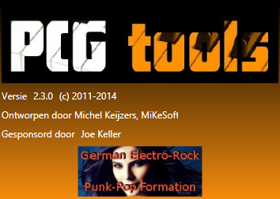

Figure 17: Splash screen

## Application Start

The application can be started in the following ways:

* Opening the icon via the start menu (or other way depending on the operating system).
* By opening/double clicking on a patch file (see Figure 18 for a screenshot of patch files shown with the PCG Tools icon).
* By a command line interpreter (like cmd.com) usable in two ways:
  + Without arguments to open PCG Tools in the default way.
  + With arguments to create a defined list from the set list generator.

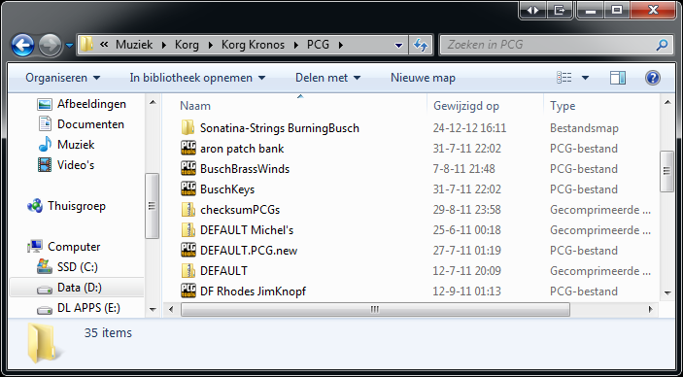

Figure 18: PCG Tools icon

## Initial screen

When the application is started a screen (somewhat) similar to Figure 19 is shown. It will start up with the same state (normal or maximized) and screen position/width height as the previous time.

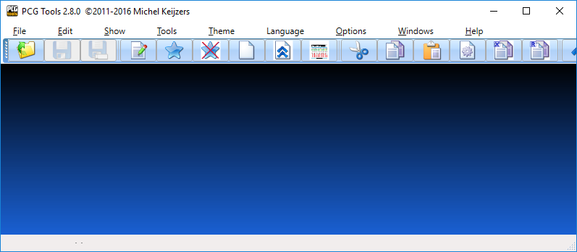

Figure 19: Initial main screen

Initially no file is loaded and an mainly empty screen is shown, except when PCG Tools has been started by double clicking a patch file which is loaded immediately or when using command line arguments loading a patch file by default.

The title of the window contains the application name (PCG Tools), the version, copyright mark/year and the name of the developer.

Furthermore, only the menu and toolbar is shown. Only commands which can be executed are selectable, items that cannot be executed are grayed out.

In the following paragraphs the common menus are explained.

## File Menu

The file menu is used for opening, closing files and more basic functionality for the application (like closing).

### Open File Command

This command is used for opening a new patch of SNG file.

The following ways can be used to select this command:

* Select the Open menu item in the File menu
* Press Ctrl + O key
* Select the Open file tool bar icon (yellow folder with the green arrow)

When selected, an Open File dialog will be shown. Here the type of file can be selected, which is one of:

* Korg PCG files (*.pcg): Load one or more PCG files.
* Korg Sysex files (*.syx): Load one or more SYSEX files.
* Korg Midi files (*.mid): Load one or more MID files (containing SYSEX information).
* Korg SNG files (*.sng): Load one or more SNG files.
* Korg 01W series files (*.01p, *01w, *.all, *.mid, *.raw, *.syx): Load one or more Korg 01W files supported by PCG Tools.
* Korg 03R/W files (*.syx): Load one or more Korg 03R/W files supported by PCG Tools.
* Korg microKorg files (*.syx): Load one or more Korg microKorg files supported by PCG Tools.
* Korg microKorg XL files (*.mkxl_all, *.syx): Load one or more Korg microKorg XL files supported by PCG Tools.
* Korg microKorg XL Plus files (*.mkxl_prog): Load one or more Korg microKorg XL files supported by PCG Tools.
* Korg microSTATION files (*.pcg): Load one or more Korg microSTATION files supported by PCG Tools.
* Korg Karma files (*.pcg): Load one or more Korg Karma files supported by PCG Tools.
* Korg Krome files (*.pcg): Load one or more Korg Krome files supported by PCG Tools.
* Korg Kronos files (*.pcg): Load one or more Korg Kronos files supported by PCG Tools.
* Korg Kross files (*.pcg): Load one or more Korg Kross files supported by PCG Tools.
* Korg M1 series files (*.syx, *.mid): Load one or more Korg M1 series files supported by PCG Tools.
* Korg M3 series files (*.pcg): Load one or more Korg M3 series files supported by PCG Tools.
* Korg M3R files (*.syx, *.mid): Load one or more Korg M3R files supported by PCG Tools.
* Korg M50 series files (*.pcg): Load one or more Korg M50 series files supported by PCG Tools.
* Korg MS2000 series files (*.prg, *.syx, *.lib, *.mid, *.exl): Load one or more Korg MS2000 series files supported by PCG Tools.
* Korg Oasys series files (*.pcg): Load one or more Korg Oasys series files supported by PCG Tools.
* Korg Triton series files (*.pcg): Load one or more Korg Triton series files supported by PCG Tools.
* Korg Trinity series files (*.pcg): Load one or more Korg Trinity series files supported by PCG Tools.
* Korg T1/T2/T3 series files (*.syx, *.mid): Load one or more Korg T1/T2/T3 series files supported by PCG Tools.
* Korg Z1 series files (*.syx, *.mid): Load one or more Korg Z1 series files supported by PCG Tools.
* All files, show all files.

When selecting/changing the type only those type of files are shown. It is possible to select more than one file.

After selecting a (PCG) file, the screen looks like Figure 20.

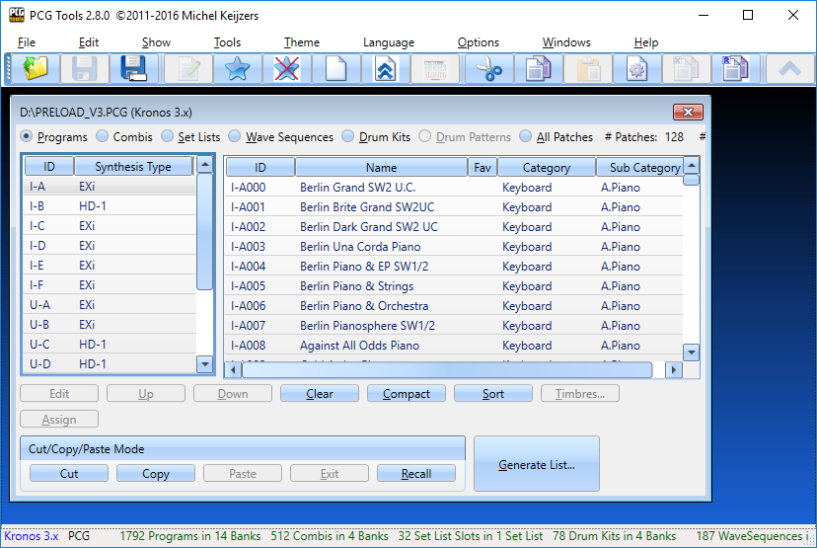

Figure 20: Opened File

**[TIP]:** If you always want start with the same patch file, pass it as an argument and it will be opened automatically when starting PCG Tools.

When the file is corrupted or a file is tried to be load from a non supported Korg model an error will be shown as shown in Figure 21.

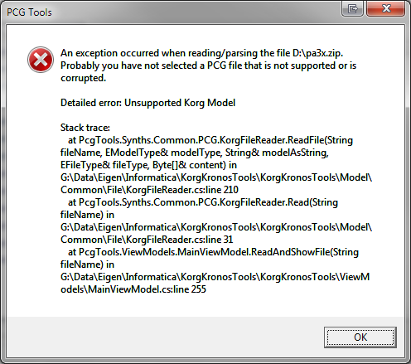

Figure 21: Corrupted or Unsupported File

In case the patch file contains no programs, no combis and no set list slot the following warning is shown, after which an empty PCG window will be presented.

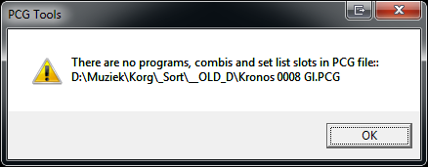

Figure 22: Empty patch File

### Save File Command

This command is used for saving a changed PCG of SNG file.

The following ways can be used to select this command:

* Select the Save menu item in the File menu
* Press Ctrl + S key
* Select the Save file tool bar icon (the blue disk without the label)

Changes made by the application are not automatically stored. You have to save them explicitly.

Saving a file is only possible if you have really changed the contents. This can be seen at the asterisk (*) that is added behind the file name in the window, in the example in Figure 23 the asterisk is placed after D:\Kronos.PCG after moving a program down.

Remember that files shown with an asterisk are NOT saved yet. It is good practice to save regularly.

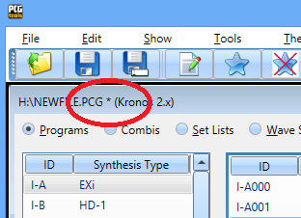

Figure 23: Changed patch file

The file is saved over the loaded file and the asterisk is removed after saving.

### Save (File) As Command

This menu command is similar to saving a file, except that it is always available (when a file is selected).

The following ways can be used to select this command:

* Select the Save As menu item in the File menu
* Press Ctrl + Shift + S key
* Select the Save As file tool bar icon (blue disk with the white label)

When selected, a save file dialog is shown and a name can be entered or a file to overwrite to can be selected for saving the file.

**[WARNING]:** There is no Undo functionality, after saving a file you cannot return to an earlier state, but you can regularly save files under different names to be able to go back to a certain file if needed.

### Export to Sequencer Command

This menu command will be handled in Paragraph 7.7.1).

### Revert to Saved Command

This command is used for reverting to the saved file.

The following ways can be used to select this command:

* Select the Revert To Saved menu item in the File menu

When selected, the selected file is reloaded. This should be used with care, because all changes since the last time the file was saved will be undone and cannot be redone.

You can use this function as a Undo feature to restore the status to the last saved situation.

When a cut/paste or copy/paste action is in progress while executing this command, Figure 73 will be shown to ask whether to continue or not. Continuing might result in partly copied patches.

**[TIP]:** when you have saved a file, changed it on your workstation and saved the patch file on the media and inserted that media into your computer again in the same folder and under the same name, to load that changed file in PCG Tools, it is not needed to close the selected file and open the same file again, but a simple 'Revert to Saved' command will do.

**[TIP]:** When too many Combi windows (see paragraph 7.4) are open, this command can be used to close all Combi windows from this patch file. Also all bank and patch selections (highlighted banks and patches) are discarded, because the file is closed and reopened again.

### Close Command

This command is used for closing the selected PCG or SNG file.

The following ways can be used to select this command:

* Select the Close menu item in the File menu
* Press Ctrl + F4 key (default Windows behavior)

When selected, the selected file is closed. In case the file has been changed without saving (shown by the asterisk), a warning message is shown to save the file or not as shown below.

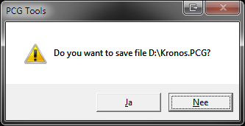

Figure 24: Warning Dialog when closing a changed file

When a cut/paste or copy/paste action is in progress while executing this command, Figure 73 will be shown to ask whether to continue or not. Continuing might result in partly copied patches.

For PCG (or similar) files, when sub windows are shown (such as the Combi window explained in Paragraph 7.4), all sub windows are closed automatically.

When a window is closed the size is remembered and the next time a window of the same type is opened, automatically those dimensions will be used. The different window types are:

* PCG Window
* Combi Window
* SNG Window

### Exit Command

This command is used for exiting the application.

The following ways can be used to select this command:

* Select the Exit menu item in the File menu
* Press Alt + F4 key (Default Windows behavior)

When selected, the application is stopped. All opened files are closed and for every unsaved changed files is asked whether it should be saved or not (as explained in paragraph 6.4.6). One extra option is available in case a file is changed but unsaved: Cancel. When selecting this option, the application does not exit and no more files are closed. See below for an example of this warning dialog.

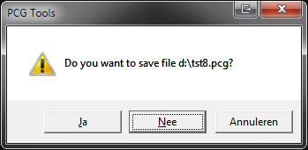

Figure 25: Warning Dialog when exiting PCG Tools

When a cut/paste or copy/paste action is in progress while executing this command, Figure 73 will be shown to ask whether to continue or not. Continuing might result in partly copied patches.

## Edit Menu

This menu shows actions depending on the current window that is shown and can be found in the corresponding window explanation.

## Show Menu

### Timbres

Timbres is only active when in a PCG window a single combination is selected. With this command a new window is displayed, showing the timbres of the selected combi. See Paragraph 7.4 for more info.

### Special Event

This menu item is not always enabled, only when a special announcement or event has occurred. Below is an example.

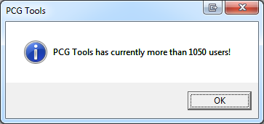

Figure 26: Special Event

## Tools Menu

This menu shows different kind of tools:

* Master File, see paragraph 7.4
* List Generator, see paragraph 7.6.

## Theme Menu

This menu shows three different types of GUI Skins that can be used for showing files:

* Generic (Pre Windows XP Theme), see Figure 27.
* Luna (Windows XP Theme), see Figure 28.
* Aero (Windows Vista/Windows 7 Theme), see Figure 29.

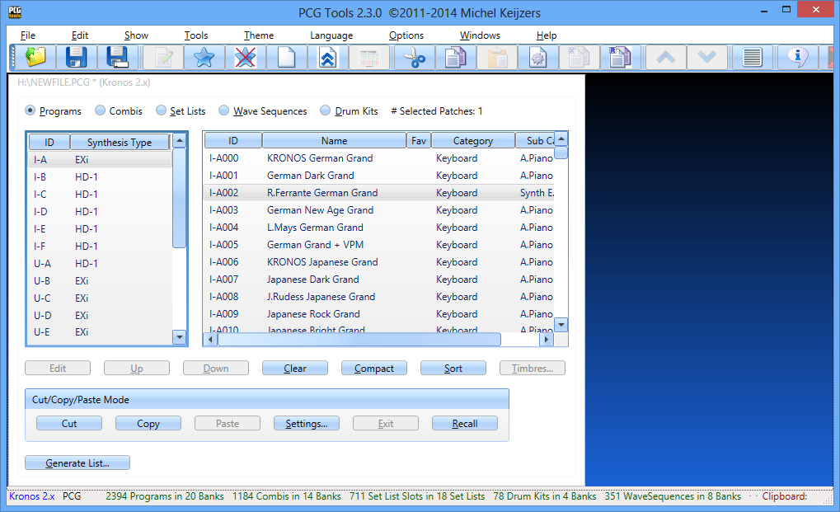

Figure 27: Generic Theme

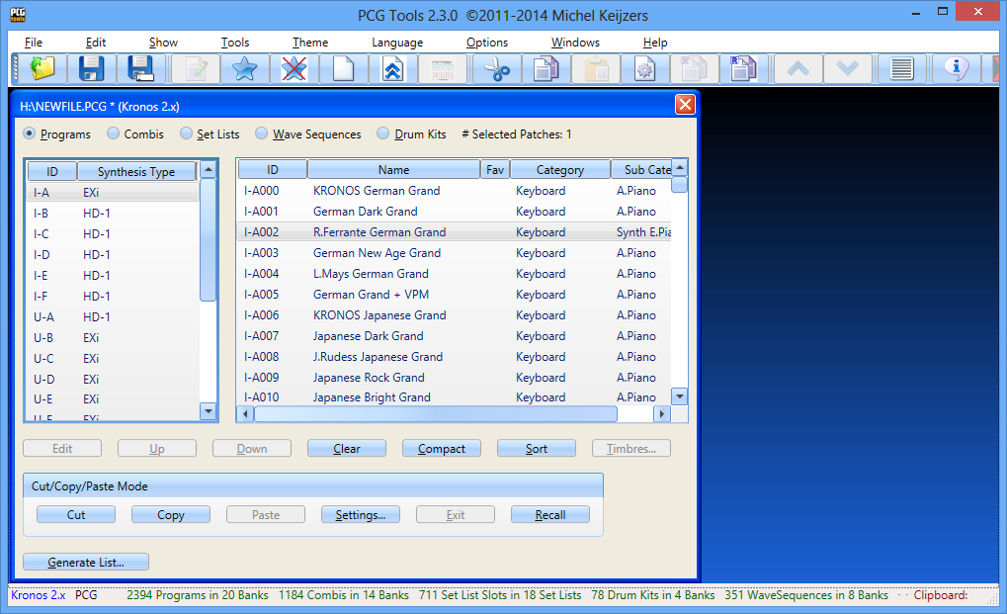

Figure 28: Luna Theme

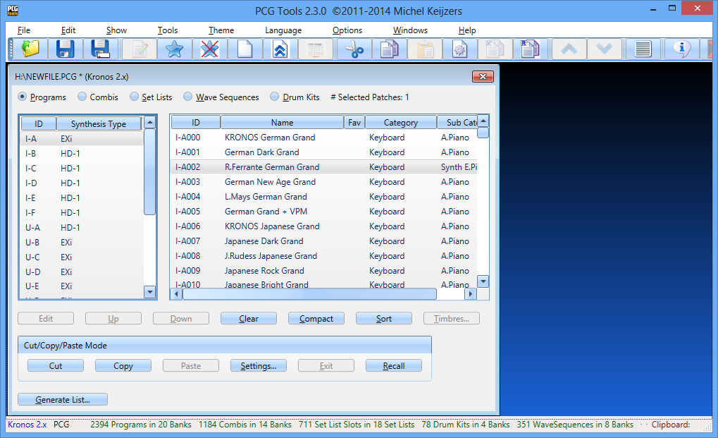

Figure 29: Aero Theme

## Languages Menu

Figure 30 shows the installed languages. These languages are:

* + Czech thanks to Syntey
  + Dutch thanks to Mathieu Maes and myself
  + English (default language) thanks to Michel Keijzers (developer of PCG Tools)
  + French thanks to Francois Rossi
  + German thanks to Jens and Yuma
  + Greek thanks to Jim Dijkstra
  + Polish thanks to DamianoMusic and Adrian4u
  + Portuguese, Brazil variant thanks to Rubens S. Felicio
  + Portuguese, Portugal variant thanks to Luis Costa
  + Serbian, Latin characters thanks to Saša Rajak
  + Spanish thanks to Mario Pablo
  + Turkish thanks to Umut Erhan

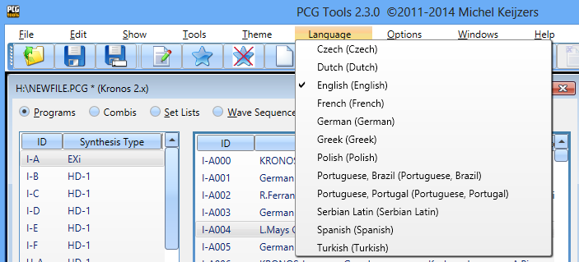

Figure 30: Language Menu

When selecting another language, Figure 31 is shown. Only when the application is restarted, the selected language will take effect. It is possible to change the language again before restarting. Then the last selected language will be used when restarting the application the next time.

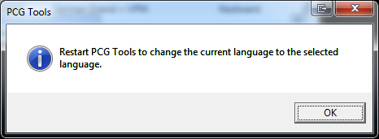

Figure 31: Language change

## Options Menu

### Menu items

This window contains two options: settings and an option to set the assigned clear program. For more info about the assigned clear program, see paragraph 7.5.2.4.

### Settings Menu

Below the Settings menu explained in more detail.

#### PCG Windows Settings

This window shoes the settings specific for PCG Windows.

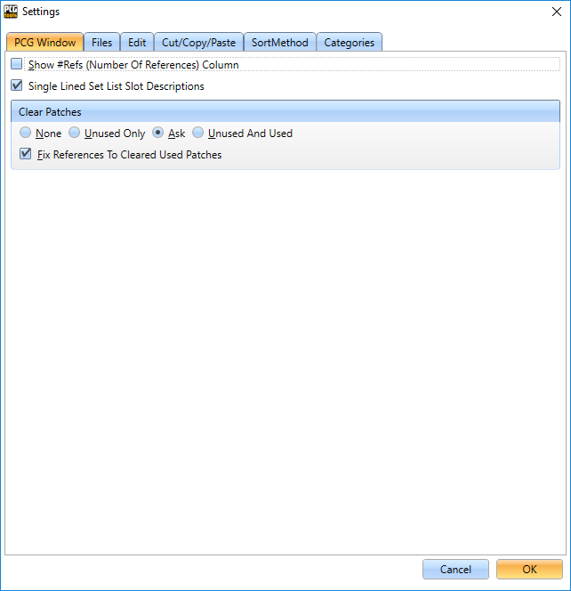

Figure 32: PCG Windows Settings

The option ‘Show #Refs (Number of References) Column show the number of times the patch (program or combi) is referenced in a set list slot or used by a combi. Default this option is disabled, since changing banks or patch type causes this to be calculated for all patches in the selected bank which can take some time. Only enable it when you want to use it.

The next option is ‘Single Lined Set List Slot Description’. Normally in a PCG Window, the set list slot descriptions are shown fully, and if new lines (returns) are used each set list slot uses an area consisting of multiple lines. By enabling this setting, a set list slot is always one line high, so more set list slots fits on the screen, making it easier to order them for example.

Clear patches has several options. One of them is a setting that checks what happens when patches are cleared:

|  |  |
| --- | --- |
| **Setting** | **Meaning** |
| None | If multiple patches have been selected and the Clear button is pressed, if at least one of the selected patches is used*, none of the selected patches will be cleared (i.e. nothing happens).  If a single patch is selected and the Clear button is pressed, only if the selected patch is not used* it will be cleared. |
| Unused Only | When the Clear button is pressed, only the patches which are not used* will be cleared. |
| Ask | When the Clear button is pressed, a question dialog will be shown**. If ‘Yes’ is pressed, all selected patches will be cleared, if ‘No’ is pressed, no patches will be cleared. |
| Unused And Used | When the Clear button is pressed, both unused and used* patches will be cleared. |

Table 14 Clear Patches Settings

* a program is ‘used’ when it is used inside a combi or referenced by a set list slot.  
 a combi is ‘used’ when it is referenced by a set list slot.

** The following dialog is shown:

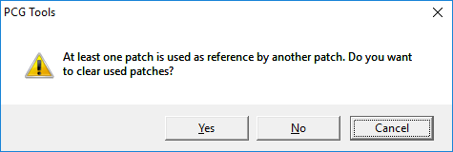

Figure 32: Patch used as referenced by another patch

#### Files Settings

Figure 32 shows the Files settings, currently used for setting the Master Files options and the default output directory for the set list generator.

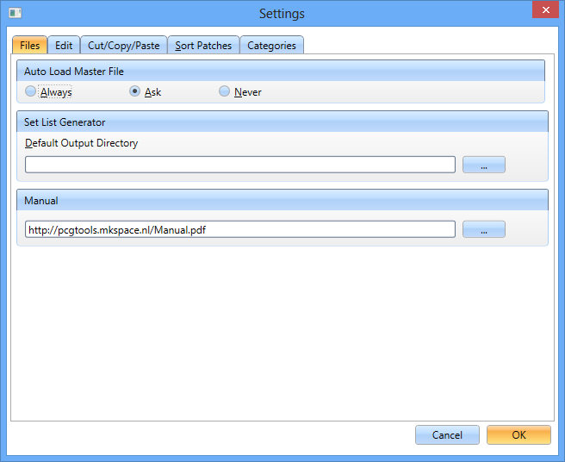

Figure 32: Files Settings

Table 14 shows the meaning of each item for the Auto Load Master File.

|  |  |
| --- | --- |
| **Setting** | **Meaning** |
| Always | When a patch file is loaded, and a Master file has been assigned, it is automatically loaded. |
| Ask | When a patch file is loaded, and a Master file has been assigned, ask to load it. |
| Never | Irrelevant if a Master file has been assigned, do not load it. |

Table 14 Auto Load Master Files Settings

The Default Output Directory for the Set List Generator, defines the default directory where files are being stored, that are being output by the various lists of the set list generator.

The Manual setting, defines where the manual will be loaded from (when selected in the Help menu). Normally this is a website where always the latest manual can be found, but for people using PCG Tools on a standalone computer without internet connection can copy it manual and fill in here the location where the manual can be found.

#### Edit settings

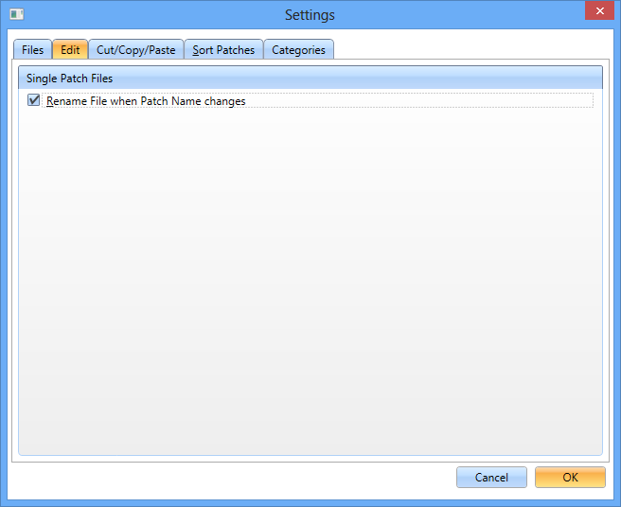

Table 15: Edit settings

This option is used for some file types which only store one program, like .KRSprog or a .SYX or .MID file with only one program or combi. These files have the name of the program/combi in their file but also as file name. When the name is changed and this option is enabled, also automatically the file name is changed accordingly.

#### Cut/Copy/Paste Settings

This window shows currently the cut/copy/paste settings. For more info, see paragraph 7.3.7.6.1.

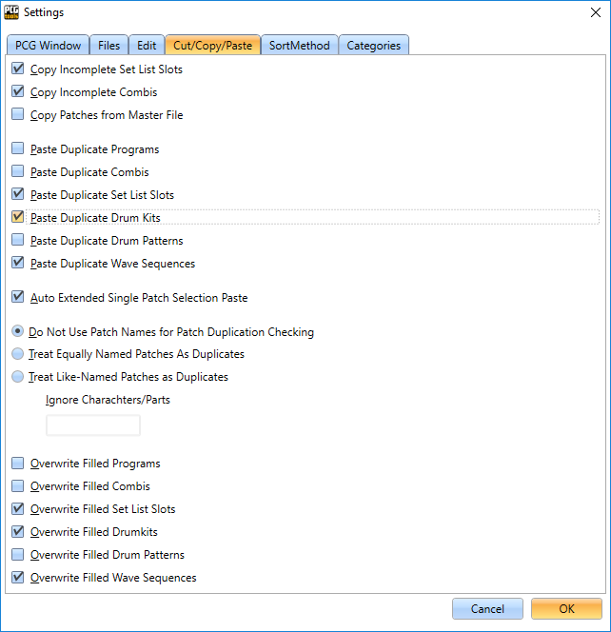

Figure 33: Cut/Copy/Paste Settings

#### Sort Settings

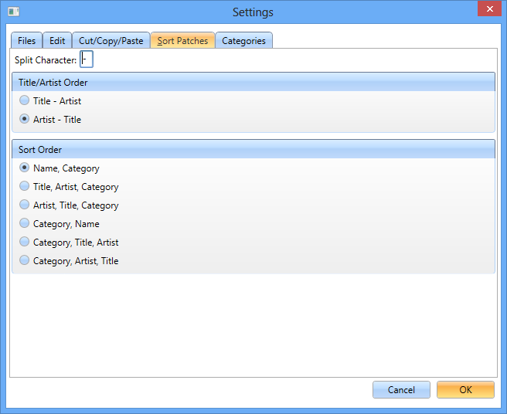

Figure 34: Sort Settings

Lots of people use a naming convention in (mostly) combis and set list slots to show both the Artist and the Title of a song, like

Queen – Innuendo

Or otherwise:

Innuendo – Queen

Because sorting on Name would make it impossible to sort on the part after the dash, the terms Artist and Title are used.

You can define the split character yourself, but normally it will be something like a dash (-) or slash (/). When a patch name contains multiple split characters (like ‘Dash-Band – First Song), the split will be made on the last split character that has the most spaces around it.

Of course when there is no split character the title/artist sorting methods are not used, then the complete name of the patch is used.

*Example 1: Assume the split character is a dash and Title – Artist is selected. When the following patch names need to be sorted by artist, they will be in the order:*

* + *Innuendo – Queen*
  + *Crazy – Seal*

*Sorting strings: Queen, Seal.*

*Example 2: Assume the split character is a slash and Artist - Title is selected. When the following patch names need to be sorted by artist, they will be in the order:*

* + *Crazy / Seal*
  + *Innuendo / Queen*

*Sorting strings: Crazy, Innuendo.*

The sort orders are explained in paragraph 7.3.6.6.

#### Categories Settings

**[KORG TRINITY ONLY]:** The Korg Trinity does not use sub categories but category A and category B. By selecting the category (A or B) in this menu, as category the selected category will be used. The other category will not be used at all.

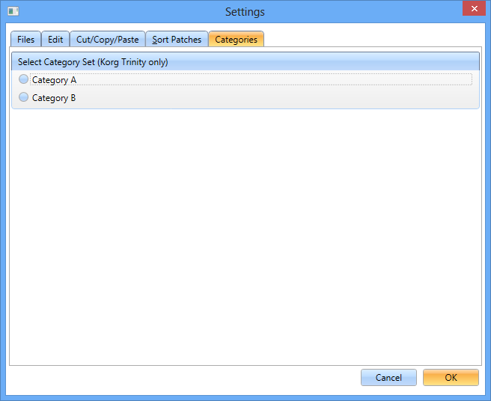

Figure 35: Categories Settings

## Windows Menu

### Goto Next Window

This menu navigates to the next window. This window can be a PCG window, a Timbres window or a SNG window.

The following ways can be used to select this command:

* Select the Goto Next Window menu item in the Help menu
* Press F6

### Goto Previous Window

This menu navigates to the previous window. This window can be a PCG window, a Timbres window or a SNG window.

* Select the Goto Next Window menu item in the Help menu
* Press Ctrl + F6

## Help Menu

This menu shows the manual and contains info about the application and external links.

### About Command

This command is used for showing generic info about PCG Tools.

The following ways can be used to select this command:

* Select the About menu item in the Help menu.
* Select the About tool bar icon (white balloon with a blue i).

When selected, a window is shown like in Figure 36.

**[TIP]** If you find this application useful, please consider using the Donate option.

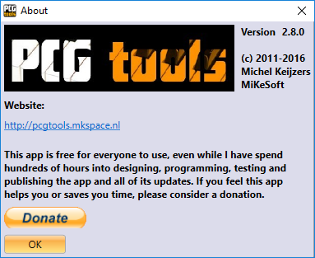

Figure 36: About window

### Home Page

This command shows the home page of PCG Tools in your browser.

The following ways can be used to select this command:

* Select the Home Page menu item in the Help menu

When selected, your default browser opens the home page of PCG Tools. An internet connection is needed.

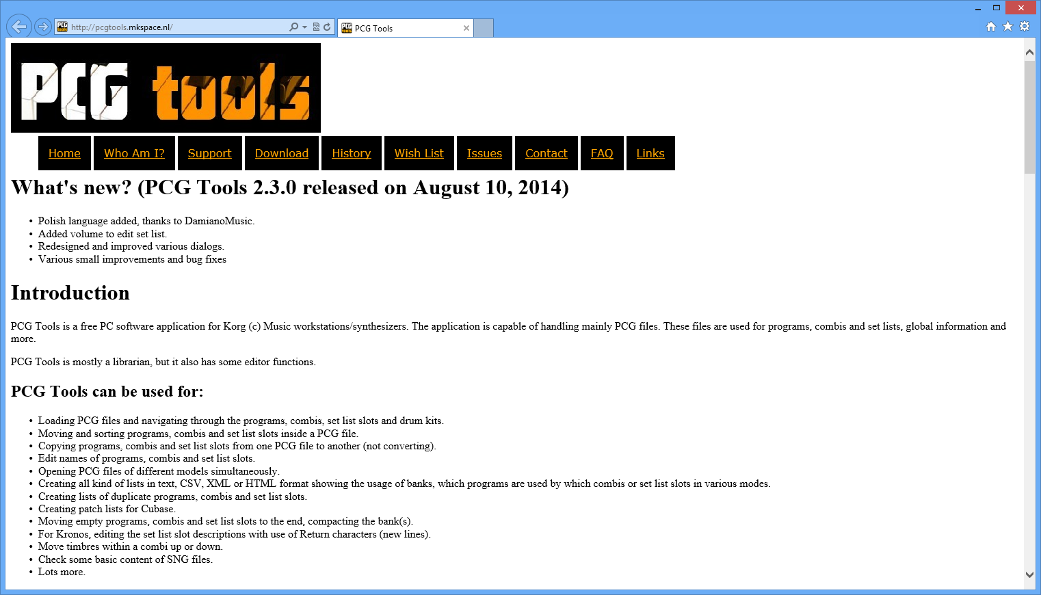

Figuur 37: Home Page

### Manual

This command shows this manual as PDF in your browser.

The following ways can be used to select this command:

* Select the Manual menu item in the Help menu

When selected, your default browser opens a PDF with the manual (same contents as this file). An internet connection is needed.

Note that it can take some time before the manual is loaded in your browser, because it is a reasonably big file (about 8 MB).

### External Links Command

This command is used for showing links/logos of sites related to Korg, donators, people who have worked at the application, translated languages, shops that are affiliated with PCG Tools, freeware tools I use for developing PCG Tools etcetera.

#### Korg related External Links

The following ways can be used to select this command:

* Select the External Links Korg Related menu item in the Help menu.

When selected, external links are shown which can be opened by the default browser as in Figure 38.

These links show the main site of PCG Tools (part of KorgForums), the social media links of PCG Tools, Korg related sites, sites that share patches for Korg workstations, external Korg applications, shops that affiliate PCG Tools and a few Korg related discussion forums. See **Fout! Verwijzingsbron niet gevonden.** for all available links on this window.

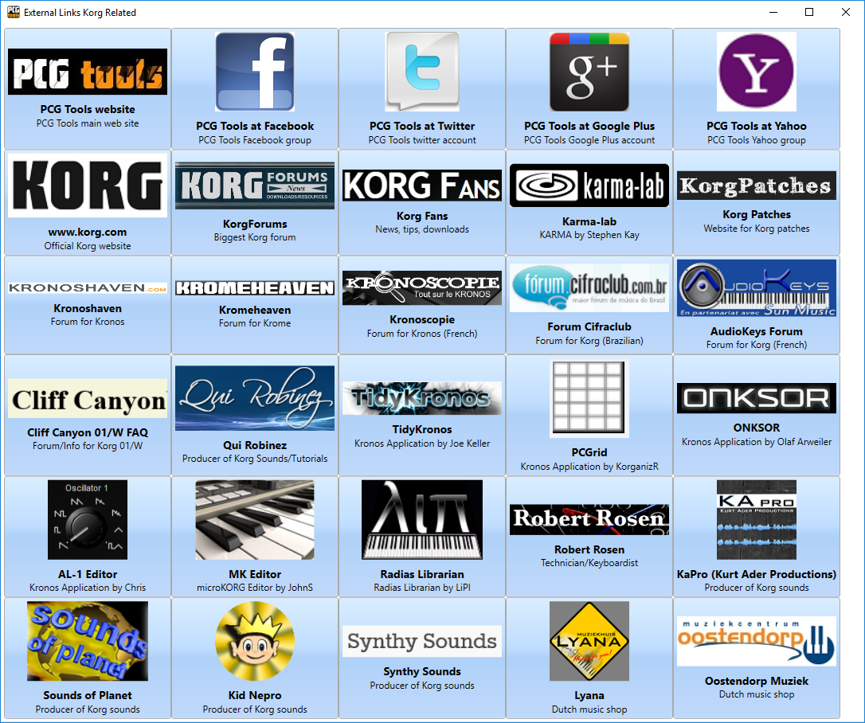

Figure 38: Korg Related External Links

All links can be found on the website or by clicking on the links above in PCG Tools.

#### Donators External Links

The following ways can be used to select this command:

* Select the External Links Donators menu item in the Help menu.

When selected, external links are shown which can be opened by the default browser as in Figure 39.

These links show the links/logos of people (or selected URL) from people who donated to PCG Tools. See http://pcgtools.mkspace.nl/links.html for all available links on this window.

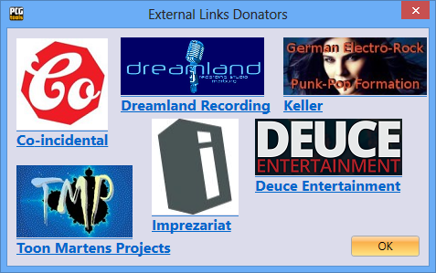

Figure 39: Donators External Links

All links can be found on the website or by clicking on the links above in PCG Tools.

#### Translators External Links

The following ways can be used to select this command:

* Select the External Links Translators menu item in the Help menu.

When selected, external links are shown which can be opened by the default browser as in Figure 40.

These links show the links/logos of people (or selected URL) from people who helped with translating CG Tools in another language. See **Fout! Verwijzingsbron niet gevonden.** for all available links on this window.

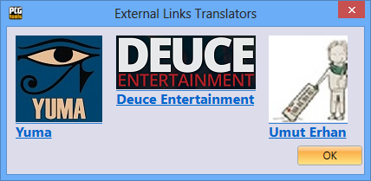

Figure 40: Translators External Links

All links can be found on the website or by clicking on the links above in PCG Tools.

#### Third Parties External Links

The following ways can be used to select this command:

* Select the External Links Third Parties menu item in the Help menu.

When selected, external links are shown which can be opened by the default browser as in Figure 41.

These links show the links/logos of third party tools used to develop PCG Tools. See **Fout! Verwijzingsbron niet gevonden.** for all available links on this window.

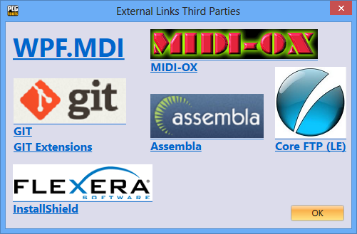

Figure 41: Third Parties External Links

All links can be found on the website or by clicking on the links above in PCG Tools.

### Oasys Codes Sponsors

Some persons donated part or full of their Korg Oasys voucher codes to Kronos owners, worth up to US $750.

On behalf of every Korg Kronos receiver of such a code, I would like to thank the following persons:

- Ian Hutty (Ianhu)

- Patrick Dumas (Fzero)

- Steve D (steved53)

- Frans van den Berg (Paulifra)

- Tim (t_tangent)

- SoulBe

- Adam P (Kontrol49)

For the screenshot, see Figure 42.

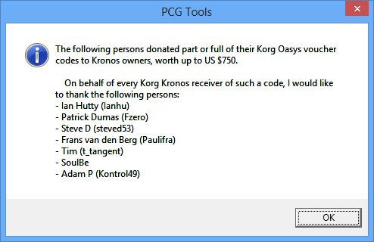

Figure 42: Oasys Codes Sponsors

## Toolbar

The toolbar can be considered as a set of icons, functioning as short cuts for the menu (or controls like buttons) on the different screens. The most important commands are gathered in the toolbar and also are mentioned in the activation of the commands.

# Using Patch Files

## Introduction

This chapter is the main chapter of this manual, since it contains all explanation how to handle with PCG OR RELATED files in PCG Tools. A related file can also be:

* + SYX file with patch data
  + MID file containing system exclusive information with patch data
  + Various other formats like 01p, 01W, ALL, RAW, mkxl_all, mkxlp_prog, mkxlp_all, KRSall, KRSapr, KRSbpr, KRSpr, KRSacm, KRSbcm, KRScm, LIB depending on the workstation type.

See the website (Support tab) for a complete list of what types are supported for which models.

If hereafter is written ‘PCG file’ or ‘file’, any of the above types can be read instead.

## Status Bar

When a file is opened the status bar shows a lot of information as shown in Figure 43.



Figure 43: Status Bar

The meaning and color of these items is shown in Table 16.

|  |  |  |
| --- | --- | --- |
| **Item** | **Description** | **Color** |
| Korg Kronos | Model of the Korg workstation (called workstation model) and if applicable, the PCG/OS version, see next paragraph. See * | Blue |
| PCG | Type of file (patch file) | Black |
| 1538 programs in 13 banks | Total of 1583 programs in 13 program banks, empty or initialized programs are not counted. | Green |
| 480 combis in 4 banks | Total of 480 combis in 4 combi banks, empty or initialized combis are not counted. | Green |
| 32 set list slots in 1 set list | Total of 32 set list slots in 1 set list, empty or initialized set list slots are not counted. | Green |
| 78 drum kits in 4 banks | Total of 78 drum kits in 4 drum kit banks, empty or initialized drum kits are not counted. | Green |
| 165 wave sequences in 2 banks | Total of 165 wave sequences in 2 wave sequence banks, empty or initialized wave sequences are not counted. | Green |
| Clipboard | Shows information about the copied patches (by cut/copy/paste):  - workstation model - workstation version - number and type of programs - number of combis - number of set list slots | Red |

Table 16: Status Bar Items

*Since most Korg Triton family patch files cannot be differentiated, an active patch file for the Triton is either showing 'Triton Extreme', 'Triton Classic/Studio/Rack' or 'Triton LE'. Other workstation models that are displayed can be Kronos (X), Oasys, M3, M50, Krome and Karma.

When multiple files are opened, the status bar shows the information of the selected file (window).

### PCG/OS Version

The PCG/OS version is displayed only for those workstation models in combination with PCG/OS versions where the difference is important. These are the following:

* Korg Kronos version 1.0/1.1
* Korg Kronos version 1.5/1.6
* Korg Kronos (X) version 2.0
* Korg M3 version 1.x
* Korg M3 version 2.0 (expanded)

## PCG Window

### Introduction

When a PCG (or other) file is opened a window is shown, a so called PCG window. Despite the name it can contain any patch data (also from other file types). In Figure 44 such a window is shown.

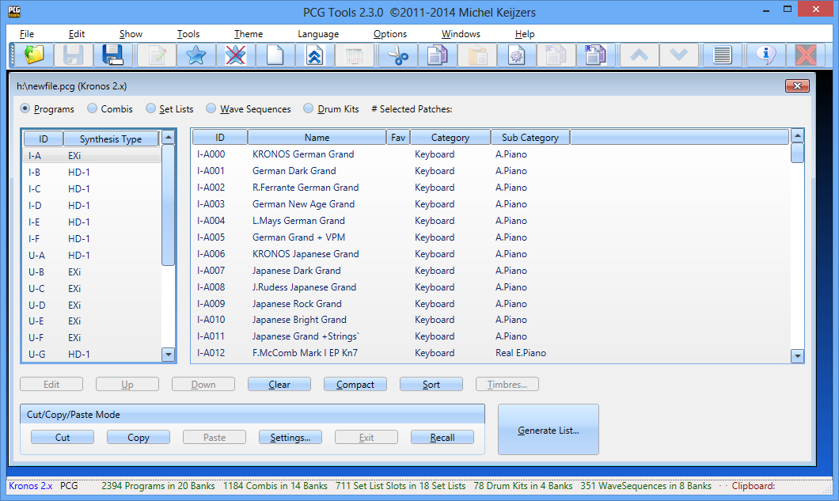

Figure 44: PCG Window

When a PCG window is made smaller, the controls on the window are automatically wrapped. This is ideal for users with a small screen. See Figure 45 for an example.

Note that the toolbar and the status bar is not wrapped.

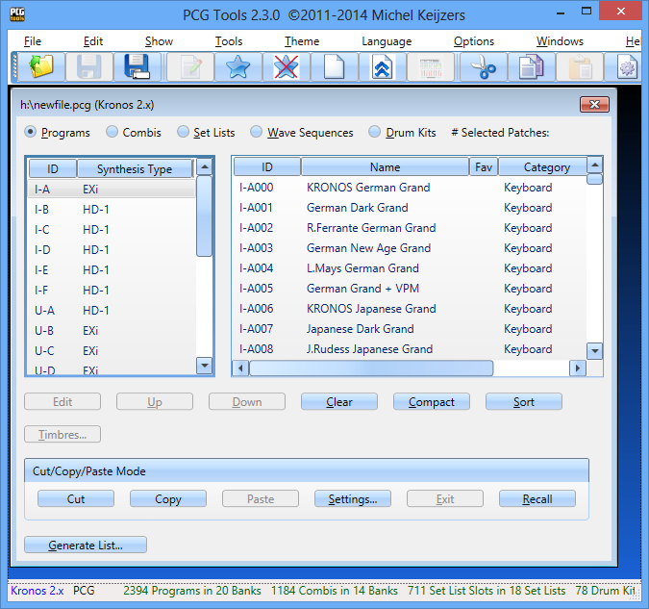

Figure 45: Wrapped PCG Window

In the following paragraphs each item of a PCG Window is explained in more detail.

### Title

The title of a PCG window is the name of the patch file including its path, in this case h:\newfile.pcg. Also the workstation model and version is added (Korg Kronos 2.0)

An asterisk is shown when the file is changed as an effect of one of the commands explained later.

### Programs/Combis/Set Lists / Wave Sequences / Drum Kits Radio buttons

These five radio buttons can be used for selecting programs, combis, set lists (when supported), wave sequences (when supported) and drum kits.

### Banks Listview (Left side)

A PCG window has two list views, one on the left and one on the right. The left list view is called the Banks Listview and contains the program banks, combi banks, set lists, wave sequences or drum kits, depending on the radio button above. See Figure 46 for a screenshot .

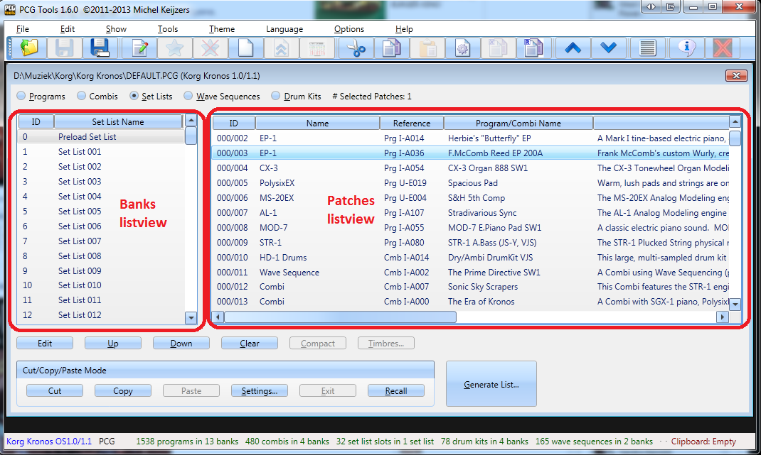

Figure 46: Listviews

#### Program Banks

When program banks are selected, the ID and synthesis type of each bank is shown.

A program bank only can contain programs of the same engine type.

**[KRONOS (X)]:** The EXi modeling synth engine type is a set name for all modeling types like SGX-1, CX-3, AL-1 EP-1, STR-1, MOD-7, MS20 and PolySix.

The GM banks are not shown because GM banks are not contained in a patch file.

See Figure 47 for a screenshot.

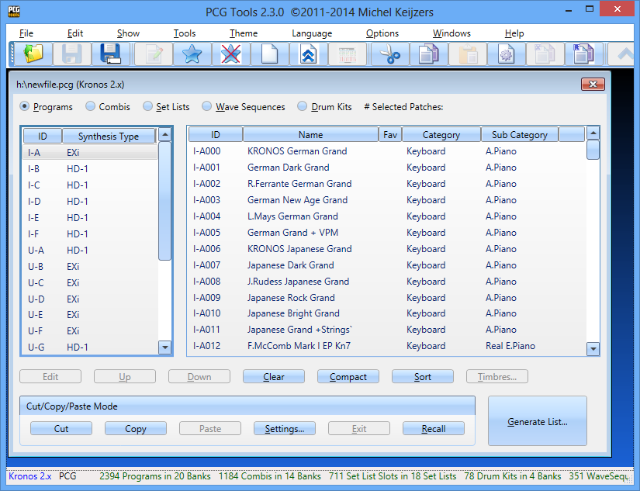

Figure 47: Program Banks

#### Combi Banks

Combi banks do not have additional information shown per bank. See Figure 48 for a screenshot.

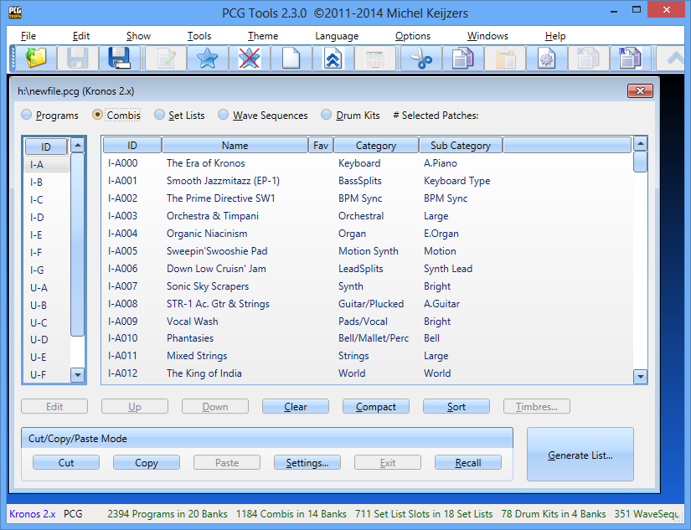

Figure 48: Combi Banks

#### Set Lists [KRONOS ONLY]

When set lists are selected, the ID (0-128) of the set list is shown and the name of the set list. See Figure 49 for a screenshot.

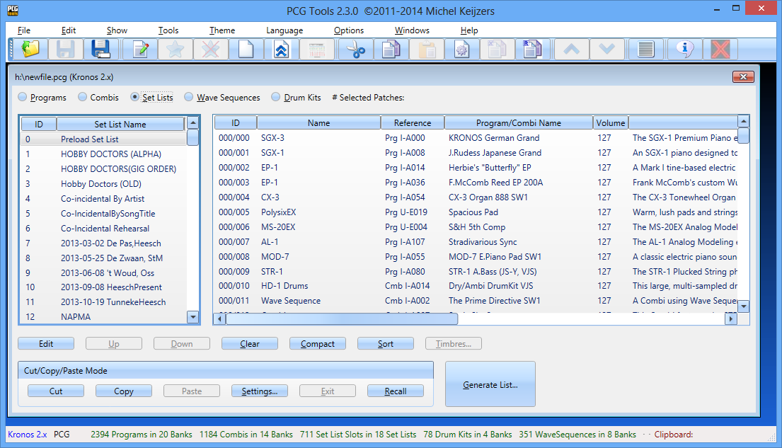

Figure 49: Set Lists

#### Wave Sequence Banks

When wave sequences are selected, the ID (0-128) is shown, see Figure 50 for a screenshot.

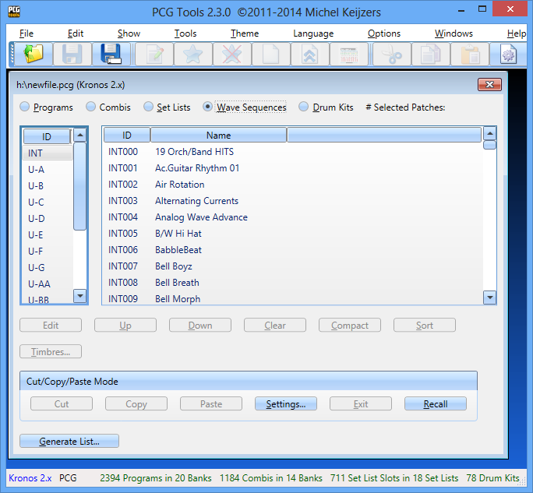

Figure 50: Wave Sequence Banks

#### Drum Kits Banks

When drum kits are selected, the ID (0-128) is shown, see Figure 51 for a screenshot.

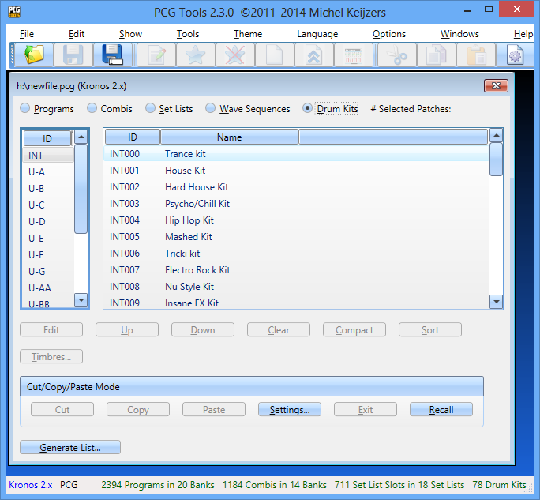

Figure 51: Drum Kits Bank

### Patches Listview (Right side)

The right list view shows the patches, depending on whether programs, combis or set lists are selected and which bank has been selected. Only the patches shown from the first selected bank in the Banks Listview are shown.

#### Number of Selected Patches

Most banks will have 128 items, however some file types only have 1 item. To see in a glance how many patches are selected, this value is shown explicitly next to the type of patches shown (e.g. as: # Selected Patches: 25).

#### Programs/Combis

When a program or combi bank is selected, the following information is shown per program/combi:

* ID: the unique ID of the program or combi, e.g. I-C124.
* Name: The name of the program or combi, e.g. "The Log Drum".
* Fav**:** Shows an asterisk if the program/combi is selected as favorite. **[KRONOS ONLY]**
* Category: Shows the category where the program/combi is assigned to.
* Sub Category: Shows the sub category where the program/combi is assigned to.

See Figure 52 for a screenshot of programs.

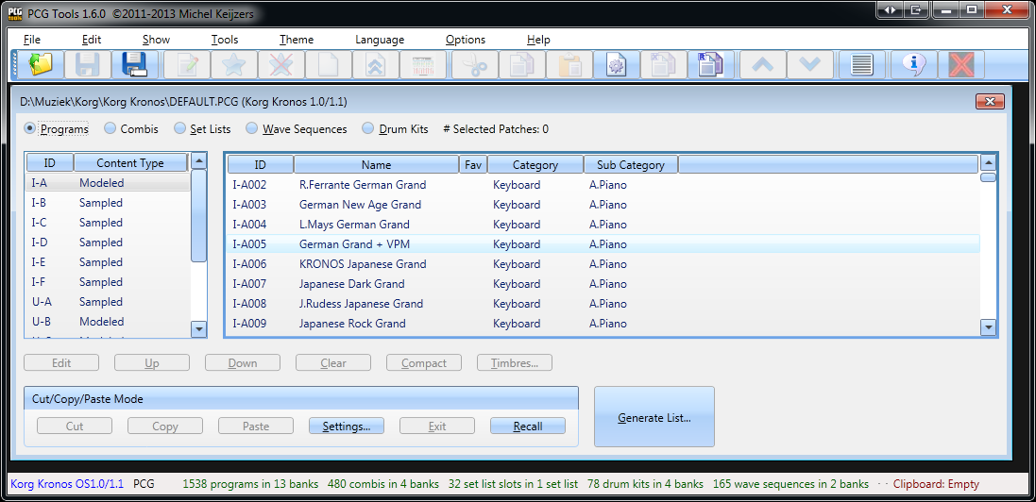

Figure 52: Programs

#### Set List Slots [KRONOS ONLY]

When a set list is selected, the following information is shown per set list slot:

* ID: the unique ID of the set list slot in format <set list>/<set list slot>, e.g. 024/037 means set list slot 37 inside set list 24.
* Name: The name of the set list slot.
* Reference: The reference of the set list slot: can be either a program or combi, examples are Prg I-A000, Cmb I-A003 etc.
* Program/Combi Name: The name of the referenced ID, e.g. "Stradivarious Sync".
* Volume: Volume of the set list slot.
* Description: The text that can be assigned to a set list slot.

See Figure 53 for a screenshot.

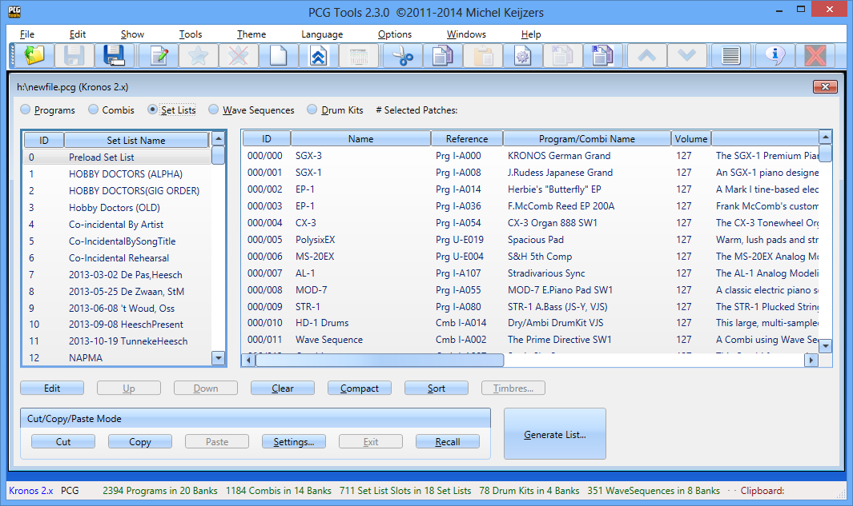

Figure 53: Set List Slots

#### Wave Sequences and Drum Kits

When wave sequences or drum kits are selected,, the following information is shown per wave sequence resp. drum kit:

* ID: the unique ID of the wave sequence resp. drum kit.
* Name: The name of the wave sequence resp. drum kit.

See Figure 53 for a screenshot.

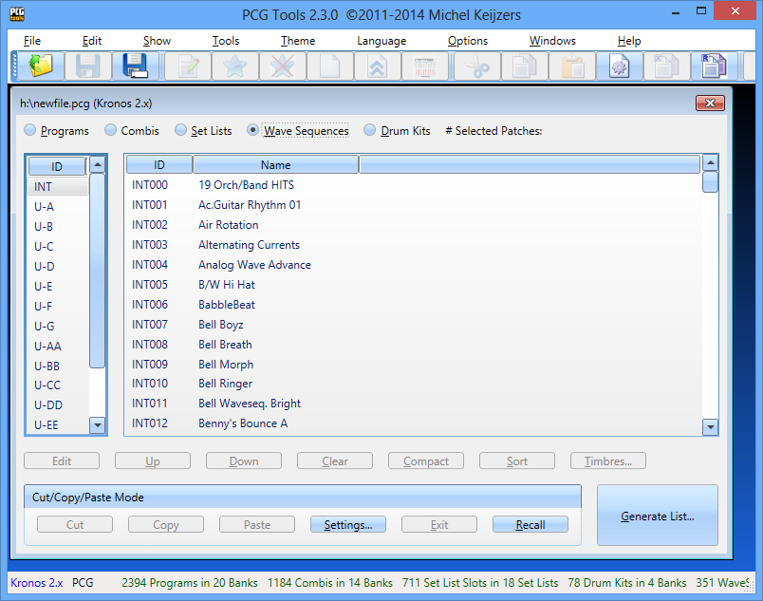

Figure 54: Wave Sequences

### Generic Commands

Below the banks and patches list, the buttons for all commands are shown. See Figure 55 for a screenshot.

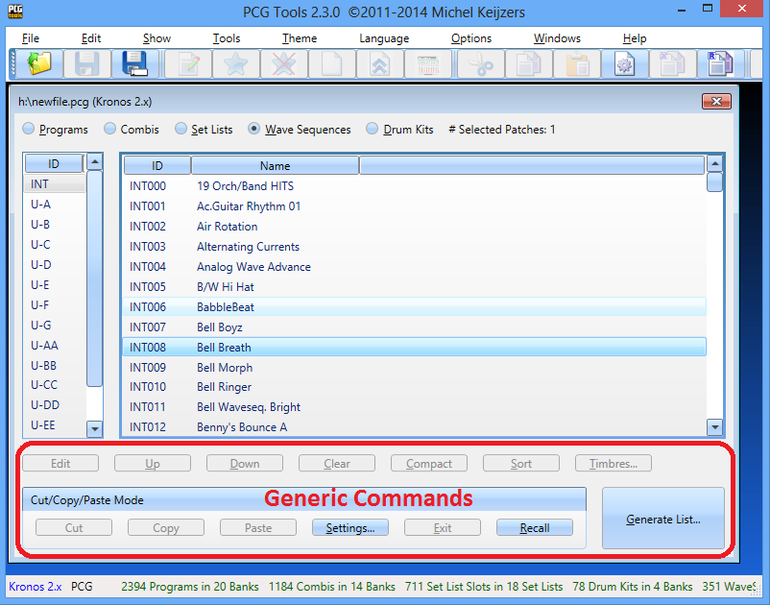

Figure 55: Generic Commands

These buttons have a different meaning depending on whether banks are selected or patches (i.e. the Banks Listview or the Patches Listview). Which list is selected, can be seen by the thick grey border around the current selected list.

One or multiple items in a list can be selected. Some commands only can be activated when one or more banks are selected, some commands only when one or more patches are selected, and some can be selected in either list. This will be shown in the activation prerequisite in each command paragraph.

The second row of buttons are the cut/copy/paste buttons.

**[WARNING]:** Most commands cannot be undone, be especially careful with the Edit, Clear and Compact commands.

#### Edit Command

This command can be used to change certain parameters of the selected patch. Depending on the type (program, combi or set list) a different dialog is shown. For wave sequences and drum kits the edit command is not available.

Activation prerequisite: select exactly one program, combi or set list slot in the patches list.

The following ways can be used to select this command:

* Select the Edit menu item in the Edit menu
* Select the Edit tool bar icon in the tool bar (white document with the green pencil)
* Click the Edit button
* Double clicking on a patch
* Press F2 key
* Press Alt-e until the Edit button is highlighted and press Enter

##### Edit Program

When a program is selected, the dialog in Figure 56 is shown.

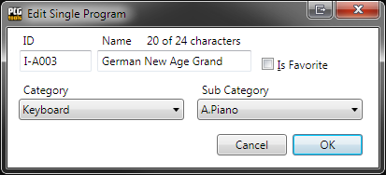

Figure 56: Edit Program

Table 17 shows what info is shown and can be changed.

|  |  |  |
| --- | --- | --- |
| **Item** | **Type** | **Description** |
| ID | Read only | Unique ID of the program. |
| Name | Editable | Name of the program including the current and maximum number of characters that can be used. The maximum number of characters depends on the workstation model. |
| Is Favorite | Editable | Selects whether the program is set as favorite or not. **[KRONOS ONLY]** |
| Category | Editable | Category of the program. |
| Sub Category | Editable | Sub category of the program. |

Table 17: Edit Program Items

Patch files optionally contain the Global part, which contains the names of the categories and sub categories. If the Global part is available, the names of categories and sub categories are shown in the two combo boxes shown in Figure 56, if not the index numbers are shown.

If you try to enter a name that is too long (the maximum length depends on the workstation model), the error 'Name too long' is shown in red (see Figure 57) and the OK button will be disabled.

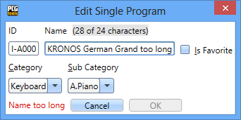

Figure 57: Program Name too long

##### Edit Combi

Editing a combi works exactly like editing a program (see Paragraph 7.3.6.1.1).

##### Edit Set List Slot [KRONOS ONLY]

When a set list slot is selected, the dialog in Figure 58 is shown.

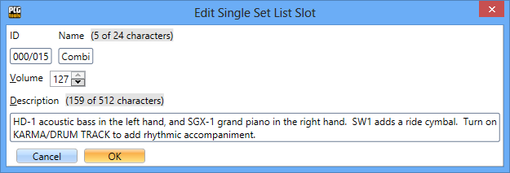

Figure 58: Edit Set List Slot

Table 17: Edit Program ItemsTable 18 shows what info is shown and can be changed.

|  |  |  |
| --- | --- | --- |
| **Item** | **Type** | **Description** |
| ID | Read only | Unique ID of the program. |
| Name | Editable | Name of the set list slot including the current and maximum number of characters that can be used. |
| Volume | Editable | Volume of the set list slot. |
| Description | Editable | Description of the set list slot including the current and maximum number of characters that can be used. |

Table 18: Edit Set List Slot Items

If you try to enter a name or description that is too long (the maximum length depends on the Korg model), the error 'Name too long' or 'Description is too long' is shown in red (see) and the OK button will be disabled. See Figure 59 for an example of a description that is too long.

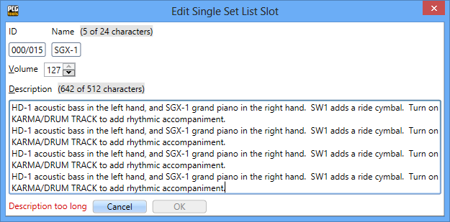

Figure 59: Set List Slot Description Too Long

For the name and description, the character set that can be used is equal to the character set of the on screen keyboard of the Kronos. However, for descriptions it is possible to enter linefeed/return characters, which will also cause a linefeed/return to be shown in the Kronos display. A linefeed/return character costs 2 characters instead of one. When changing the description text on the Kronos the linefeed/return characters, the cursor will be misaligned, so it is best to use this dialog screen for editing descriptions.

When returning to the PCG Window (after closing the Edit screen), when using line feeds/returns the set list slots look like (after selecting several set list slots).

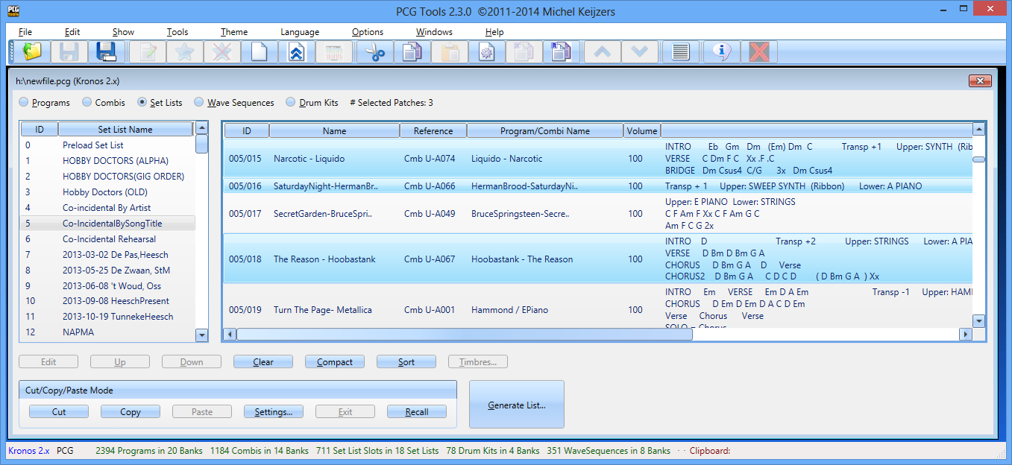

Figure 60: Set List Slots with Line Feeds/Returns

#### Move Up Command

This command moves the selected program, combi or set list slot one position up. Wave sequences and drum kits cannot be moved.

Activation prerequisite: select exactly one patch (not the first patch) in the patches list.

The following ways can be used to select this command:

* Select the Move Up menu item in the Edit menu.
* Select the Move Up tool bar icon in the tool bar (blue half arrow pointing up)
* Click the Up button.
* Press the up cursor key on the numeric keyboard (on the 8 key).
* Press Alt-u until the Up button is highlighted and press Enter.

When moving a program, all combis and set list slots referring to the selected program (and programs moved down to let the selected programs move up) are changed accordingly.

When moving a combi, all set list slots referring to the selected combi (and combis moved down to let the selected combis move up) are changed accordingly too.

#### Down Command

This command moves the selected program, combi or set list slot one position down. Wave sequences and drum kits cannot be moved.

Activation prerequisite: select exactly one patch (not the last patch) in the patches list.

The following ways can be used to select this command:

* Select the Move Down menu item in the Edit menu.
* Select the Move Down tool bar icon in the tool bar (blue half arrow pointing down)
* Click the Down button.
* Press the Down cursor key on the numeric keyboard (on the 2 key).
* Press Alt-d until the Down button is highlighted and press Enter.

When moving a program, all combis and set list slots referring to the selected programs (and programs moved down to let the selected programs move up) are changed accordingly.

When moving a combi, all set list slots referring to the selected combis (and combis moved up to let the selected combis move down) are changed accordingly too.

#### Clear Command

This command clears or erases the selected programs, combis or set list slots or all patches in the selected program or combi banks or set lists. Wave sequences, wave sequence banks, drum kits and drum kit banks cannot be cleared.

Activation prerequisite: select one or more banks or one or more patches.

The following ways can be used to select this command:

* Select the Clear menu item in the Edit menu.
* Select the Clear tool bar icon in the tool bar (blank page)
* Click the Clear button.
* Press Alt-c until the Clear button is highlighted and press Enter.

This command behaves differently depending on whether the banks or patches list is active.

When banks are active, all patches in the selected banks will be cleared. When patches are active, only all selected patches will be cleared.

Clearing a patch is not equal to initializing them.

Clearing a program means:

* Clearing the name (empty name).
* Setting the category (and if supported sub category) to the first category/sub category.
* Deselect the Favorite setting **[KRONOS ONLY]**

**[WARNING]:** When clearing programs, combis/set list slots using those programs are not broken, but it will not be trivial that empty programs are still used by combis/set list slots.

Clearing a combi means:

* Clearing the name (empty name).
* Setting the category and sub category to the first category/sub category.
* Deselect the Favorite setting
* Clearing the most important parameters of all timbres in thecombi:
  + Program set to I-A000 / A000 (depending on the workstation model).
  + Status set to Off.
  + Muted.
  + Volume set to 0.
  + MIDI Channel set to 16.
  + Bottom/Top key set to the lowest key.
  + Bottom/Top velocity set to 0.
  + Osc Mode set to Mono.
  + Osc Select set to OSC2.
  + Transpose set to 0.
  + Portamento set to 0.
  + Bend Range set to 0.

**[KRONOS ONLY] [WARNING]:** When clearing combis, combi parameters are changed and set list slots using these cleared combis will not be audible anymore (equal to the cleared combis).

**[KRONOS ONLY]** Clearing a set list slot means:

* Clearing the name (empty name).
* Clearing the description (empty description)
* Set the reference to program I-A000.
* Setting the category and sub category to the first category/sub category.

Figure 61 shows the result of clearing the selected patches.

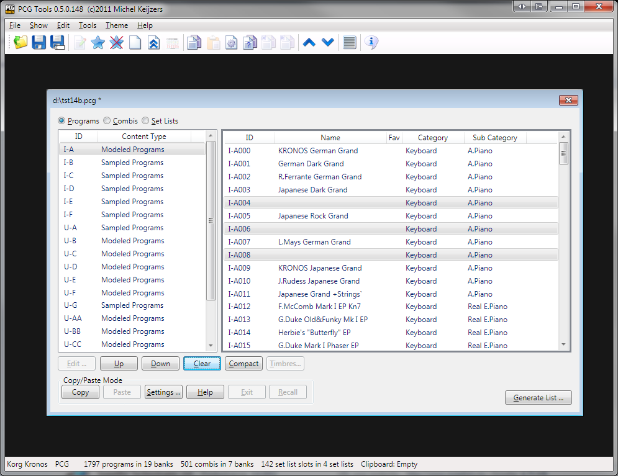

Figure 61: Clear Command

**[TIP]:** The reason to clear/empty the names instead of giving them a initialized name (e.g. INIT PROGRAM I-A030) is that emptying them shows in a glance that those patches are empty. If you want to create a new sound, initialize the patch on the workstation to start from a 'real' initialized patch .

**[TIP]:** A quick way to remove patches you don't like is to load the patch file that is currently in your workstation, audition patches on your workstation and if you find one or more patches, select them in PCG Tools and clear them. Do not make changes on your workstation. When finished, save the patch file and load it in your workstation.

**[TIP]:** After clearing patches, there might be gaps with empty patches within your bank(s). Consider to use the Compact command to remove these empty gaps.

**[TIP]:** Note that deleting a patch is not possible, since there are always 128 patches in a bank (or set list). What comes most close to deleting a patch is to clear a patch, and then use the Compact command to move the cleared patch to the bottom.

#### Compact Command

This command moves all empty or initialized programs, combis or set list slots down and all filled patches up. Wave sequences and drum kits cannot be compacted.

Activation prerequisite: select one or more banks or at least two patches.

The following ways can be used to select this command:

* Select the Compact menu item in the Edit menu.
* Select the Compact tool bar icon in the tool bar (blank page)
* Click the Compact button.
* Press Alt-c until the Compact button is highlighted and press Enter.

Compacting should be used to remove the gaps that exist after clearing patches or when patches are splintered over a bank.

This command behaves differently depending on whether the banks or patches list is active.

When patches are active, only all selected patches will be compacted. In Figure 62 several set list slots have been selected and some of them are empty. When the Compact command is used, all set list slots (also those which are initialized or empty) are moved up within the selection. Set list slots that are not selected are left alone, thus not moved. In Figure 63 the result is shown after compacting.

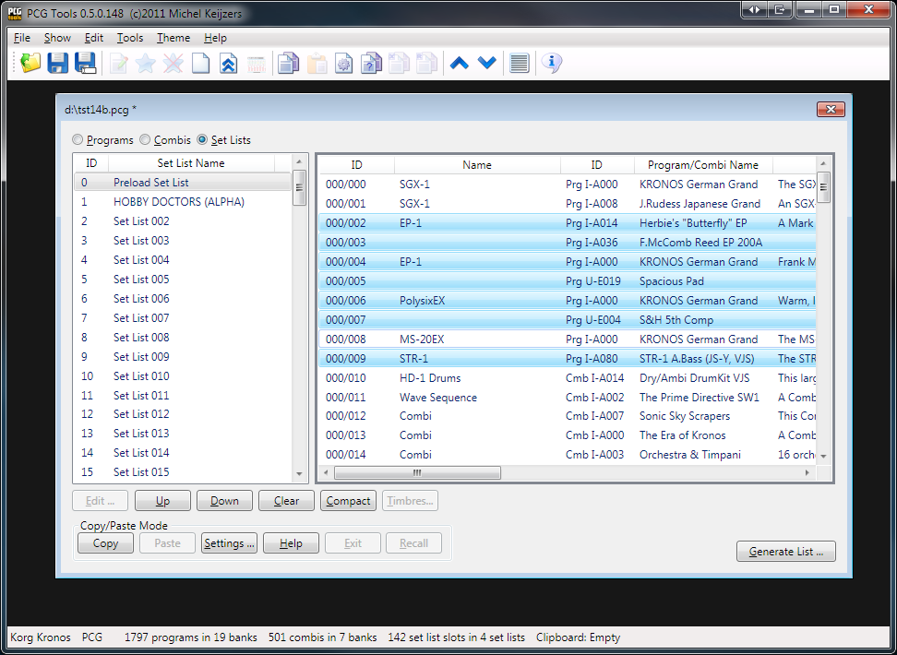

Figure 62: Before Compacting

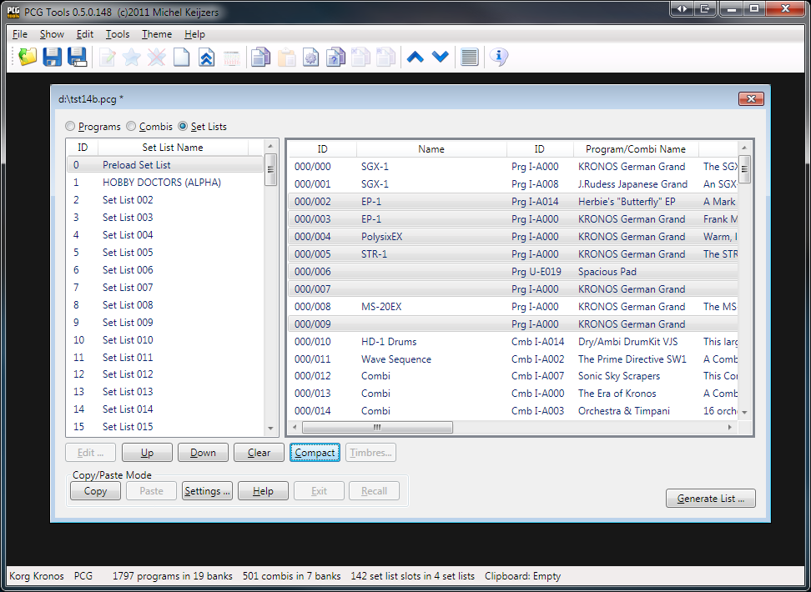

Figure 63: After Compacting

If multiple program banks are selected and the selection contains programs from different synth engines, the programs are split into groups per synth model engine. Every list is then compacted separately (as if you would first select only programs of the first synth engine type and compact them and then select the programs from the next synth engine and compact etc.).

Also when selecting multiple banks, compacting them is not performed per bank. E.g., if two banks are selected and the first selected bank contains 20 empty patches, then 20 patches from the second selected bank (if not empty) are moved to the first selected bank.

**[TIP]:** To create empty banks, first remove unwanted patches by clearing them, then select all banks and compact all banks. The result is (depending on the amount of removed patches), that completely empty banks are available (which will be the last banks of the sampled/modeled type).

When compacting programs, all combis and set list slots referring to the selected programs (and programs moved down to let the selected programs move up) are changed accordingly.

**[KRONOS ONLY]** When compacting combis, all set list slots referring to the selected combis (and combis moved down to let the selected combis move up) are changed accordingly too.

#### Sort Command

This command sorts all selected programs, combis or set list slots according to the method to be specified. Wave sequences and drum kits cannot be sorted.

Activation prerequisite: select one or more banks or at least two patches.

The following ways can be used to select this command:

* Select the Sort menu item in the Edit menu.
* Click the Sort button.
* Press Alt-s until the Sort button is highlighted and press Enter.

This command behaves differently depending on whether the banks or patches list is active.

When patches are active, only all selected patches will be sorted. Empty or init patches will always be moved to the end.

If multiple program banks are selected and the selection contains programs from different synth engines, the programs are split into groups per synth model engine. Every list is then sorted separately (as if you would first select only programs of the first synth engine type and sort them and then select the programs from the next synth engine and sort etc.).

Also when selecting multiple banks, sort them is not performed per bank. E.g., if two banks are selected and the first selected bank contains 20 empty patches, then 20 patches from the second selected bank (if not empty) are moved to the first selected bank (depending on the sort criteria).

When the sort command has been selected, the sort selection has to be selected, see Figure 64.

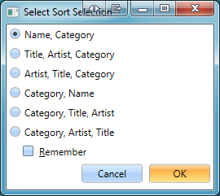

Figure 64: Select Sort Selection

Below each sort selection is explained in more detail. For every selected patch (or all patches in the selected banks the sort selection is performed).

* Name, Category: First sort by name, if patches have the same name, sort by category (and sub category if supported).
* Title, Artist, Category: First sort by title, if patches have the same title, sort by artist, then by category.
* Artist, Title, Category: Same as before, but first sorting on artist.
* Category, Name: First sort by category, if equal, sort by name.
* Category, Title, Artist: Sort by category, if equal, sort by title, otherwise by artist.
* Category, Artist, Title: As before but secondly sort by artist, then title.
* Remember: Check this option to remember the sort method for the next time. It will also be saved for the next time PCG Tools is started. The default select sort selection can also be selected in the Options/Settings menu, see paragraph 6.10.2.4

See for more info on Title and Artist, see paragraph 6.10.2.4.

When no split character has been selected, the title and artist sorting selections are disabled.

When sorting programs, all combis and set list slots referring to the selected programs (and programs moved up or down to let the selected programs moved) are changed accordingly.

**[KRONOS ONLY]** When sorting combis, all set list slots referring to the selected combis (and combis moved down to let the selected combis move up or down) are changed accordingly too.

Below are a few examples of the result of sorting.

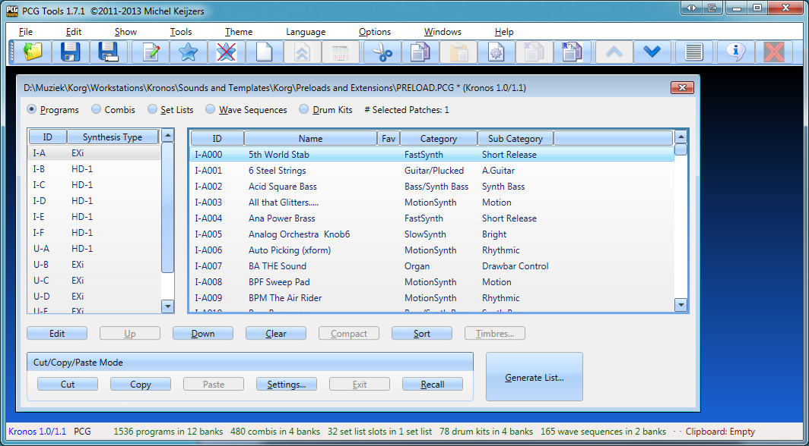

Figure 65: Programs sorted by name.

In Figure 66 can be seen that the set list slots are now sorted by the part after the split character (Title):

* Free – **A**llright Now
* GoldenE-**A**nother45Miles
* The Scene - **B**lauw

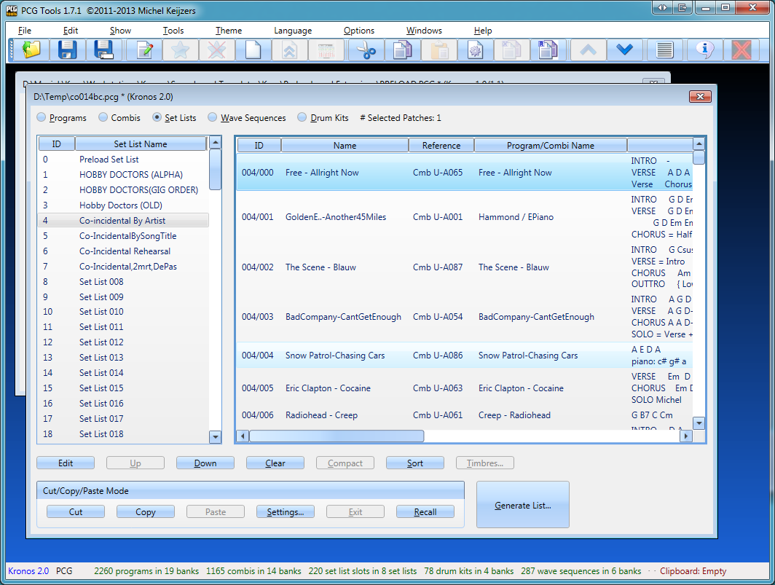

Figure 66: Set list slots sorted by Artist

**[TIP]:** Sort combis or set list slots by both artist and title for easy reference and place them in two separate combi banks or set lists.

#### Timbres Command

This command is used to manage the timbres inside a combi.

Activation prerequisite: select exactly one combi.

The following ways can be used to select this command:

* Select the Timbres menu item in the Show menu.
* Select the Timbres tool bar icon in the toolbar (page with green and red controls)
* Click the Timbres… button.
* Press Alt-t until the Timbres button is highlighted and press Enter.

This command shows the timbres of the selected combi. A new window will appear and is explained in more detail in Paragraph 7.4.

### 

### Cut/Copy/Paste Commands

#### Introduction

Cut / Copy / Paste commands are for moving and copying patches and are also called Copy/Paste commands in short. Cut/Copy/Paste patches is unlike cut/copy/pasting text in a text editor (e.g. NotePad) a lot more complicated. The reason for this, is that programs are used in combis and set list slots and combis are used in set list slots and by copy/pasting combis or set list slots, the underlying used patches should also be pasted.

Wave sequences and drum kits cannot be cut, copied and/or pasted.

**[WARNING]:** Wave sequences and drum kits will not be copied. This means that if programs, combis and/or set list slots making use of non default wave sequences or drum kits, may sound differently when copy/cut/pasted. This only can occur when copying to another patch file. If programs, combis and/or set list slots are cut/copy/pasted within the same patch file then the patch will not have this problem.

When combis or set list slots would be copied and pasted without their used programs or combis, they would not sound at all or at least not sound as their originals, resulting in so called broken combis or set list slots. Therefore, when combis are copy/pasted, all used programs in those combis should be pasted too. If set list slots are copy/pasted, all used programs and combis in the copied set list slots should be pasted, but also the programs used in the combis used in the copied set list slots.

Because you need to have control over the location where programs, combis and set lists can be pasted, a copy/paste action is not a two step action like in a text editor: copy, then paste. Instead, a copy action is performed, and after that one or more paste actions are needed, until all programs, combis and set list slots are pasted.

For cut/paste something similar is true. When moving programs to another location, the combinations and set list slots where that program is used in, should be changed accordingly. Something similar should occur for moved combinations in set list slots where the moved combinations are used in.

**[WARNING]:** Most commands cannot be undone, be especially careful with the Paste command, Exit and Recall commands. Check the Cut/Copy/Paste settings (see paragraph 7.3.7.6.1) before starting with one or more cut/copy/paste actions.

#### Copying between different file types

As long as you copy from the same workstation model, it does not matter if you copy from a one file type to another (as long as the file type is supported)

**[EXAMPLE]:** You can copy programs from a .syx file to a .mid file or otherwise.

#### Copying between different workstation models

Unlike on the real Korg workstation, there are limitations of patches able to be copied between different workstation models. Only workstations within the same PCG Tools Compatibility box (shown in the table below) are allowed to be copied between them.

|  |  |
| --- | --- |
| **Workstation Group** | **PCG Tools Compatibility** |
| Korg Kronos (X)/Oasys1 | Korg Kronos X  Korg Kronos OS 2.x |
| Korg Kronos OS 1.5/1.6 |
| Korg Kronos OS 1.0/1.1 |
| Korg Oasys |
| Korg M family | Korg M3 2.0 |
| Korg M3 v1.x |
| Korg M50 |
| Korg Krome |
| Korg Triton family / Karma | Korg Triton Extreme |
| Korg Triton Studio  Korg Triton Classic  Korg Triton TR  Korg Triton Rack  Korg TR |
| Korg Triton LE |
| Korg Karma |
| Korg Trinity | Korg Trinity V1  Korg Trinity V2  Korg  Korg TR-Rack |
| microKORG/MS2000 | microKORG  MS2000 |
| microKORG XL | microKORG XL  microKORG XL Plus |

1 Korg Oasys PCG files are only readable on Korg Kronos (X) workstations, not vice versa

Table 19: Compatible workstation models

However, if you want to copy patches between two patch files from different Korg workstation models that are incompatible for PCG Tools, there is a solution. Perform the following steps:

* Find out which (or both) patch file(s) is (are) not from the same workstation model or current operating system of your workstation model. With that file (or those files), perform the following steps.
* Load the patch file in your workstation.
* Save the patch file. This will automatically convert the patch file in a format equal to your workstation model and to the same Operating System version as your workstation model.
* Load the patch file in PCG Tools.

Once a patch file is converted to your workstation model and latest Operating System version, you do not have to do this again.

#### Cut Command

This command is used for moving programs, combis or set list slots, by first cutting them and later patching them to the wanted position(s).

Activation prerequisite: select one or more program banks, combi banks or set lists, or select one or more programs, combis and set list slots. Also a current cut/copy/paste action should not be active (when the paste operation from a cut/copy action has been started, it should be finished or exited before being able to use the Cut command again).

The following ways can be used to select this command:

* Select the Cut menu item in the Edit menu.
* Select the Cut tool bar icon in the toolbar (the pairs of scissors icon)
* Press Ctrl + X key (default windows Cut behavior)
* Click the Cut button.

This command depends on whether banks or patches are selected, and also depends on the type of patches which are cut. All selected patches are copied to the so called clipboard, and also cleared (see Clear command). The clipboard is shown in the status bar at the bottom of the PCG Tools screen in red. It is not part of the patch file but serves as a temporary storage for cut and copied patches. There is only one clipboard available, when a cut or copy is performed, the clipboard is filled and a new cut or copy will overwrite the current clipboard content.

**[EXAMPLE]:** When cutting program I-A000 (Kronos Piano), the program will be cleared (shown as an empty program). When moving this program to bank U-G, it will be shown there, see below. Note that the clipboard is being empty again.

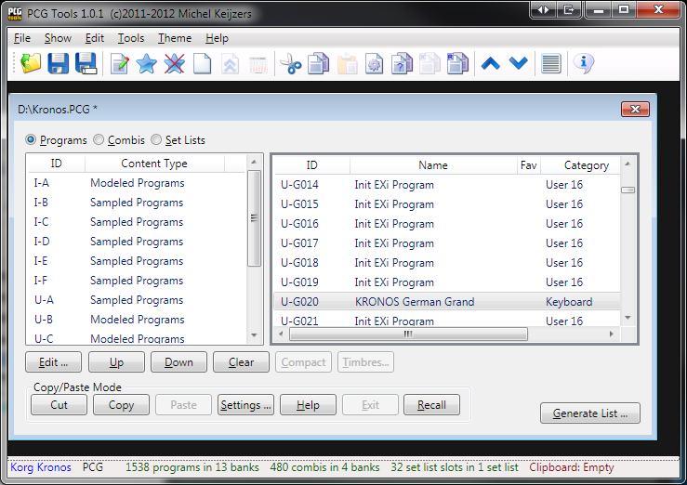

Figure 67: Program after cut and paste

Also when the timbres window of combi I-A000 is opened, one of the timbres point to U-G020 instead of I-A000, see below.

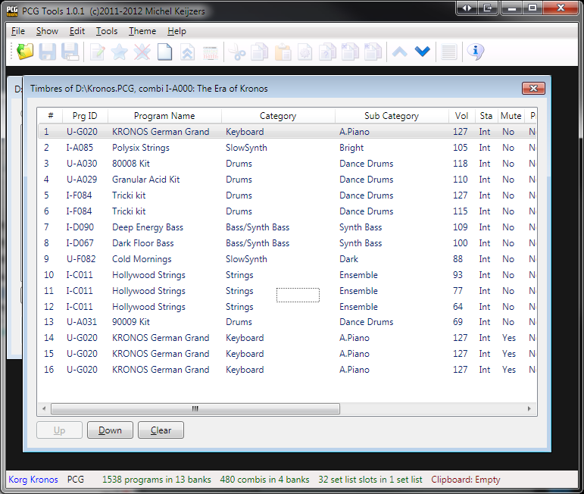

Figure 68: Clipboard content after copying a set list

A cut action cannot be used to paste the patches in another patch file.

**[WARNING]:** Take care not to close a patch file that has patches pasted into it before the clipboard is empty, otherwise the non pasted patches are lost.

#### Copy Command

This command is used for copying programs, combis or set list slots, to be pasted later.

Activation prerequisite: select one or more program banks, combi banks or set lists, or select one or more programs, combis and set list slots. Also a current cut/paste or copy/paste action should not be active (when the paste operation from a cut/copy action has been started, it should be finished or exited before being able to use the Copy command again).

The following ways can be used to select this command:

* Select the Copy menu item in the Edit menu.
* Select the Copy tool bar icon in the toolbar (page with a shadow page behind it)
* Press Ctrl + C key (default windows Copy behavior)
* Click the Copy button.

This command depends on whether banks or patches are selected, and also depends on the type of patches which are copied. All necessary patches are copied to the so called clipboard. The clipboard is shown in the status bar at the bottom of the PCG Tools screen in red. It is not part of the patch file but serves as a temporary storage for copied patches. There is only one clipboard available, when a copy is performed, the clipboard is filled and a new copy will overwrite the current clipboard content.

In **Fout! Verwijzingsbron niet gevonden.** is shown which patches are copied into the clipboard.

|  |  |  |
| --- | --- | --- |
| **Type Selected** | **Patch type selected** | **What is copied to the clipboard** |
| Patches | Programs | - All selected programs. |
| Patches | Combis | - All selected combis.  - All selected programs by the selected combis. |
| Patches | Set List Slots | - All selected set list slots.  - All combis used by the selected set list slots.  - All programs used by the copied combis above.  - All programs used by the selected set list slots. |
| Banks | Program Banks | - All programs inside the selected program banks. |
| Banks | Combi Banks | - All combis inside the selected combi banks.  - All programs used by the combis above. |
| Banks | Set Lists | - All set list slots inside the selected set lists.  - All combis used by the set list slots above.  - All programs used by the copied combis above.  - All programs used by the set list slots above. |

Table 20: Cut / Copied Patches

**[EXAMPLE]:** When the Preload Set List is copied (set list 0), not only the set list slot is copied but also all used programs and combis and programs used in the combis. See Figure 69 for the resulting content in the clipboard: 57 sampled programs, 128 modeled programs, 9 combis and 127 set list slots.

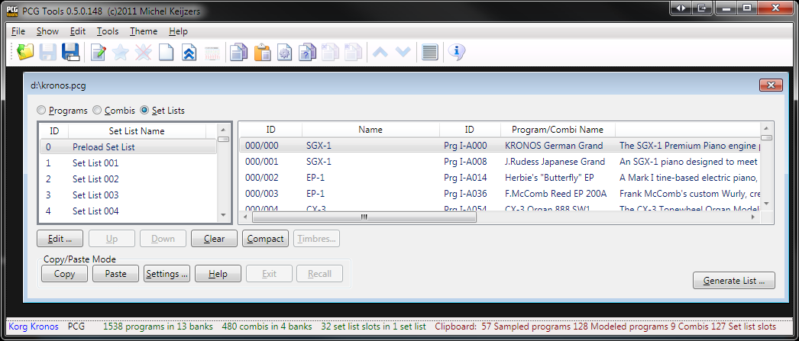

Figure 69: Clipboard content after copying a set list

After a Copy action, all necessary patches are copied to the clipboard and that patch file can be closed without affecting the clipboard.

**[WARNING]:** Take care not to close a patch file that has patches pasted into it but not the complete clipboard is empty.

#### Paste Command

This command is used for pasting programs, combis or set list slots which are present in the clipboard, either by cutting or copying.

Activation prerequisite: select one or more banks or patches. Also the clipboard should be nonempty.

The following ways can be used to select this command:

* Select the Paste menu item in the Edit menu.
* Select the Paste tool bar icon in the toolbar (orange clipboard with a page on it)
* Press Ctrl + V key (default windows Paste behavior)
* Click the Paste button.

This command depends on whether banks or patches are selected and whether a single patch or multiple patches are selected. Also, the cut/copy/paste settings affect this command.

Because pasting patches is not trivial, in paragraph 7.3.7.10 several examples are given how to cut/paste and copy/paste.

Note that after the first paste (i.e. when copying only a portion of the clip board), it is not possible to paste to another patch file until the cut/paste or copy/paste operation is finished. The reason is that if you would paste combis to one patch file and paste the used programs in those combis to another patch file, the combis would not sound correctly (would be broken).

Cut patches can only be pasted within the patch file they are cut from.

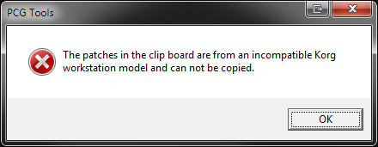

Figure 70: Incompatible Korg workstation model

Also most commands that can change the order of patches are disabled until the cut/paste or copy/paste operation is finished. You can imagine that the results of moving, clearing or compacting patches during a cut/paste or copy/paste operation would get very unclear (e.g. what if you cleared a program and the combi you have pasted contain that just cleared program?).

A cut/paste or copy/paste operation is finished as soon as the clip board is empty. If you want to force to finish a cut/paste or copy/paste operation, you can use the Cut/Copy/Paste Exit command (see Paragraph 7.3.7.8).

##### Pasting to different workstation models

It is not possible to paste patches to patch files from different workstation models. The only exception is the Triton family which has compatible patch files.

* There are a lot of reasons why this is not possible: The synthesis engine is different, so the parameters of one workstation model is different than the other.
* Even if the parameter is equal, the curve/linearity might be different.
* The sample sets are different.

##### Pasting to different OS versions.

In some cases patches cannot be pasted to patch files from the same workstation model.

For the Korg Kronos (and Kronos X) patches cannot be pasted between the following versions:

- Korg Kronos version 1.0/1.1

- Korg Kronos version 1.5/1.6

- Korg Kronos (X) version 2.0

Meaning: a patch from Korg Kronos version 1.1 cannot be pasted into a patch file from a Korg Kronos version 1.5 (or vice versa).

And Korg M3 patches cannot be pasted between the unexpanded and expanded versions:

- Korg M3 version 1.x

- Korg M3 version 2.0 (expanded)

When trying, you will see the following error:

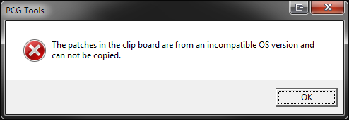

Figure 71: Incompatible OS version

However, you can easily work around this, as long as the workstation model is equal:

* Load the older version in the M3 or Kronos (make a backup of your current patch file first)
* Save the file again, then the M3 or Kronos will automatically save it in the latest (current) OS version.
* Revert to the just saved fie.
* Now copy/paste is possible between the two files.

#### Cut/Copy/Paste Settings Command

##### Showing the settings

This commands manages the cut/paste and copy/paste settings.

The following ways can be used to select this command:

* Select the Settings menu item in the Options menu.
* Select the Settings tool bar icon in the toolbar (page with a saw disk)
* Click the Cut/Copy/Paste Settings button.
* Press Alt-s until the Cut/Copy/Paste Settings button is highlighted and press Enter.

Cut/Copy/Paste settings are global for all patch files, so it does not matter from which patch file it is shown or changed.

##### Settings

The figure below shows all copy/paste settings including its default settings.

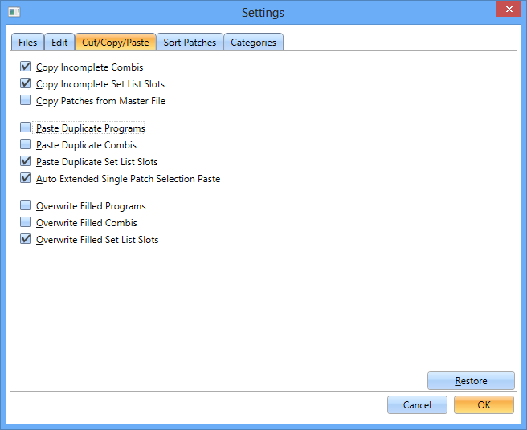

Figure 72: Cut/Copy/Paste Settings

Figure 72 shows all default cut/copy/paste settings and Table 21 shows the description of each setting.

| **Item** | **Default** | **Description** |
| --- | --- | --- |
| Copy Incomplete Combis | Off | When selected, only combis which have ALL programs present in the patch file will be copied (together with their used programs). This cannot result in broken combis.  If not selected, all combis (together with their used programs) will be selected. This means combis will be copied that are incomplete and can result in broken combis.  This option is ignored when using cut/paste operations. |
| Copy Incomplete Set List Slots | Off | When selected, only set list slots which have ALL combis and ALL programs present in the patch file will be copied (together with their used combis and programs and programs used in the used combis). This cannot result in broken set list slots.  If not selected, all set list slots (together with their used programs, combis and used programs in used combis) will be selected. This can result in broken set list slots.  This option is ignored when using cut/paste operations. |
| Paste Duplicate Programs | Off | If selected, programs can be pasted even if there are already duplicates in the patch file, otherwise the duplicate programs will be automatically removed from the clip board after the first paste action to a patch file.  This option is ignored when using cut/paste operations. |
| Paste Duplicate Combis | Off | If selected, combis can be pasted even if there are already duplicates in the patch file, otherwise the duplicate combis will be automatically removed from the clip board after the first paste action to a patch file.  This option is ignored when using cut/paste operations. |
| Paste Duplicate Set List Slots | On | If selected, set list slots can be pasted even if there are already duplicates in the patch file, otherwise the duplicate set list slots will be automatically removed from the clip board after the first paste action to a patch file.  This option is ignored when using cut/paste operations. |
| Auto Extended Single Patch Selection Paste | On | If selected, a single patch can be selected for pasting multiple patches from the clipboard. All legal patches are used to fill up the remainder of the bank starting from the selected patch (taking into account the other settings, such as not overwriting filled patches). |
| Overwrite Filled Programs | Off | If selected, already filled programs can be overwritten by pasted programs. |
| Overwrite Filled Combis | Off | If selected, already filled combis can be overwritten by pasted combis. |
| Overwrite Filled Set List Slots | Off | If selected, already filled set list slots can be overwritten by pasted set list slots. |

Table 21: Copy/Paste Settings

Note that when incomplete combis and set list slots is selected, and these are pasted to another patch file, it may result in broken combis and set list slots (depending on what is currently loaded in the workstation before loading the patch file).

When the setting Paste Duplicate Programs, Combis or Set List Slots is deselected, and patches are pasted to the same or another patch file, if those patches already exist in the patch file to be pasted to, these programs, combis and set list slots will be automatically removed from the clipboard without being pasted.

When pasting in the same patch file and combis have been copied, the used programs will automatically be removed because it simplifies copy/pasting patches.

Also, when set list slots are pasted in the same patch file, the programs and combis (including used programs) are automatically removed because it simplifies copying set list slots.

The reason duplicate Set list slots are allowed to be pasted by default, is that set list slots are used multiple times with the same references and parameters (volume, description etc).

Duplicate patches are considered patches that are 100% equal, but the name is ignored for the equality check.

**[WARNING]:** When one or more of the settings for overwriting patches is selected, it is possible to paste multiple times over the same patch, resulting in overwriting earlier pasted patches and in broken combis and/or set list slots.

Take a look at the settings BEFORE starting a copy/paste action, because after the first paste, some options are not allowed to be changed once a copy/paste action is active (i.e. one or more patches have been pasted in a patch file and the clipboard is not empty thus the current copy/paste action is unfinished). These are:

* Paste Duplicate Programs
* Paste Duplicate Combis
* Paste Duplicate Set List Slots

The (Cut)/Copy/Paste settings are retained and do not have to be set again after each restart of the application and are saved immediately after pressing the OK button (which also closes the settings dialog).

##### Restore Button

The restore button can be used to restore the settings of the (Cut)/Copy/Paste settings back to the default, shown in Table 21.

The following ways can be used to select this command:

* Click the Restore button.
* Press Alt-r until the Restore button is highlighted and press Enter.

#### Cut/Copy/Paste Exit Command

This command ends the active copy/paste operation and clears the clip board.

The following ways can be used to select this command:

* Select the Cut/Copy/Paste Exit menu item in the Edit menu.
* Select the Cut/Copy/Paste Exit tool bar icon in the toolbar (page with a cross in the top left corner).
* Press Alt-e until the Exit button is highlighted and press Enter.
* Click the Exit button.

This command should be used when you accidentally pasted something (in the wrong file or wrong location) and wants to end the active copy/paste operation. Note that an undo is not possible, so the (unintended) pasted patches can/should be removed manually if needed.

Because this command should be used with care the dialog shown in Figure 73 warns you about the consequences.

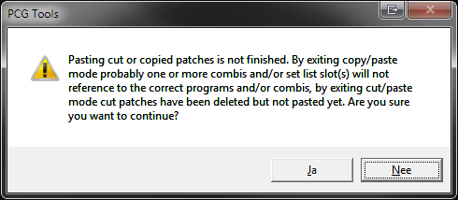

Figure 73: Copy/Paste Exit Warning Dialog

**[WARNING]:** This command should be performed with care, because when exiting copy/paste mode, not all patches are already pasted and combis and set list slots may contain references to unpasted patches, resulting in broken combis and set list slots. When exiting cut/paste mode, patches have been cleared but not yet pasted again.

#### Cut/Copy/Paste Recall Command

This command can be used to recall the original copied patches again to repaste them again.

The following ways can be used to select this command:

* Select the Recall menu item in the Edit menu.
* Select the Cut/Copy/Paste Recall tool bar icon in the toolbar (page with a blue R in the top left corner).
* Press Alt-r until the Recall button is highlighted and press Enter.
* Click the Recall button.

This command can be used after a cut/paste or copy/paste action to perform the paste operation again without selecting the originally copied patches again. It automatically selects the used programs for copied combis and used programs/combis and programs in used combis for copied set list slots.

**[TIP]:** Suppose you have a program you like to copy 20 times. Follow the instructions to perform this:

* Copy the program.
* Paste it to the requested location (inside the same patch file or another). Then the clipboard will be empty again.
* Press the Recall button. The copied patch will be in the clip board again for another paste action.
* Paste it again.
* (Optionally: then select both programs and copy them so you have two (equal) programs copied in the clip board)
* Press Recall again and continue pasting and you have 20 equal programs (using a new copy/paste to select even more programs at the same time).

#### Cut/Copy/Paste Examples

##### Introduction

Since cut/paste and copy/paste operations are not trivial as can be read in the previous paragraphs, the following paragraphs are dedicated for examples and usages of the Copy/Paste possibilities within PCG Tools.

The following examples are handled:

* Copying programs inside a patch file.
* Copying programs from one patch file to another patch file.
* Copying combis inside a patch file.
* Creating a patch file with default set list slots **[KRONOS ONLY]**.
* Using cut and paste (inside a patch file).
* Having fun with Copy and Paste.

Note that depending on the cut/copy/paste settings (see Paragraph 7.3.7.6.1), a lot more options and use cases are available, but I leave these to try yourself. Some settings will be handled though.

##### Example: Copying programs inside a patch file

This example shows how to copy multiple programs inside the same patch file.

Perform the following steps:

1. Select the Copy/Paste settings.
2. Open a patch file.
3. Check Paste Duplicate Programs and press OK.
4. Select a few programs from a program bank.
5. Copy these to the clipboard. The clipboard will show the copied programs.
6. Go to another part of the program bank or another bank (of the correct type if applicable) and find some empty spaces, select the first of them.
7. Select the Paste command. Combis and set list slots will **NOT** reference to the newly pasted programs, so you only copy the programs without changing combis/set list slots.
8. The programs will be pasted and the clipboard will be empty.

The result of copy/pasting programs U-G014 until U-G16 to the programs starting at U-G019 can be seen in Figure 74.

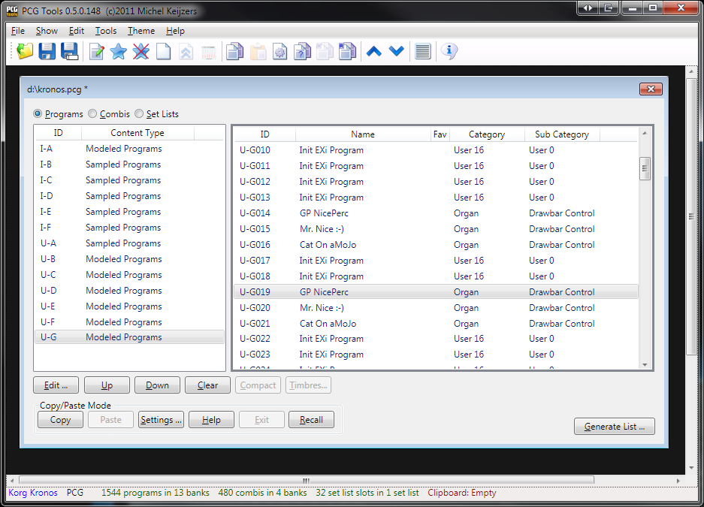

Figure 74: Copy Programs inside a patch file

##### Example: Copying programs from one patch file to another patch file

This example shows how to copy multiple programs from one patch file to another patch file.

Perform the following steps:

1. Open two patch files (e.g. a source patch file called Kronos.pcg and a destination patch file called KronosNew.pcg) from the same workstation model.
2. Select a few programs from a program bank from the source patch file.
3. Copy these to the clipboard. The clipboard will show the copied programs.
4. Go to the destination patch file and find some empty spaces, select the first of them.
5. Select the Paste command. Combis and set list slots will NOT reference to the newly pasted programs.
6. If you get a big warning dialog, then probably the programs you tried to paste are already existing in the destination patch file and by default pasting duplicating programs is disabled. Change the copy/paste and continue with step 2.  
   If successful, the programs will be pasted to the destination patch file and the clipboard will be empty.

The result can be seen in Figure 75.

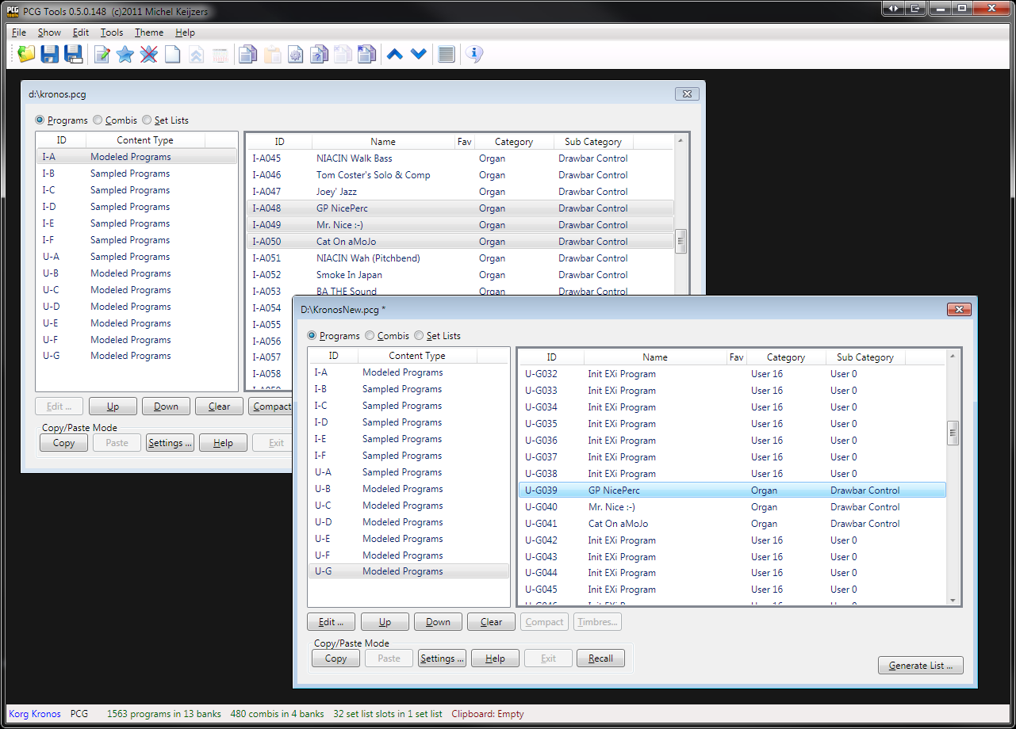

Figure 75: Copy Programs from one Patch file to another Patch file

##### Example: Copying combis inside a patch file

This example shows how to copy combis inside a patch file.

Perform the following steps:

1. Select the Copy/Paste settings.
2. Open a patch file.
3. Check Paste Duplicate Combis and press OK.
4. Select approximately five combis from a combi bank.
5. Copy these to the clipboard. The clipboard will show the copied banks and also the programs (possibly split in sampled programs and modeled programs).

From here you can first copy the programs, and then the combis or vice versa. However, when the default Copy/Paste settings (except for the changed Paste Duplicate Combi setting changed above) are used, programs will not be pasted, but let us try to do anyway:

1. Go to a program bank and find some empty spaces, select the first of them.
2. Select the Paste command. You probably get a warning box that no patches have been copied. This is normal, because the copy/paste setting for pasting duplicated programs is switched off. Since all used programs are already present in the patch file they are not pasted. Also note that all programs (not only from the type of programs which can be stored in the program bank) are removed from the clipboard.

Now we have seen the programs cannot be pasted. (You can paste them if you want to, but to do that, the copy/paste setting for pasting duplicate programs should be checked).

Now we paste the combis:

1. Go to a combi bank and find some empty spaces, select the first of them.
2. Select the Paste command. The pasted combis show up and the clipboard is empty.

As usual, when pasting programs and combis (in which order does not matter), all references of combis to programs and set list slots to programs and combis will be fixed so that combis and set list refer to the correct programs and combis.

##### Example: Creating a PCG with default set list slots [KRONOS ONLY]

This example shows how to create a PCG file that only contains the programs, combis and used programs from combis used in the default set list slot.

Perform the following steps:

1. Open a PCG file (in this example assumed to have name Kronos.pcg).
2. Save this PCG file as SetListOnly.pcg.
3. Clear all program banks by selecting Programs, select all banks on the left side and press the Clear button.
4. Do the same with all combi banks.
5. And also with all set lists.
6. Open the original PCG file again (Kronos.pcg)
7. Select from SetListSlotOnly.pcg the first set list (on the left side).
8. Press Copy. You see that 57 sampled programs, 128 modeled programs, 9 combis and 127 set list slots are copied.
9. Select a combi bank and press Paste. Note see that all combis are pasted in this bank.
10. Select a modeled program bank and press Paste. Note that all modeled programs are pasted in this bank. If there is not enough space, some modeled programs would stay in the clip board.
11. Select a sampled program bank and press Paste. Note that all sampled programs are pasted in this bank.
12. Now paste all set list slots.
13. Now everything is pasted, the copy/paste mode is inactive again (note that the Exit button is disabled).
14. Save the PCG file.

**[TIP]:** You can use these steps to create a small PCG file which only contains programs/combis of the set lists you use. When you want to remove the unused banks, load it in the Kronos and save the PCG file again with only the (partially) filled banks.

##### Using cut and paste (inside a patch file)

This example shows how to use cut and paste. Both some programs, combis and set list slots will be pasted.

Perform the following steps:

1. Open a patch file.
2. Select three programs and press Cut. Notice that the Clipboard contains the cut programs and the selected programs are cleared.
3. Now find an empty bank of the same type (sampled or modeled) and select one program. Press Paste and notice all programs are pasted, clearing the Clipboard.
4. Now try steps 2 and 3 again but cut as above 3 programs, but select two programs to paste to. Notice that two programs are pasted and one stays in the Clipboard. This last programs should also be pasted (can be in a different location).
5. Try steps 2 and 3 again but select a complete program bank. You can paste to a program bank but also can select ranges (consecutive or not) of programs.
6. Try steps 2 and 3 again with a few combis. Notice that unlike copy/paste operations, the used programs are not cut or copied to the Clipboard.
7. Try steps 2 and 3 again with some set list slots. Notice that unlike copy/paste operations, the used programs and combis (and programs used in those combis) are not cut or copied to the Clipboard.

##### Example: Having fun with Copy and Paste

This example shows an advanced example what you can do with copy and paste.

Perform the following steps:

1. Open two patch files (in this example assumed to be named From.pcg and To.pcg).
2. Open the Copy/Paste settings and activate all Paste Duplicate check boxes and press OK. This makes is possible to copy all patches even though they may already exist in To.pcg.
3. In From.pcg, select three combi banks which are completely or reasonable filled.
4. Copy them to the clipboard, resulting in (probably) a number of combis, and a number of samples and/or modeled programs in the clipboard.
5. In my case I the clipboard consists of 525 Sampled programs, 277 Modeled programs and 512 (4 banks) Combis. The 525 + 277 programs are the programs used by the combis.
6. Go to To.pcg and select an empty combi bank. Press Paste and note that 128 combis are removed from the clipboard. The empty combi bank is filled with 128 programs of the correct type that can be pasted (either sampled or modeled programs).
7. Go to another combi bank and now select a range of (empty) combis with gaps, e.g. I-G000 to I-G010 and I-G012 to I-G014 (use the shift and control keys to select/deselect patches).
8. Press Paste and watch the selected combis being filled with patches from the clipboard. No programs are pasted yet.
9. Let us now start to paste some programs.
10. Select 2 empty or partially empty program banks (in my case one modeled and sampled program banks). Press Paste and see that filled programs are not being overwritten (this is a Copy/Paste setting) and that all empty programs in the program banks are filled with the correct type of programs (i.e. sampled programs in Sampled Program banks and modeled programs in Modeled Program banks). In my case I have 397 Sampled programs, 165 Modeled programs and 371 Combis left to be pasted.
11. I leave the rest of the pasting up to you. If you are tired or pasting everything, you can try Exit, but remember that only pasted patches are being connected (meaning combis that refer to programs that have not been pasted yet, will be broken).

## Master Files

### Introduction

The reason for introducing Master Files is that patch files do not have to contain all programs, combis, set list slots and a global section. In theory, it could even be empty.

Because inside a patch files there are a lot of references (e.g. combis using programs, and set list slots using combis and programs, and patches having a category and sub category) this can result in problems.

Normally you will have a default file (mostly factory default or preload patch file) and save a patch file that contains either everything or only the part you changed (e.g. some program banks).

Because maybe not everything uses the factory default patch file by default, it can be selected. This file is called the Master File.

There can be a Master File set for each kind of workstation model and each version if applicable. E.g.

### Usage

It is used in the following circumstances:

* When a program or combi that is referenced (by a combi or set list slot) is not present in the file itself, automatically the program or combi from the Master File is used.
* If a patch file contains no global section (containing categories and sub categories), automatically the categories and sub categories of the Master File are used.

### Conditions of a Master File

The following conditions must be met for a patch file to be selected as Master File:

* All program banks have to be present
* All combi banks have to be present
* The Global section has to be present.

The reason is that if one of these items are not present, then there still are programs, combis, categories and sub categories possible that cannot be traced.

**[WARNING]:** For some workstation models a program bank exist for a hardware extension (like a MOSS board for the Korg Triton Extreme). If the patch file does not contain the F bank (containing MOSS programs), it cannot be used as a Master File.

### Master Files Menu

The Tools menu has two sub menu items, one for showing the Master Files and one for setting the current patch file as Master File. See Figure 76 for a screen shot.

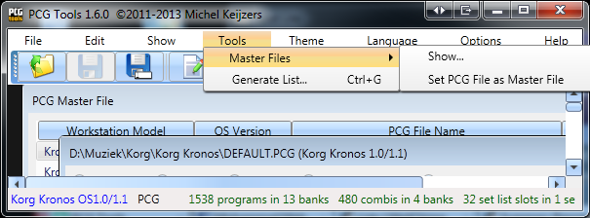

Figure 76: Master Files menu

### Show Master Files Command

The command can be activated by:

* Select the Show… menu item in the Master Files sub menu of the Tools menu.

It shows per workstation (and per OS version if applicable) the current file (path) of the Master patch file. Also it shows the File state which can be:

* Empty (unassigned): there is no patch file assigned as Master File for this workstation (and OS version).
* Not Present: there is a patch file assigned as Master File but it cannot be read (probably because it is not existing at that location).
* Unloaded: there is a patch file assigned as Master File but it is not currently open.
* Loaded: there is a patch file assigned as Master File which is currently open.

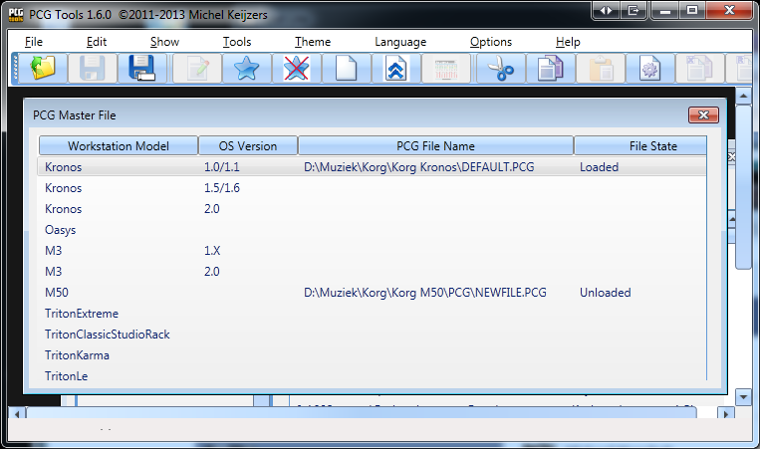

Figure 77: Show Master Files

### Set patch File as Master File

The command can be activated by:

* Select the Set patch File as Master File menu item in the Master Files sub menu of the Tools menu.

It will only be enabled when a patch file is currently selected and the conditions of a Master File are met for the selected patch file.

### Auto Load Master Files

The command can be activated by:

* Select the Files tab of the Settings menu item in the Options menu.

If a patch file is loaded, depending on the setting the Master file is loaded or not (see Figure 78 for a screen shot):

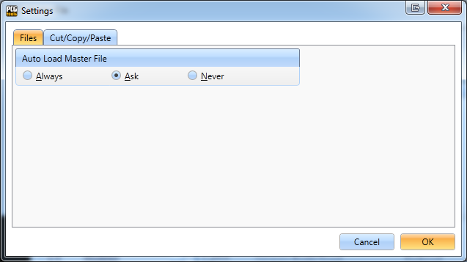

Figure 78: Auto Load Master Files

The options are:

* Always: When a patch file is loaded, automatically load the Master File of the same workstation model (and OS version if applicable), if not already loaded.
* Ask: When a patch file is loaded, ask to load the Master File of the same workstation model (and OS version if applicable), if not already loaded. See Figure 79 for a screenshot. If Yes (Ja in Dutch) is selected, the Master File will be opened, otherwise it will not be opened.
* Never: Never load the Master File of the selected patch file.

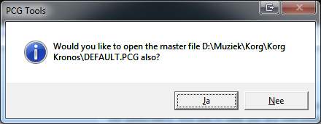

Figure 79: Ask to load Master File

## Combi Window

### Content

The Combi(nation) Window shows information about the timbres inside the selected combi and the most important parameters.

Activation prerequisite: select exactly one combi.

The command can be activated by:

* Select the Timbres menu item in the Show menu.
* Click the Timbres… button.
* Press Alt-t until the Timbres… button is highlighted and press Enter.

The Combi Window shows details about the selected combi as can be seen in Figure 80.

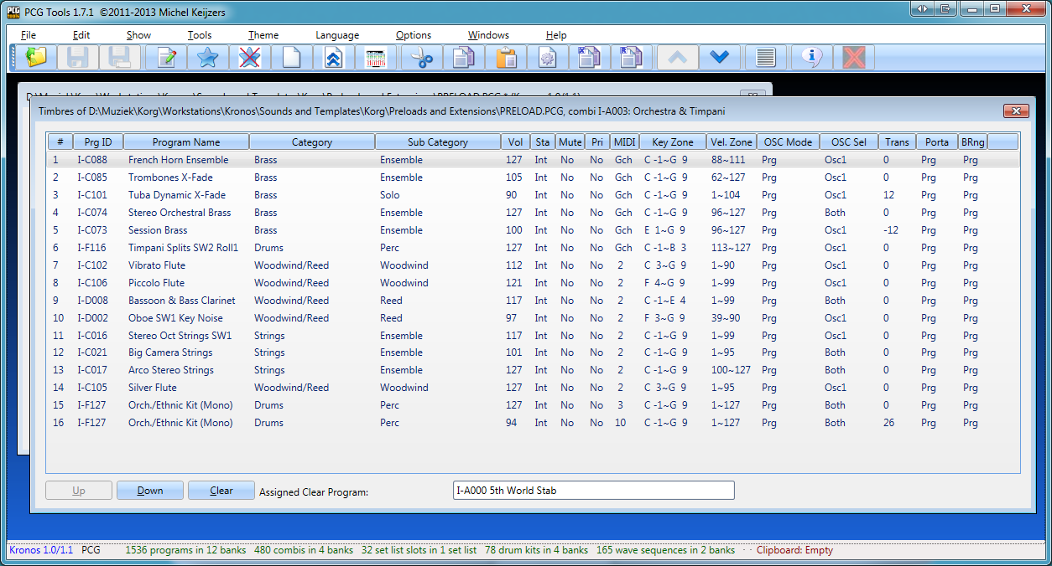

Figure 80: Combi Window

The combi window shows the following information for each timbre (8 or 16 depending on the workstation model):

* # : The number of the timbre, ranging from 1 to 16.
* Prg ID : The program ID of the program where the timbre is referencing to[2].
* Program Name : Name of that program[3].
* Category : Category of that program2.
* Sub Category : Sub category of that program[4],2.
* Vol : Volume of that program.
* Sta : Status of that program.
* Mute : Mute on/off of that program (depends on work station model)
* Pri : Priority of that program (depends on workstation model).
* MIDI : MIDI Channel of the timbre.
* Key Zone : Key zone where that program is assigned to, both lower and upper key.
* Vel. Zone : Velocity zone where that program is active, both lower and upper velocity.
* OSC Mode : Oscillator mode of that program.
* OSC Sel : Oscillator select of that program.
* Trans : Transpose of that program.
* Porta : Portamento (time or according program) of that program.
* BRng : (Pitch) Bend Range of that program.

The Assigned Clear Program is used for clearing timbres and will be discussed in paragraph 7.5.2.3.

### Commands

#### Move Up Command

Activation prerequisite: select one or more timbres in the patches list, without selecting the first patch.

The command can be activated by:

* Select the Move Up menu item in the Edit menu.
* Click the Up button.
* Press the up cursor key on the numeric keyboard (on the 8 key).
* Press Alt-u until the Up button is highlighted and press Enter.

This command moves all selected timbres one position up. The selected timbres do not have to be contiguous.

When this command is used, the changed file attribute (the asterisk in the title of the window) will not be shown in the Combi window, but in its parent patch file window.

#### Move Down Command

Activation prerequisite: select one or more timbres in the timbres list, without selecting the last patch.

The command can be activated by:

* Select the Move Down menu item in the Edit menu.
* Click the Down button.
* Press the Down cursor key on the numeric keyboard (on the 2 key).
* Press Alt-d until the Down button is highlighted and press Enter.

This command moves all selected patches one position up. The selected patches do not have to be contiguous.

When this command is used, the changed file attribute (the asterisk in the title of the window) will not be shown in the Combi window, but in its parent patch file window.

#### Clear Command

Activation prerequisite: select one or more timbres.

The command can be activated by:

* Select the Clear menu item in the Edit menu.
* Click the Clear button.
* Press Alt-c until the Clear button is highlighted and press Enter.

This command clears the selected timbre(s). Clearing a timbre means:

* Program set to the Assigned Clear Program shown in the bottom of the screen.
* Status set to Off.
* Muted.
* Volume set to 0.
* MIDI Channel set to 16.
* Bottom/Top key set to the lowest key.
* Bottom/Top velocity set to 0.
* Osc Mode set to Mono.
* Osc Select set to OSC2.
* Transpose set to 0.
* Portamento set to 0.
* Bend Range set to 0.

When this command is used, the changed file attribute (the asterisk in the title of the window) will not be shown in the Combi window, but in its parent patch file window.

The reason that some values may seem strange (e.g. like setting the bottom/top velocity both to 0), is on purpose. This way, it is immediately visible on the workstation that this timbre is not used. When copy a timbre from another combi on a workstation, automatically all parameters will be overwritten anyway. For the Kronos however there is even a better solution; see the next paragraph.

#### Assigned Clear Program

A combi can contain up to 8 or 16 timbres, depending on the workstation model. However, in most cases not all of these are used. It is very hard to see which timbres are used and which not, except on the page that shows the State (INT/EXT/EX2) or Mute (On/Off). Therefore, when clearing timbres some values on other pages will have non default values to see more easily that timbres are not used.

For the program being used for a cleared program, the Assigned Clear Program is used which is shown in the bottom part of the Combi Window. This program can be changed in the following way:

* Go to the PCG Window
* Select a single program.
* From the Settings menu, select the 'Assign Clear Program' menu option.

Every opened Combi Window will then display that Assigned Clear Program and use it. When assigned, the following message is shown.

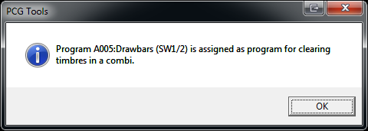

Figure 81: Assign Clear Program

The program has to be set once per PCG Window that is opened. The reason is that every patch file can have different programs so it is not possible (easily) to store this value. Once set, it will be used for all Combi Windows opened within that patch file.

**TIP:** For the Kronos (X) this function is even more useful. When using a program that uses a sample that is not loaded, a red bar in the top of each screen of that Combi will show up. So you can see immediately in all Combi screens that that particular timbre is not used. Therefore, it is advised to create a program with an unloaded sample in it and use that program as the Assigned Clear Program.

## List Generator (Generate List)

With this command you can make different kind of lists based on the information in the PCG.

The command can be activated by:

* Select the Generate List menu item in the Tools menu.
* Press Ctrl-G key.
* Select the Generate List tool bar icon in the toolbar (the page with the grey thick lines on it).
* Click the Generate List… button.
* Press Alt-g

A new dialog is shown with a lot of options. See Figure 82 for a screenshot.

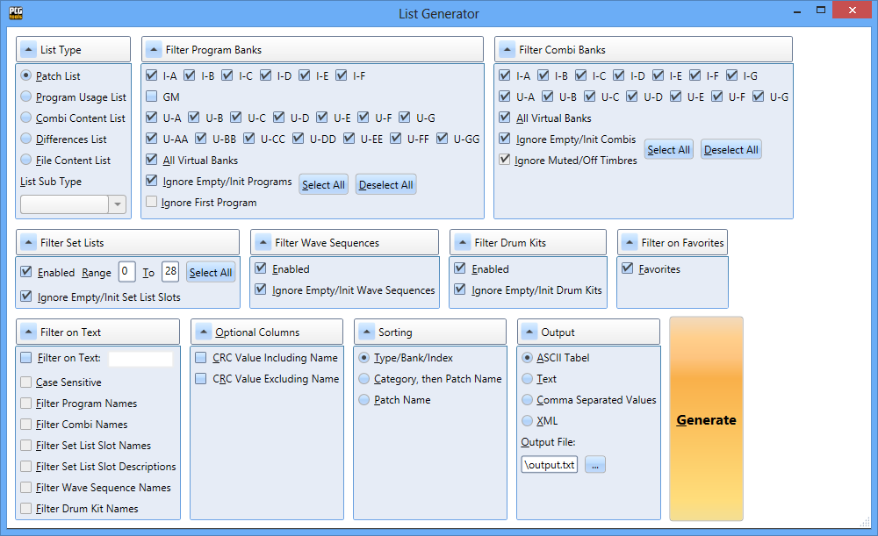

Figure 82: List Generator

The most important is the List Type group box, where you can select what kind of list type you want to generate (and if applicable list sub type). With other settings you can change filtering, sorting and selecting the output.

After selecting all options, press the Generate button to show the output.

### List Types

The types of lists that can be generated is shown in Table 22.

|  |  |
| --- | --- |
| **List Type** | **Description** |
| Patch List | Generates a list that contain programs, combis and set list slots. |
| Program Usage List | Generates a list that per program shows in which combis it is used.  It also shows per program and combi in which set list slots those are used. |
| Combi Content List | Generates a list of timbres per combi. |
| Differences List | Generates a list of patches that are (more or less) duplicates. |
| File Content List | Generates a summary of the content of the file. |

Table 22: List Types

All options will be explained in Paragraph 7.6.2).

In the following paragraphs each list type is explained in detail.

For each list type some output formats are shown except for CSV files (since these require some post processing, see Paragraph 7.6.2.10.1).

#### Patch List

The patch list shows a list of all (filtered) programs, combis and set list slots.

The table below shows all columns being generated.

|  |  |  |
| --- | --- | --- |
| **Column name** | **Description** | **Conditions** |
| Patch Name | Name of the program, combi, or set list slot | - |
| Patch Type | Program, Combi or Set List Slot | - |
| Patch ID | ID of the patch, e.g. I-B036 for programs or combis or 001/017 for set list slots. | - |
| Fav | Shows a mark if the patch is set as favorite. | Only displayed if supported by the workstation/synthesizer. |
| Category | Name or number of the program or combi | Only displayed for programs or combis. |
| Sub Category | Sub category name or number of the program or combi | Only displayed for programs or combis and if supported by the workstation model. |
| Set List | Name of the set list. | Only displayed for set list slots. |
| Set List Slot Description | Description of the set list slot. | Only displayed for set list slots. |

Below are some examples of fragments of generated Patch Lists.

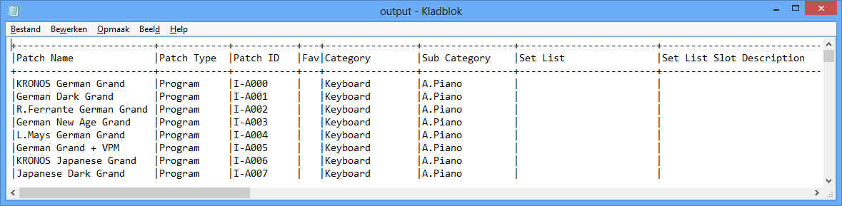

Figure 83: Patch List in ASCII Table, sorted by name

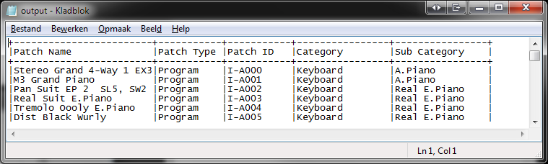

Figure 84: Patch List of programs only, in ASCII Table output, sorted by bank/index.

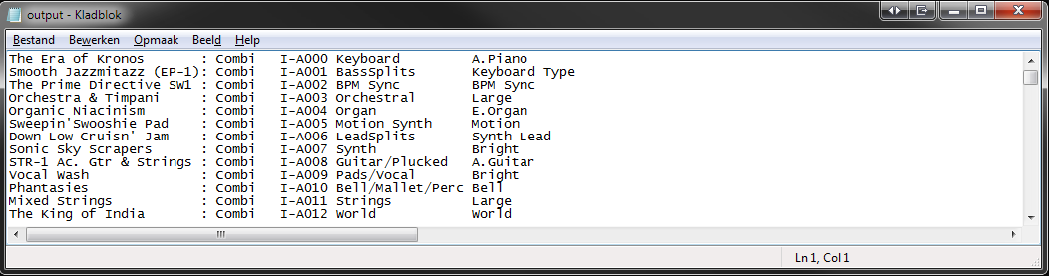

Figure 85: Patch List with Combis, Text Output

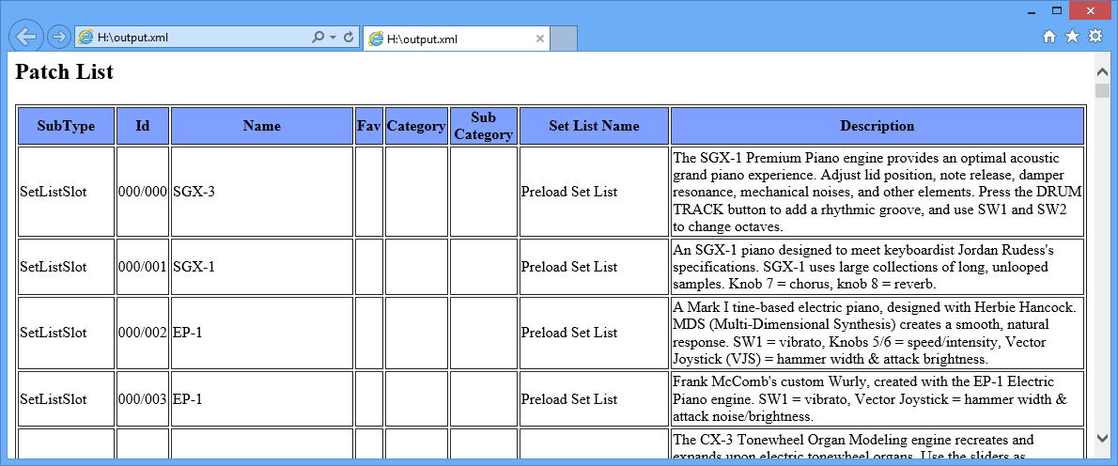

Figure 86: Patch List with Set List Slots, XML Output (shown in browser)

#### Program Usage List

The Program Usage List shows a list that contains for each program, all combis and set list slots where that program is used in.

The Filter Program Banks options can be used to only check those programs.

For all programs (selected in the Filter Program Banks), the settings in the Combi Banks and Filter Set Lists groups are used for each program.

**[EXAMPLE]**: If only the I-A and I-B banks in Filter Program Banks are selected and U-C and U-D combi banks and set list 1 to 5, then a list will be generated that checks for all programs in banks I-A and I-B if they are used in combi banks U-C and U-D and/or set lists 1 to 5.

The following figures show some examples of fragments of the output.

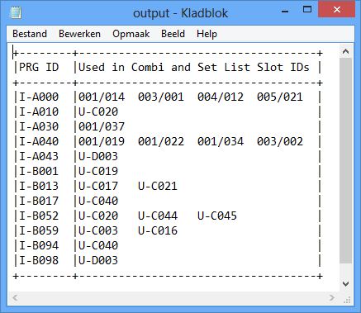

Figure 87: Programs Usage List, ASCII Table Output

This means: Program I-A000 is used in set list slots 001/014 (set list 1, slot 14), set list slot 003/001 etc. Program I-A010 is only used in combi U-C020 etc.

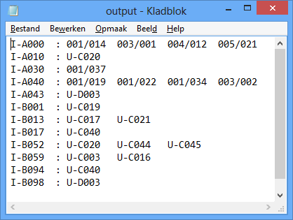

Figure 88: Programs Usage List, Text Output

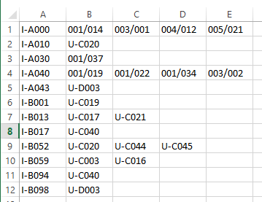

Figure 89: Programs Usage List, CSV output (after splitting to columns in Excel)

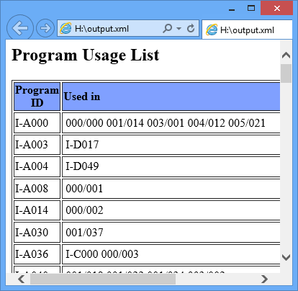

Figure 90: Programs Usage List, XML Output

#### Combi Content List

The Combi Content list shows a list of all (filtered) combis with some generic info about those timbres and information about the timbres. This list type has three list sub types, which configures the amount of detail to be shown.

##### Compact Combi Content List

This list shows the programs used by each timbre after removing duplicates and ordered by bank/index.

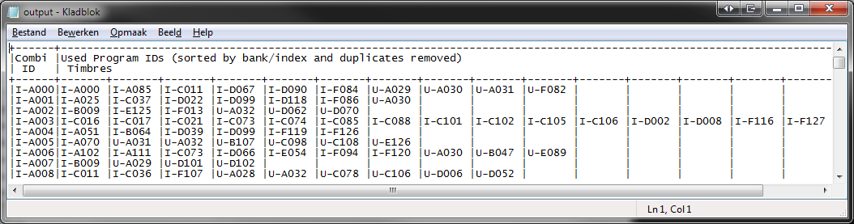

Figure 91: Combi Content List, Compact form, ASCII Table Output

##### Short Combi Content List

This list shows the programs used by each timbre in the correct timbre index.

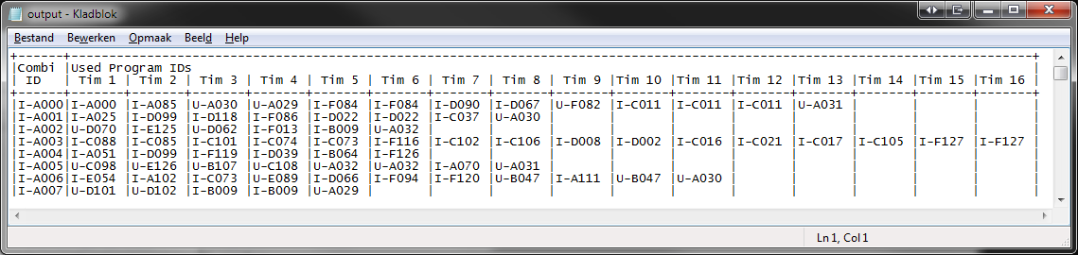

Figure 92: Combi Content List, Short Form, ASCII Table Output

##### Long Combi Content List

This list shows more detailed info about each (filtered) combi and its used programs.

Depending on the number of combis selected, the output can be very long (max. 26 lines per combi, on a Korg Kronos this would result for all combis a text file of almost 30,000 lines, the default is 10,000 lines). However, even if the output can be a long file, the generation is finished almost instantly.

Because the output is not a table and text output would not look nice, only ASCII Table output is selectable for this list sub type.

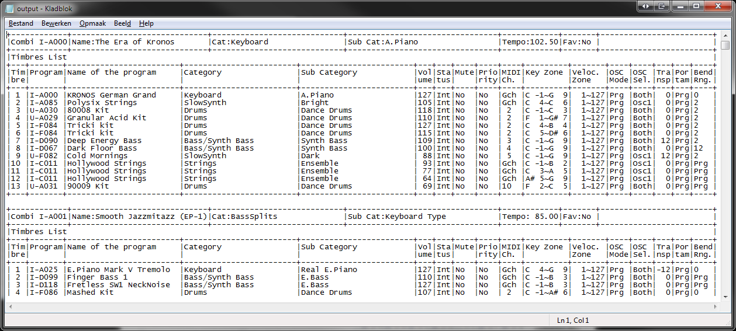

Figure 93: Combi Content List, Long Form, ASCII Table Output

#### Differences List

This list differs each (filtered) patch to all other patches (of the same type) and list them if they are (more or less) equal. See for an example of a text output file, the screenshot at Figure 94.

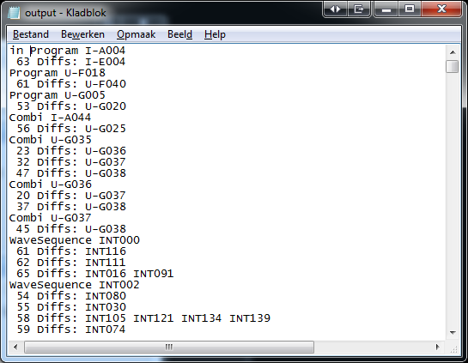

Figure 94: Differences List

For this type of list, some extra options are available in the Differences List Options which are only enabled if the Differences list is selected and these options are shown below.

|  |  |
| --- | --- |
| **Item Name** | **Description** |
| Max Number of Differences (in bytes) | Defines how many bytes a patch may differ at maximum. A rough thumb rule is that one parameter equals one byte. |
| Ignore Patch Names | Since a patch name is irrelevant for the sound/settings of the patch, when unchecked, the patch name will not be taken into account for calculating the number of differences between two patches. |
| Ignore Set List Descriptions | Since a set list slot description is irrelevant for the sound/settings of a set list slot, when unchecked, the set list description will not be taken into account for calculating the number of differences between two set list slots. |
| Search Both Directions | Normally, each patch only checks patches further into the banks/indices, which this option you can switch this search algorithm off.  E.g. When unchecked, program I-C040 is checked against programs I-C041 to I-C127 and all patches in further banks (assuming the Filter Program Banks has all bans selected). |

Table 23: Differences List Options

To generate such a list can take a lot of time, especially for the Kronos (which has a lot of program banks), if all program banks are selected (default setting). With the default settings, creating a difference list for a complete Kronos patch file takes (on my computer) about 25 seconds. If you change the max. number of difference to 500 (bytes), it takes 2 minutes, 20 seconds.

For an Oasys default patch file generating this list costs about 20 seconds and for other workstations (considerably) less.

**[WARNING]:** For patch files created with a Kronos with OS1.5, certain parameters (such as program/combi references are not always taken into account). This can result in a few too less differences being counted.

Table 24 shows the properties/settings affecting the speed of generating this list.

|  |  |
| --- | --- |
| **Item Name** | **Description** |
| Max Number of Differences (in bytes) | The more differences are allowed, the longer it takes to check two patches against each other (if more than the maximum number of specified changes have been found, the check is stopped, and the next set of two patches can be checked). |
| Search Both Directions | Note that searching in both direction can take twice as long, because all previous patches have to be calculated for the number of differences too. |
| All filter settings | Since the filter settings which patches to be checked, it immediately affects the number of pairs to be checked. Especially the amount of program banks selected (either by Filter on Text, Filter Program Banks and Filter on Favorites) matters. |
| Speed of the (available) computer CPU/Cores | The processing speed of your computer also affect the speed of generating this list. |

Table 24: Properties/Settings affecting generation speed of Differences List

**[BACKGROUND]:** Suppose all program banks are selected (20 on a Kronos, GM banks are ignored). Then 20 * 128 = 2560 patches have to be checked against each other, resulting in 6.5M pairs of programs to be checked (if Search Both Directions would be enabled, otherwise it can be halved). Let us assume almost all programs are quite similar and all programs are EXI (modeled) programs using 4960 bytes. This means 6,5M x 4960 bytes = 3.25x1010 byte difference checks.

For non Kronos patch files it probably takes not that long, but since the computer CPU also is relevant, always the following warning is displayed:

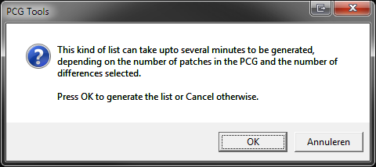

Figure 95: Dialog before generating a Differences List

#### File Content List

This list shows a summary of all banks of the loaded patch file. See Figure 96 for an example

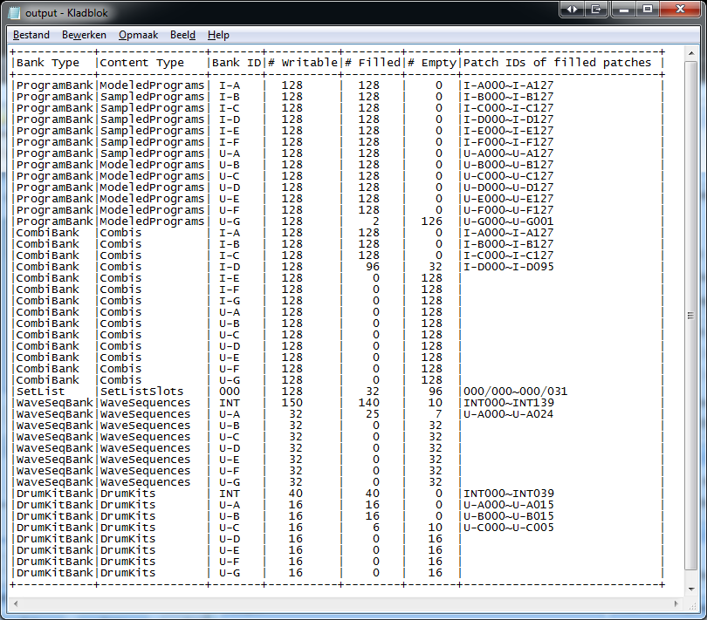

Figure 96: File Content List

For each bank the following information is shown:

* Bank Type, shows if the bank contains programs, combis, set lists, wave sequences or drum kits.
* Content Type: Mostly the type is trivial, but for the Korg Kronos (X) and Oasys, for programs the type of programs is shown (either sampled or modeled).
* Bank ID: The ID of the bank.
* # Writable: The number of writable patches (i.e. total storage).
* # Filled: The number of filled (non-initialized) patches.
* # Empty: The number of unfilled (initialized) patches.
* Patch IDs of filled patches: the range or ranges of the filled patches.

### Settings

Besides the list types mentioned already before, a lot of settings can be made to tweak the list generation, see the screenshot at Figure 97. Note that the settings shown can be depending on the list type selected. Also the settings are wrapped when changing the screen size.

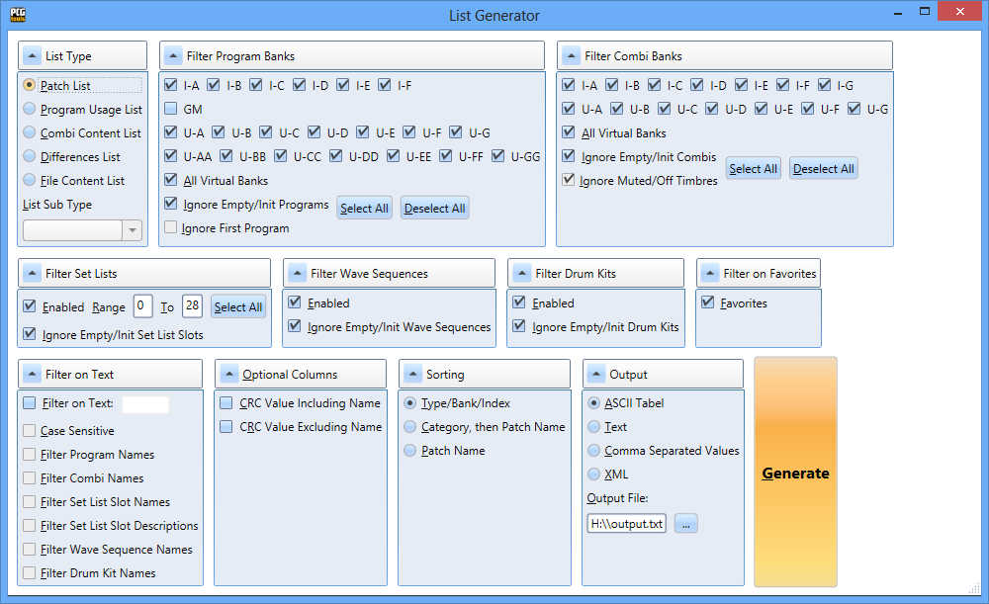

Figure 97: List Generator settings

With the expanders, you can minimize each ‘set’ of settings to save screen for small screen monitors. So the screen can be look like below. Although some of the settings are not shown, they are still taken into account.

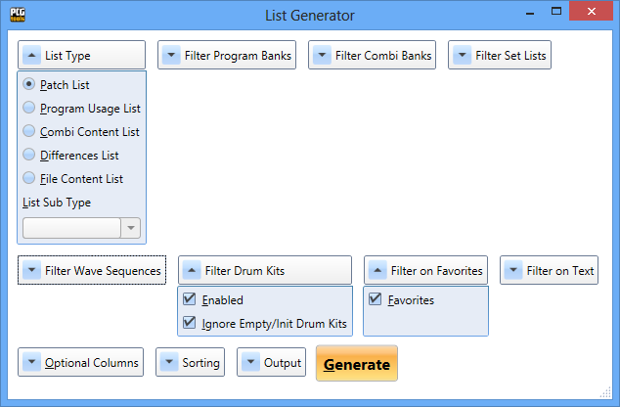

Figure 98: List Generator settings with minimized expanders

Most have to do with filtering (decreasing the number of items in the list), sorting and selecting the output type. The settings are grouped in Table 25.

| **List Generator Settings Group** | **Decription** |
| --- | --- |
| Differences List Options | These options are only used for the Differences List. |
| Filter on Text | Filter different patch names on text.  Also set list slot descriptions can be searched (Kronos (X) only) |
| Sorting | Defined the way the generated list is sorted. |
| Optional Columns | Some columns are optional and can be set here. |
| Output | Defines the type of output file that is generated. |
| Filter Program Banks | Shows or hides certain program banks or certain programs. |
| Filter Combi Banks | Shows or hides certain combi banks or certain combis. |
| Filter Set Lists | Shows or hides certain set lists or certain set list slots. |
| Filter Drum Kits | Shows or hides certain drum kits banks or certain drum kits. |
| Filter Wave Sequences | Shows or hides certain wave sequence banks or certain wave sequences. |
| Filter on Favorites | Shows or hides favorites. This can be either programs or combis (Kronos (X) only). |

Table 25: List Generator Settings Groups

In the following paragraphs all settings will be explained in more detail.

#### Filter On Text

The settings in this box are used for using only patches with a certain (part of the) name. In Table 26 is shown what each setting means.

| **Setting** | **Description** |
| --- | --- |
| Filter On Text | With this option you can switch on/off text searching. If switched on all other controls become enabled. |
| Filter On Text, Text part | Text to be used for filtering. Below can be defined what parameters are used for text filtering. |
| Case Sensitive | If switched on, the text entered has to be exactly be a part of the patch name/description, otherwise the case is irrelevant. |
| Filter Program Names | When switched on, all programs containing a part of the filter text in their name are used. If switched off, program names are not filtered for text. |
| Filter Combi Names | When switched on, all combis containing a part of the filter text in their name are used. If switched off, combi names are not filtered for text. |
| Filter Set List Slot Names | When switched on, all set list slots containing a part of the filter text in their name are used. If switched off, set list slot names are not filtered for text. |
| Filter Set List Slot Descriptions | When switched on, all set list slots containing a part of the filter text in their descriptions are used. If switched off, set list slot descriptions are not filtered for text. |
| Filter Wave Sequence Names | When switched on, all wave sequences containing a part of the filter text in their name are used. If switched off, wave sequence names are not filtered for text. |
| Drum Kit Names | When switched on, all drum kits containing a part of the filter text in their name are used. If switched off, drum kit names are not filtered for text. |

Table 26: Filter On Text Settings

**[Example]:** To find out all patches (programs, combis and set list slots) that have piano in their name, switch on Filter On Text, type as text 'piano', switch off case sensitive, enable all other filtering settings and press Generate. Figure 99 shows a fragment of the output.

Note that if you would have searched the category for keyboards/pianos on your workstation, you would not have found Combi I-A019 since it is in category BassSplits.

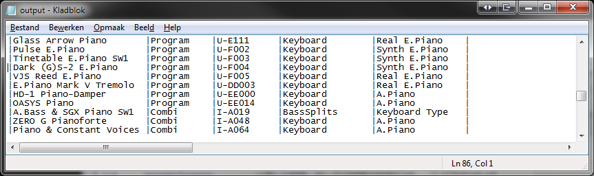

Figure 99: Searching for patches with a certain name in it (1)

**[Example]:** You cannot remember where the patch (program or combi) is located with the name Indigo in it. Just search for it and get something like Figure 100.

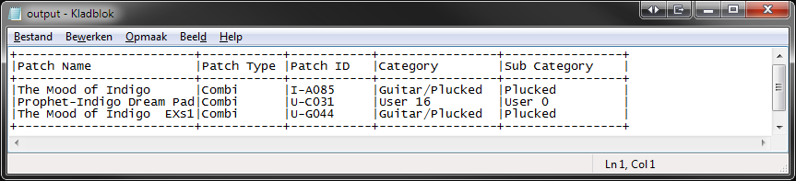

Figure 100: Searching for patches with a certain name in it (2)

**[EXAMPLE]:** When adding a special text to any of the patch names you want to mark in a special way, you can generate a patch list containing this mark. E.g. when marking a program with ^ at the end to show you have edited it or have created it yourself, you can very easily create a patch list with a filter on this character to get a list of all patches you edited/created.

**[TIP]: [NON KRONOS ONLY]:** You can use the example above to emulate favorite programs by using e.g. %F or one or two other symbols. Of course you will not be able to search it directly on your workstation but by creating a list with PCG Tools it is easy to find them.

**[EXAMPLE] [KRONOS ONLY]:** When you put in the description of your set lists keywords you can find them very easily. For example, if you put the text #SET1 in your description for every song that you play in set 1 of your band and #SET2 and #SET3 for your other sets, you can very easily make set lists by generating a patch list containing all set lists containing the word SET (for all 3 sets), SET1, SET2 or SET3. You even can use multiple keywords for the same set list slot, e.g. adding keywords #SET1, #SELFMADE, #PROJECT_X.  
If you use this option, also consider using PCG Tools for editing set list slots, because it can add returns (new lines), so you can put your keywords on new lines in such a way you will not see them directly when iterating through the set list slots.

#### Filter Program Banks

This box contains a lot of settings, but the most important are all program bank check boxes. It only shows program banks that are valid for your workstation (although some Korg Triton Workstation might show too many).

Program banks which are not present in the patch file cannot be selected (these are disabled). Also the GM bank is default switched off (it is not in the patch file).

Some special files which can be downloaded from the website contain virtual banks. With the Áll Virtual Banks’ check boxes, these can be take into account or not.

The buttons Select All and Deselect All can be used for switching all program banks present in the patch file on or off. Note that the GM bank is also switched with this setting so check it manually before using it to generate a list.

Furthermore it has two different options:

* Ignore Empty/Init Programs: Default it is switched on, to make sure empty or init programs will not be used for generating lists. This means that programs with an empty name (after clearing them) or with an initialized name (default name after initializing a program on your workstation) will not show up in the Patch List, or will not be used in the Program Usage List or any other list.
* Ignore First Program: In most cases, unused timbres reference to program I-A000 or A000 even if not used. These unused timbres are mostly muted or have a status set to OFF, but sometimes you might want to show every reference, but there are cases of patch files where this is not true, so this setting can be changed to be flexible.

#### Filter Combi Banks

Filter Combi Banks acts like Filter Program Banks (see previous paragraph), but for combi banks.

This box contains a lot of settings, but the most important are the combi bank check boxes. It only shows combi banks that are valid for your workstation (although some Korg Triton Workstation might show too many).

Combi banks which are not present in the patch file cannot be selected.

Some special files which can be downloaded from the website contain virtual banks. With the Áll Virtual Banks’ check boxes, these can be take into account or not.

The buttons Select All and Deselect All can be used for switching all combi banks present in the patch file on or off.

Furthermore it has two different options:

* Ignore Empty/Init Combis: Default it is switched on, to make sure empty or init combis will not be used for generating lists. This means that combis with an empty name (after clearing them) or with an initialized name (default name after initializing a combi on your workstation) will not show up in the Patch list, or will not be used in the Combi Usage List or any other list.
* Ignore Muted/Off Timbres: This option is only used for the Combi Content List (which shows timbre information) and Programs Usage List (which uses references to programs from combis). Normally you do not want to have muted or programs with status Off being used in lists, however some users switch timbres on while playing (especially live) and then those programs should be used while generating a list.

**[Example]:** To show for all programs in program bank I-C in which of combi I-A to I-G they are used, select Program Usage List, select the program and combi banks mentioned above and generate the list. Figure 101 shows a fragment of the output.

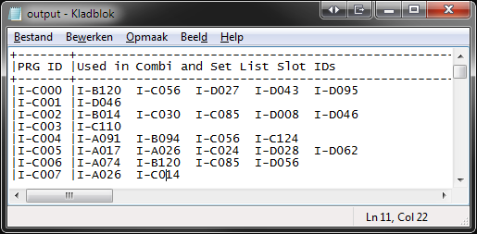

Figure 101: Combis using a Program

**[Example]:** To show for all combis from combi banks I-A to I-G the usage of programs in program bank I-C, select Combi Content List, select the program and combi banks mentioned and generate the list. Figure 102 shows a fragment of the output. You also can use a Long sub type, to get more details from the timbres.

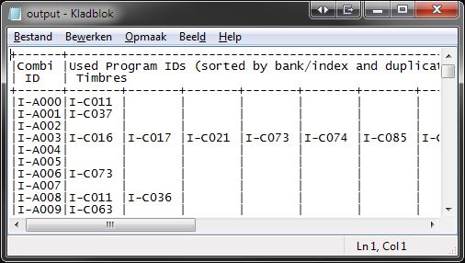

Figure 102: Programs being used by Combis

#### Filter Set List Slots [KRONOS ONLY]

This setting is used to filter for set lists. The Enabled button switches the complete filtering for set lists on or off and the range (both inclusive) specifies which set lists to be taken into account.

The button Select All is used to select all set lists which are filled (partially or complete).

Furthermore it has the following option:

* Ignore Empty/Init Set List Slots: Default it is switched on, to make sure empty or init set list slots will not be used for generating lists. This means that set list slots with an empty name (after clearing them) or with an initialized name (default name after initializing a set list slot on your workstation) will not show up in the Patch list).

**[EXAMPLE]:** To get a list of which programs are used by set list slots of set list 0 (default), select Program Usage List, deselect all combis, set the filter set lists range from 0 to 0 and press Generate. Figure 103 shows a fragment of the output.

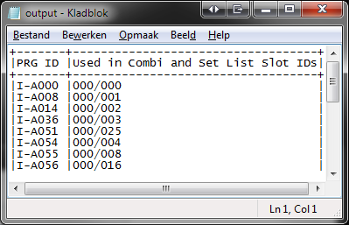

Figure 103: Programs used by a certain Set List Slot

#### Filter Drum Kits

This setting is used to filter for drum kits. Drum kits cannot be selected per bank, but only for all banks or none (Enabled or not).

Furthermore it has the following option:

* Ignore Empty/Init Drum Kits: Default it is switched on, to make sure empty or init drum kits will not be used for generating lists. This means that drum kits with an empty name (after clearing them) or with an initialized name (default name after initializing a drum kit on your workstation) will not show up in the Patch list).

#### Filter Wave Sequences

This setting is used to filter for wave sequences. Wave sequences cannot be selected per bank, but only for all banks or none (Enabled or not).

Furthermore it has the following option:

* Ignore Empty/Init Wave Sequences: Default it is switched on, to make sure empty or init wave sequences will not be used for generating lists. This means that wave sequences with an empty name (after clearing them) or with an initialized name (default name after initializing a wave sequence on your workstation) will not show up in the Patch list).

#### Filter on Favorites [KRONOS (X) ONLY]

( [NON KRONOS ONLY]: See one of the examples in paragraph 7.6.2.1. )

This setting filters the lists by using only patches marked as favorite.

For the Programs Usage List and the Combi Content List only the main type is filtered for the favorite setting, meaning that for the Programs Usage List, only the programs' favorite settings are taken into account and not the combis' favorite settings.

For the Combi Content List it means that only the combis' favorite settings are taken into account and not the programs' favorite settings.

The Favorites setting can have three states:

* Indeterminate (filled box): Both favorite and non favorite patches are taken into account.
* Checked (√ symbol) : Only favorite patches are taken into account.
* Unchecked (empty box): Only non favorite patches are taken into account.

Set lists are used independent of the setting of Filter on Favorites.

#### Optional Columns

Some columns are default disabled, but can be enabled. These are:

* CRC Value Including Name: This value is a Cyclic Redundancy Check value, which can be used for checking if two patches are equal. If two patches have the same value, it is very likely these patches are the same.
* CRC Value Excluding Name: This value is equal as above, except the name is not taken into account.

If you want to check if patches are equal inside one file, the Differences List can be used. However, for two different files there are currently no difference analysis possibilities available. The first option can best be used to check if two patches are equal between two different files if you want also to check if the names are equal. If you want to check if patches are different between two different files and you suspect only the name has been changed, the second column should be used. Of course you can switch on both columns.

These values are calculated for all patches: programs, combis, but also set list slots, wave sequences and drum kits.

Below is an example of output with these columns enabled.

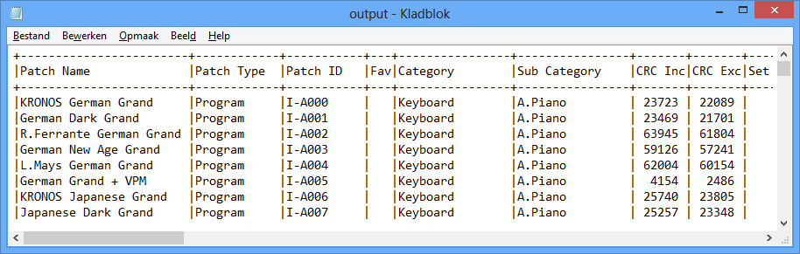

Figure 104: CRC Values

#### Sorting

Currently three sorting types are available, which are explained in the following paragraphs.

The sorting method is only used for the Patch List, for other types it is not supported.

**[TIP]:** If a certain sort method is not supported or available, you always can generate a comma separated value (CSV) file for certain list types and reorder it in the spreadsheet.

##### Type/Bank/Index

This is the default sorting method, which sorts in the following order:

First order key is type, which is 1) Programs, 2) Combis, 3) Set List Slots

Second order is bank, which is the program bank, combi banks and set lists.

Third order is the index within the bank.

This means the order of a complete PCG patch list is:

1. Program Bank A, index 0 to 127
2. All consecutive program banks
3. Combi Bank A, index 0 to 127
4. All consecutive combi banks
5. Set List 0, slots 0 to 127
6. All consecutive set list slots.

Below is an example of a fragment of the (default) Type/Bank/Index sorted Patch List.

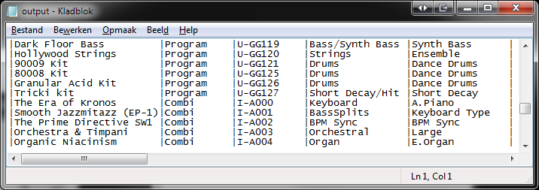

Figure 105: Type/Bank/Index Sorted Patch List

##### Category, then Patch Name

This is the sorting method, based on categories:

* First order key is category.
* Second order key is sub category (or ignored if the workstation model does not support it)
* Third sort order is the patch name.

If the patch file does not contain the global section, then category (and sub category) names are not available. However, category numbers and sub category numbers are so it will not matter in reality.

Since set list slots do not have categories (nor sub categories), set list slots will be appended at the end, sorted only by set list slot name.

Below is an example of a fragment of a category sorted Patch List.

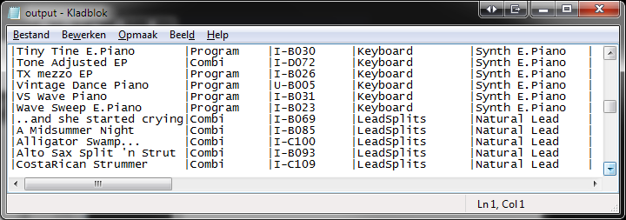

Figure 106: Category Sorted Patch List

##### Patch Name

This is the sorting method, based on patch names.

Below is an example of a fragment of the patch name sorted Patch List.

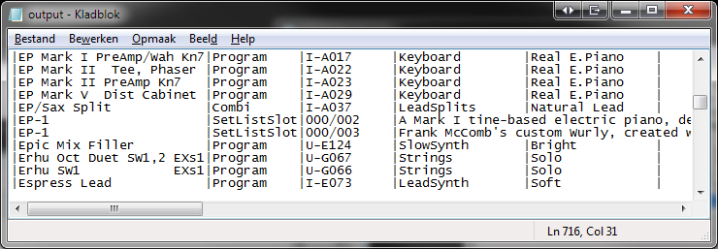

Figure 107: Patch Name Sorted Patch List

#### Output

There are several type of output formats that can be used for generating lists.

The name of the file is shown in the output field. You can type in the file name to be used as output file or browse for a file to be overwritten.

You can use a default extension but it is not necessary. In case you use do not use a default extension (like .txt for a CSV file), then the application connected to such a file is not automatically opened.

In the following paragraphs each output type will be explained in detail with examples.

##### ASCII Table Output

This is the default output type showing a text file using ASCII characters (+, - and |, see below) for creating a table which is opened by your default text viewer/editor as long as the output file ends with .txt; the default name is output.txt.

Below is an example of a fragment of a Patch List with ASCII Table output.

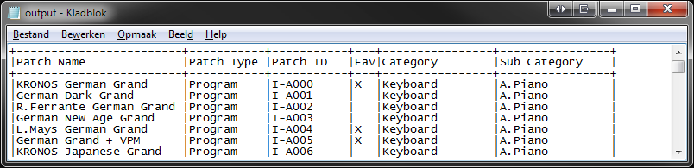

Figure 108: ASCII Table Output

##### (Plain) Text Output

This output format shows the same columns as the ASCII Table format except it does not generate the ASCII characters that creates the horizontal and vertical lines.

Below is an example of a fragment of a Patch List with Text output.

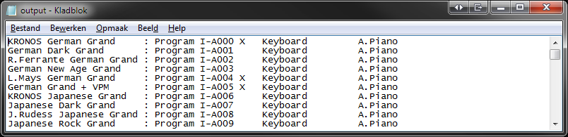

Figure 109: Text Output

##### CSV (Comma Separated Value) File Output

This output format creates a so called Comma Separated Value file, or in short CSV file.

Depending on the setting of your computer, these files are automatically loaded by a spreadsheet application, for example Microsoft Excel©. In MS Excel it will show up as text lines separated with commas and should be manually converted to separated columns. To do this, perform the following steps (example for MS Excel 2011 but other versions have similar capabilities):

1. Select the first column (A).
2. In the Data ribbon control tab, select the icon 'Text to Columns'. A dialog is shown.
3. Press the Next button.
4. In the next screen (step 2 of 3) select 'Comma'.
5. Press the Next button.
6. In the next screen (step 3 of 3) press 'Finish'.
7. Double click on each column transition to automatically change the width of each column or do it manually.
8. Now you can use all possible spread sheet function to further process the data.

**[WARNING]** Make sure you close the Excel file before generating a new CSV file with the same name. If not, the file that is open cannot be overwritten (generated) by PCG Tools and the following error will show up:

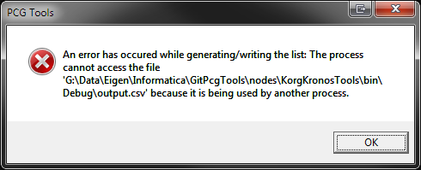

Figure 110: Error message after document in use.

The output will look like Figure 111.

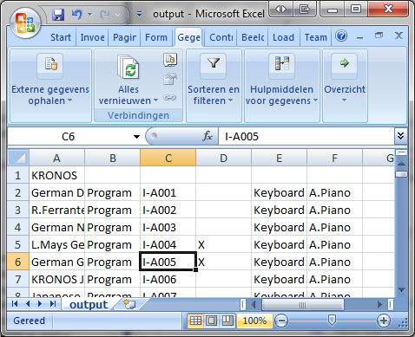

Figure 111: CSV (Comma Separated Values) Output in Microsoft Excel

In case there is no spread sheet application coupled to the .csv extension or you selected a .txt extension instead of a .csv extension, probably a text viewer/editor will be opened and an example fragment of the output will look like below.

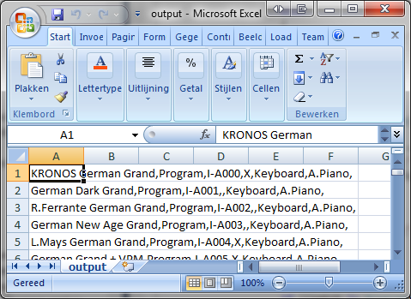

Figure 112: CSV (Comma Separated Values) Output as Text File

##### XML

This output format creates a so called E(X)tensible Markup Language, or XML file. XML files are widely used by internet application but also can serve as a structured data file for input by other applications.

Together with an XML file a so called E(X)tensible Stylesheet Language, or XSL file is created. This file contains HOW the XML file is shown.

When XML output is selected, normally the default browser will be opened to show the output, using the XML file as data content input and the XSL file as visualization of the data.

Below a fragment of the output for a patch list is shown.

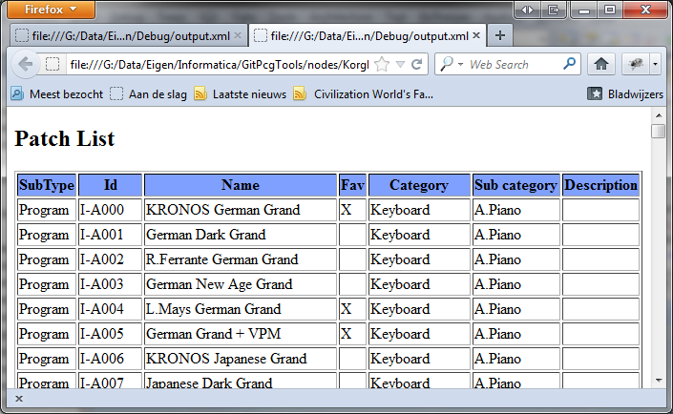

Figure 113: XML Output

**[TIP]:** If you want to use/see the source XML file, you can open the created files with a text editor, or depending on the browser, see the source (mostly via a right mouse button click on the generated page in the browsers). The XSL file should be browsed and opened in a text editor (manually).

Below a fragment of the XML source of a patch list is shown.

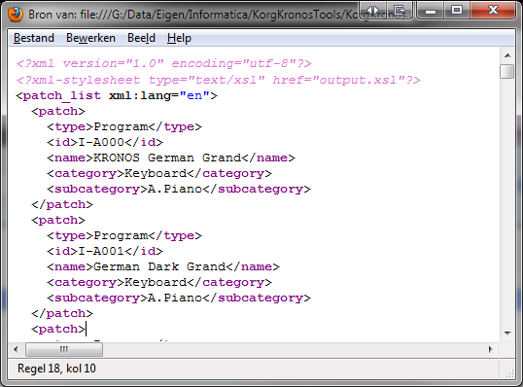

Figure 114: XML Source of a Patch List

Below a fragment of the accompanied XSL source of the patch list is shown.

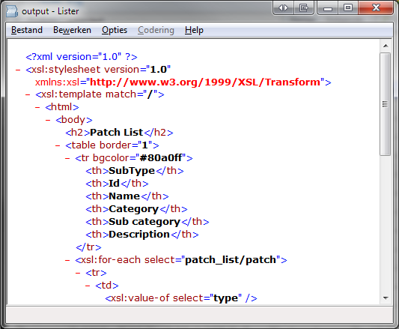

Figure 115: XSL Source of a Patch List

### Command Line Arguments

PCG Tools can also be started up with command line arguments to create a list from the set list generator.

To execute this, start cmd.exe, and set all parameters needed. Without arguments or with wrong arguments a help screen will be shown.

Example of a patch list command:

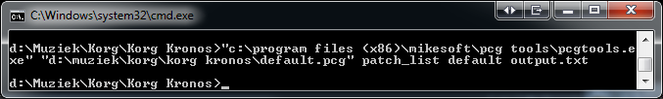

Figure 116: Patch List command

And the output will be stored in output.txt, see the next screenshot for a fragment:

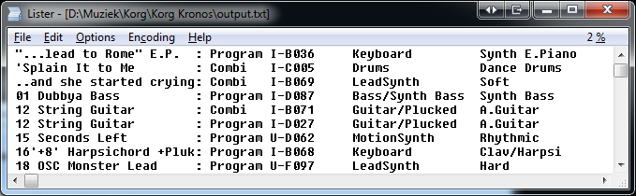

Figure 117: Fragment of a patch list

Below are all possible arguments:

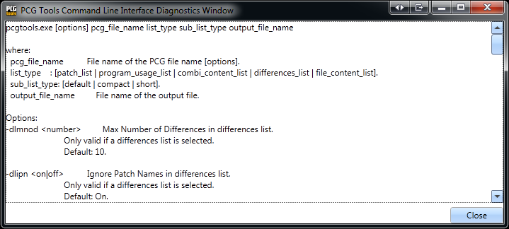

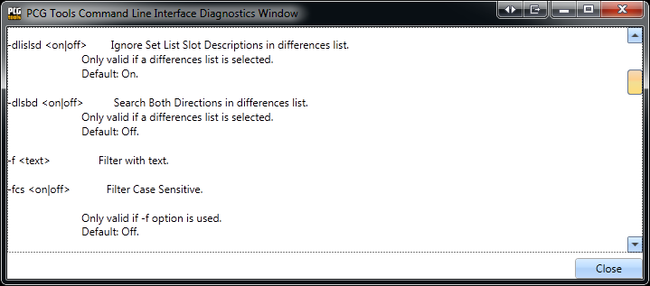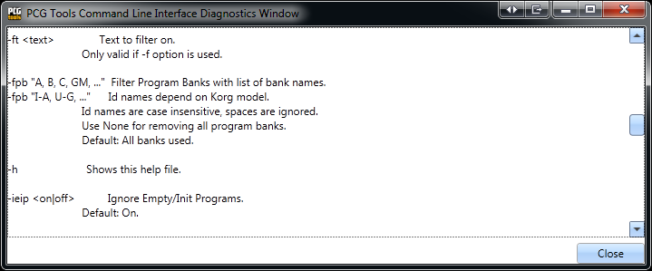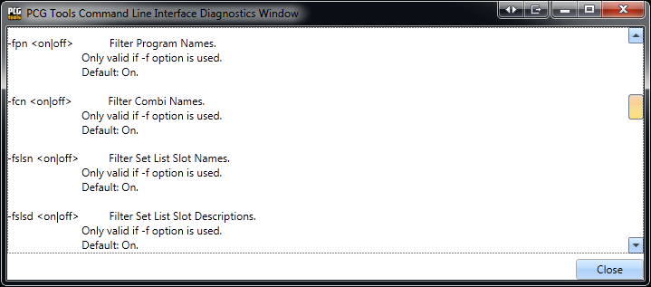

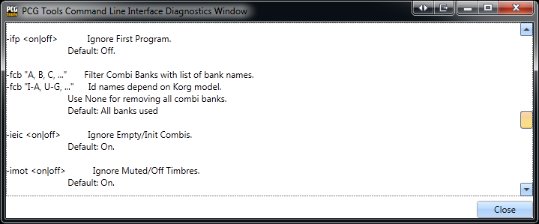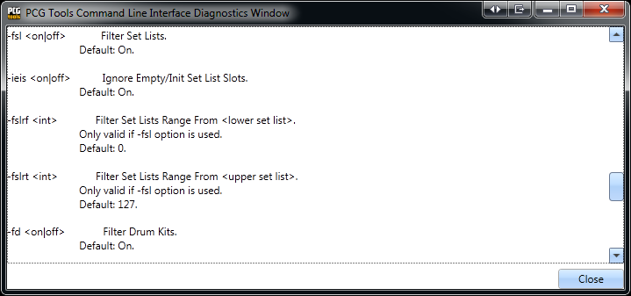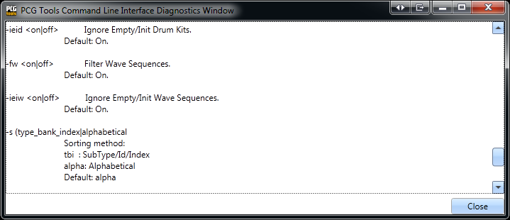

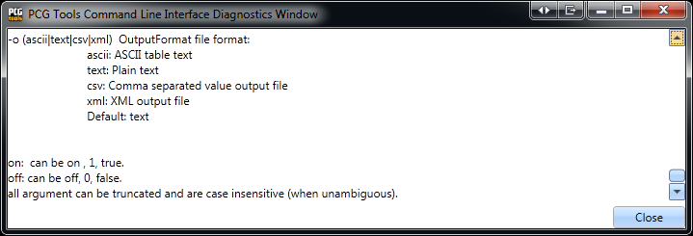

Figure 118: Command Line Arguments

## Additional patch File Features

In this paragraph additional features are explained. Currently there is one such feature: to export a patch file to a Cubase® instrument definition file.

### Generating a Cubase Instrument Definition File

This command can be used to generate an instrument definition file for Cubase.

The following way should be used to select this command:

* Select the Cubase sub menu item from the 'Export for Sequencer' menu item in the File menu.

Cubase is a sequencer application that can use patch list for easy navigating through the patches from within the application. For this functionality, Cubase uses instrument definition files.

This file can be copy/pasted to the Cubase directory after manually adapting if needed (depending on the Cubase version). However, manual adaptation is outside the scope of PCG Tools. Please refer to your Cubase documentation for the content of an instrument definition file.

A fragment of the output is shown in the figure below.

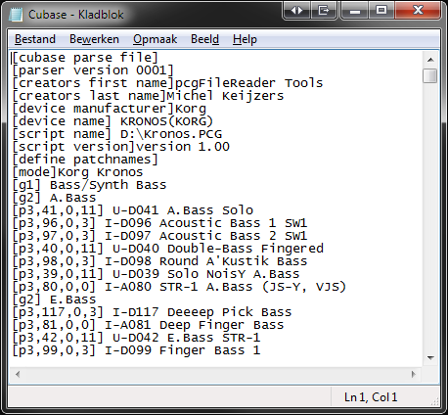

Figure 119: Cubase Instrument Definition File

# Using SNG (Song) Files

This file type contains songs created by the sequencer of your workstation. One such SNG file can contain multiple songs.

A song file contains a lot of information and only a very small portion is analyzed with PCG Tools, namely the songs contained in the files and the samples being used by those songs.

A song file can be opened by the regular Open command (see Paragraph 6.4.1). When the dialog is opened, select in the right bottom corner the correct type: SNG Files (*.sng) and open the song you want to be shown.

Multiple song files can be opened and even song files from different workstation models.

The window contains two tabs, one for songs information and one for samples information. These tabs are explained in more detailed in the following paragraphs.

The status bar shows the workstation model, the type of file (SNG), the number of songs in the loaded SNG file and the number of samples used in the loaded SNG file.

## Songs Tab

This tab shows the indices and the names of the songs contained in the SNG file and this tab will be opened by default. Below is an example of this tab.

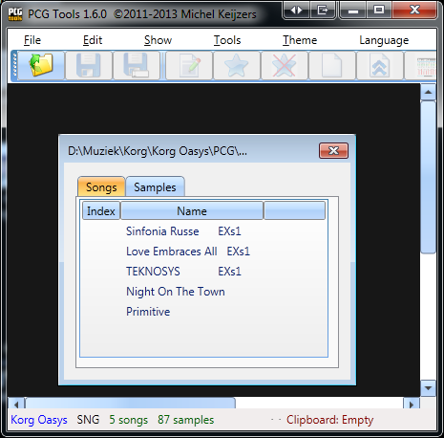

Figure 120: Songs Tab

## Samples Tab

This tab shows the samples that are used by all songs in the SNG file. Per sample, the index, name and (Sample) file name is shown. See below for an example.

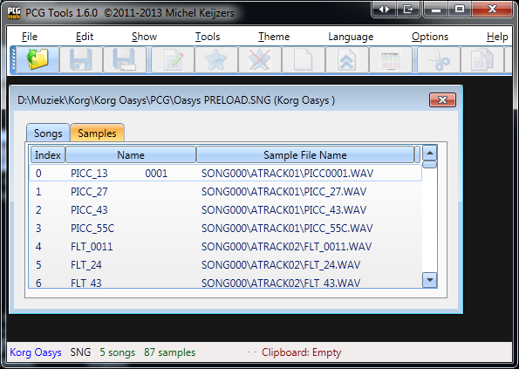

Figure 121: Samples Tab

# Keyboard Usage & Shortcut Keys

By default, the Windows operating system has a lot of automatic keyboard shortcuts and special predefined usages for selections and commands. Besides that, PCG Tools has some additional keyboard shortcuts.

Most shortcuts need a special key, like the Control (Ctrl) or Alt key together with another key. For this a special notation is used, like e.g. Ctrl g is used which means: press AND HOLD the Control key, press the g key and release the g key without releasing the control key before releasing the g key.

## Keyboard Command Selection

When pressing the left Alt key, all file menus, menu options and most screen controls show an underlined character. When the left Alt key is pressed together with that underlined character that control is focused. Pressing the Enter key (or space key for buttons), will activate/change the selected control.

If there are multiple controls with the same underlined character, PCG Tools focuses to the next control with the same underlined character, even if it is on another opened patch file (so you can also use this feature for jumping quickly to another PCG window by keyboard).

To execute the focused control, press the Enter key.

## Generic Commands Shortcut Keys

|  |  |
| --- | --- |
| **Key** | **Command** |
| Ctrl F4 | Closes the current selected window (and sub windows). |
| Alt F4 | Exits the application. |
| Alt Tab | Go to the next application or in some cases another PCG Window, like the List Generator or the output of the list generator. |
| (Shift) Alt Tab | Go the previous application. |
| Left Alt Tab | Focus on the menu (you can use the cursor keys to navigate to the correct menu item and press Enter to activate the focused menu item). |
| F6 | Go to the next window (e.g. PCG Window, Timbres window, SNG window). |
| Ctrl F6 | Go to the previous window (e.g. PCG Window, Timbres window, SNG window). |
| Ctrl Tab | Go to the next control. |
| Shift Ctrl Tab | Go to the previous control. |
| Alt + Space | Focus on the window menu. |

Table 27: Generic Commands Shortcut Keys

This list is not complete. For a complete list, see <http://support.microsoft.com/kb/301583>.

Not all commands are usable in PCG Tools, but most keys that are related to PCG Tools are.

## Main Menu Shortcut Keys

The short cuts shown below are active only when the menu is active.

|  |  |
| --- | --- |
| **Key** | **Command** |
| F10 | Go to/from the Main menu |
| Ctrl O | File Open |
| Ctrl S | File Save |
| Ctrl Shift S | File Save as |

Table 28: Main Menu Shortcut Keys

## Keyboard Shortcut Keys and Mouse handling

In an opened patch file two lists are displayed: the Banks (or set lists) list on the left side and the Patch list containing programs, combinations or set list slots from the bank or list selected in the Banks Listview on the right side.

One of the lists has a thick gray line around it, which shows the active list. Commands below the lists are executed for the selected items in the active list view only.

**[EXAMPLE]**: When the Banks Listview is active and five banks are selected, and Left Alt + c is pressed to clear them, all patches within those five selected banks will be cleared. If the Patches Listview (right list view) would be active, then only the selected patches in the patch list will be cleared.

Some commands are available depending on the active list (Banks Listview or Patches Listview).

You can use multiple selections on both lists by using the Shift or Control key together with other keys or with the mouse. The shift key can be used to select a continuous range, the control key can be used to deselect or select items in a list without affecting other selections.

The table below shows the short cut keys possible on either list.

|  |  |
| --- | --- |
| **Key** | **Command** |
| Cursor Up | Move the cursor one item up. |
| Cursor Down | Move the cursor one item down. |
| Page Up | Move the cursor one page up. |
| Page Down | Move the cursor one page down. |
| Home | Move the cursor to the first item. |
| Home | Move the cursor to the first item. |
| End | Move the cursor to the last item. |
| Shift | Keep the Shift key pressed to select a consecutive range (can be used in conjunction with the Control key).* |
| Control | Keep the Control key pressed to select multiple items (can be used in conjunction with the Shift key).* |
| Ctrl Numeric 8 (Up) | Moves the selected patch one location up. |
| Ctrl Numeric 2 (Down) | Moves the selected patch one location down. |
| Left Mouse Button Double Click | Opens the Edit dialog for the selected patch. |
| Control x | Cuts the selected banks or patches (for pasting later) |
| Control c | Copies the selected banks or patches (for pasting later) |
| Control v | Pastes the selected banks or patches (only allowed type). |

* These keys cannot be used to select multiple items by using the keyboard only, but only by concurrently using the mouse.

Table 29: Keyboard Shortcut Keys and Mouse Handling

## PCG Window Shortcut Keys

The table below shows the short cuts which can be used inside a PCG Window.

|  |  |
| --- | --- |
| **Key** | **Command** |
| Ctrl X | Cut the selected items to the clip board |
| Ctrl C | Copy the selected items to the clip board |
| Ctrl P | Pasts the selected items possible to paste in the selected items. |

Table 30: PCG Window Shortcut Keys

## SNG Window

For the Song window, there are no short cut keys available.

# 

# Installation of Core FTP LE

## Introduction

The Korg Kronos from OS version 2.0 and the Korg Kronos X can make use of an Ethernet connection for transferring files. This is the ideal way of using PCG Tools because you do not need to use an USB stick or memory card for transferring the PCG file(s) from your workstation to your computer and vice versa.

Below are the steps needed to set up such communication.

## Setup the FTP connection on the Kronos site.

First the Kronos (X) needs to have some values being entered for making an FTP connection possible. Perform the following steps:

* Press the 'Global' button on your Kronos (X).
* Go to the Basic tab.
* Go to the Network tab.
* Press the Configure button.
* Enter a host name. This name can be anything but is needed later in an FTP application as identification for the Korg Kronos (X).
* Set the Address Method to DHCP. This means that the Korg Kronos (X) automatically creates a number that uniquely identifies the machine.
* Press the 'OK' button.
* Select a user name (this can be anything).
* Select a password (this can be anything). Remember the password well for later usage.

## Install Core FTP LE

Perform the following steps:

* First browse to <http://www.coreftp.com/download.html>. Core FTP (LE) is a free software application for managing FTP connections. There are also other (free) applications for FTP but I just used this application as example.
* Download the latest free version for your operating system (32 or 64 bit) and run it.
* You will see the following screen:

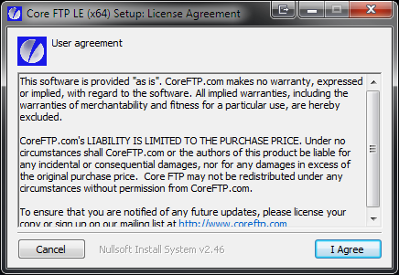

Figure 122: Core FTP Installation screen shot 1

* Press the button 'I Agree'.
* You will see the following screen:

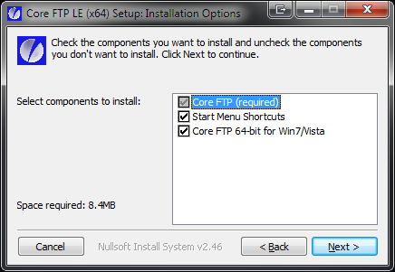

Figure 123: Core FTP Installation screen shot 2

* Press the 'Next' button.
* You will see the following screen:



Figure 124Core FTP Installation screen shot 3

* Press the 'Next' button.
* You will see the following screen after the installation has been completed successfully:

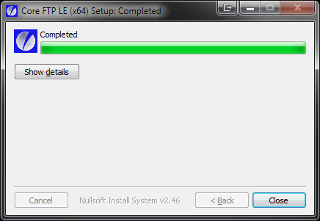

Figure 125: Core FTP Installation screen shot 4

* Press the 'Close' button.

## Set up the FTP connection

* Make sure that both the computer and the Korg Kronos (X) are connected to the same router/switch.
* Start up Core FTP LE.
* You will see the Site manager window. If not, select it from the Sites menu, sub menu Site Manager.

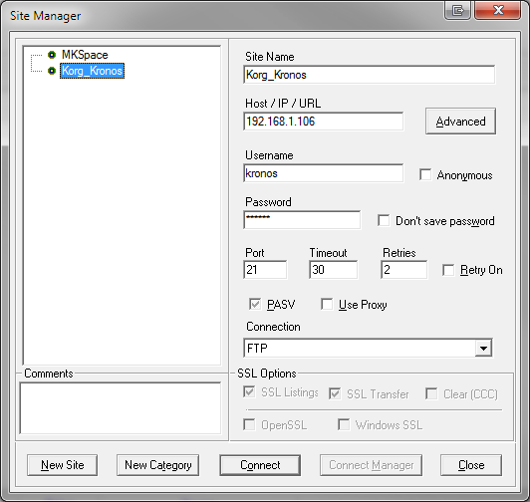

Figure 126: FTP Site Manager

* Press the 'New Site' button and fill in the items according to the table below. All other values can be left to default.

|  |  |  |
| --- | --- | --- |
| **Item** | **Value** | **Remarks** |
| Site Name | e.g. Korg Kronos (X) | You can use any name here. |
| Host / IP/ URL | The host name you entered on the Korg Kronos (X) |  |
| Username | The user name you entered on the Korg Kronos (X) |  |
| Password | The password you entered on the Korg Kronos (X) |  |

Table 31: New (FTP) Site

* Press the 'Connect' button.
* You will see a screen similar as below.

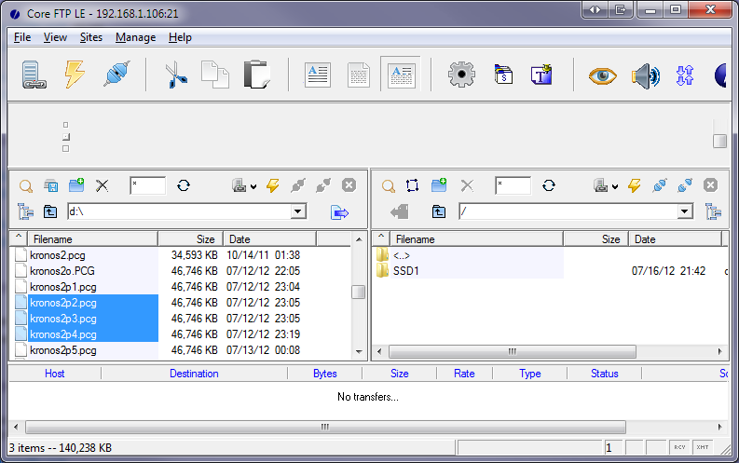

Figure 127: FTP Connection

On the left site is a folder on your computer; you can change this to any location. On the right side the Korg Kronos (X) SSD contents are shown. With the left and right arrow button you can copy files from the computer to the Korg Kronos (X) or vice versa. In the example above you can see the left arrow in the red circle). The arrow will only be enabled if one or more files are selected.

Always make a backup file before you are going to change a patch file with PCG Tools.

After copying one or more patch files from the Korg Kronos (X) to your computer, you can use PCG Tools to load it. When finished with PCG Tools (or in between if you like), save the file and copy the file with FTP Core LE to the Korg Kronos (X) and load it.

Note that sample files are hidden and will not be shown.

Index

A

About Window, 53

Application Start, 35

Artist, 82

ASCII Table, 130

Assigned Clear Program, 108

Asterisk, 40

B

Banks Listview, 62

Bend Range, 107

Broken combis, 84

Broken Set List Slots, 84

C

Category, 30

Category A, 30

Category B, 30

CF, 31

Clear Command, 76, 108

Clipboard, 86, 88

Close, 41

Combi, 27

Combi Bank, 28

Combi Banks, 29, 65

Combi Content List, 115

Combi window, 43

Combi Window, 106

Combis, 69

Command Line Arguments, 135

Commands, 107

Close, 41

Exit, 42

Export to Sequencer, 40

Open, 36

Revert, 40

Save, 39

Save As, 40

Compact Combi Content List, 115

Compact Command, 79, 81

CompactFlash, 31

Copy Command, 87

Copy/Paste Commands, 84

Copy/Paste Exit Command, 94

Copy/Paste Recall Command, 95, 96

Copy/Paste Settings, 91

Core FTP LE, 146

CRC Values, 127

CSV (Comma Separated Values) File, 131

Cubase, 138

Cut Command, 85

Cut/Copy/Paste Settings, 49

Cyclic Redundancy Check, 127

D

Delete. *See Clear Command*, *See Compact Command*, *See Compact Command*

Differences List, 117, 120

Discussions, 1

Donations, 2

Down Command, 76, 107

E

Edit Combi, 74

Edit Command, 73

Edit Program, 73

Edit Set List Slot, 74

Email Addresses, xiv

Empty Bank, 27

Erase. *See Clear Command*, *See Compact Command*, *See Compact Command*

Exit, 42

Exit Command, 94

Extensible Markup Language, 133

Extensible Stylesheet Language, 133

External Links, 54, 57

F

FaceBook, 1, 2

factory default, 102

Figures, x

Files

01p, 22

01W, 22

ALL, 22

KMP, 30

KRSacm, 22

KRSall, 22

KRSapr, 22

KRSbcm, 22

KRSbpr, 22

KRScm, 22

KRSpr, 22

KSC, 30

KSF, 30

LIB, 22

MID, 22

Mkxl_all, 22

mkxlp_prog, 22

PCG, 22

RAW, 22

SNG, 30

SYX, 22

Filter Combi Banks, 124

Filter on Favorites, 126

Filter On Text, 122

Filter Program Banks, 123

Filter Set List Slots, 125

Forum, 1

G

Generate List, 110

Generic Commands, 72

Global, 30

GM, 24

Google Plus, 2

Goto Next Window, 52

Goto Previous Window, 52

H

Help, 53

History Changes, xix

Home Page, 1, 54

I

Initial screen, 35

Installation Problems, 17

Instrument Definition File, 138

Internal Bank, 24

K

Key Zone, 107

Keyboard

Shortcut Keys, 143

Usage, 3, 143

Keyboard Shortcut Keys, 144

Keyboard Shortcuts, 54

Keyboard Usage, 3, 143

KMP Files, 30

Korg Kronos, 60

Korg M3, 60

Korg Triton, 60

Korg.com, 1

KorgForums, 1

KSC Files, 30

KSF Files, 30

L

Linux, 8

List Generator, 5, 110

List of

Email Addresses, xiv

Figures, x

Tables, xiii

List Types, 110

Long Combi Content List, 116

M

Mac OS X, 8

Main Screen, 34

Master Files, 102

Media, 18, 31

Menu, 36

Help, 53

Mouse handling, 144

Move Up Command, 76

Mute, 107

N

Newsletter, 1

O

Optional Columns, 127

Options Menu, 46

OS Version, 60

Osc Mode, 107

Osc Select, 107

Oscillator Mode, 107

Oscillator Select, 107

Output, 130

P

Paste Command, 89

Patch List, 111

Patches Listview, 68

PCG Files, 22, 59

PCG Version, 60

PCG Window, 61

Pitch Bend Range, 107

Portamento, 107

preload, 102

Priority, 107

Program, 24

Program Bank, 24

Program Banks, 27, 64

Program Usage List, 113

Programs, 69

Programs/Combis/Set Lists Radio buttons, 62

R

Recall Command, 95, 96

Restore Button, 94

Revert, 40

Rompler, 24

S

Samples Tab, 142

Save, 39

SD, 31

SecureDigital, 31

Sequencer, 138

Set List, 29

Set List Slot, 29

Set List Slots, 70

Set Lists, 29, 66

Settings, 92, 120

Settings Menu, 46

Setup, 8

Setup Problems, 17

Short Combi Content List, 115

Shortcut Keys, 143, 144

SNG (Song) Files, 140

Social Media, 2

Song Files, 30

Songs Tab, 140

Sort, 81

Sorting, 128

Splash Screen, 34

Split character, 82

SSD, 31

Standalone Installation, 17

Status, 107

Status Bar, 59

Sub Category, 30

System Requirements, 7

T

Tables, xiii

Text output, 131

Themes, 43

Timbre, 28

Timbres, 28, 43

Timbres Command, 83

Title, 82

Transpose, 107

Twitter, 2

U

Up Command, 107

USB Stick, 31

User Bank, 24

V

Velocity Zone, 107

W

Web site, 1

Window types, 41

Windows, 8

About, 53

External Links, 54, 57

Windows Menu, 52

Workflow, 31

Workstation models, 84

X

XML, 133

XML source, 134

XSL Source, 134

1. Having 14 banks of 128 combis containing 16 programs would be 28,672 programs needing to be stored, resulting in a PCG file of hundreds of MBs.
2. In case of a General MIDI program, always GM is shown as bank, even if the bank is g(1)..g(d).
3. In case of a General MIDI program, ??? is shown since that information is not available.
4. Workstation model dependent feature.